LAUDA honors Rainer Deinert for 45 years of company loyalty

Electrical engineering expert plays a decisive role in shaping the company’s history

Lauda-Königshofen, October 29, 2024 – On September 30, 2024, LAUDA DR. R. WOBSER GMBH & CO. KG celebrated Rainer Deinert's remarkable 45th anniversary with the company. During the ceremony, the long-time employee was honored for his extraordinary commitment and loyalty to the family-owned company.

Rainer Deinert began his career at LAUDA on September 3, 1979 with an apprenticeship as an energy device electronics technician. In the decades that followed, he worked in various positions at LAUDA and continually improved his qualifications. From setting up the repair shop, to managing the service shop, to managing the electrical assembly with a total of 35 employees, Deinert has played a decisive role in the technical development of the company.

In his laudatory speech, Dr. Gunther Wobser, President & CEO of LAUDA, acknowledged the special achievements of the jubilee: “Rainer Deinert was one of 100 applicants for only eight training positions at LAUDA at that time. His development from apprentice to manager is impressive. With his hard work, commitment and technical expertise, he has helped shape LAUDA for decades and contributed to the company's success.”

Christoph Baumann, Head of Global Production, added: “Rainer Deinert was the technical rock in the surf. He actively supported product development beyond his duties and was always a competent contact person for superiors, colleagues and trainees.”

In addition to his full-time job, Deinert has held various honorary positions at LAUDA. Since March 2007, he has been a member of the board of examiners for the professions of electronics technician for devices and systems and mechatronics technician, and since February 2007 he has also been a trainer for electronics technicians for devices and systems. In April 2010, he was appointed fire safety officer and also acted as a company first aider. In addition, he supported the development of the LAUDA site in China in 2013.

In his acceptance speech, Rainer Deinert emphasized his deep connection to the world market leader in temperature control: “It was a calling for me to work here. I am proud that I was able to contribute to the success of the company and that during my time here I was able to accompany a total of 36 young people through their training, 19 of whom are still working for the company today. It has been a great honor and pleasure for me to work at LAUDA.”

In recognition of his many years of service, Rainer Deinert received the LAUDA certificate of honor and a certificate from the Chamber of Commerce and Industry. On the same day, a new phase of life began for the jubilee employee with his entry into passive semi-retirement.
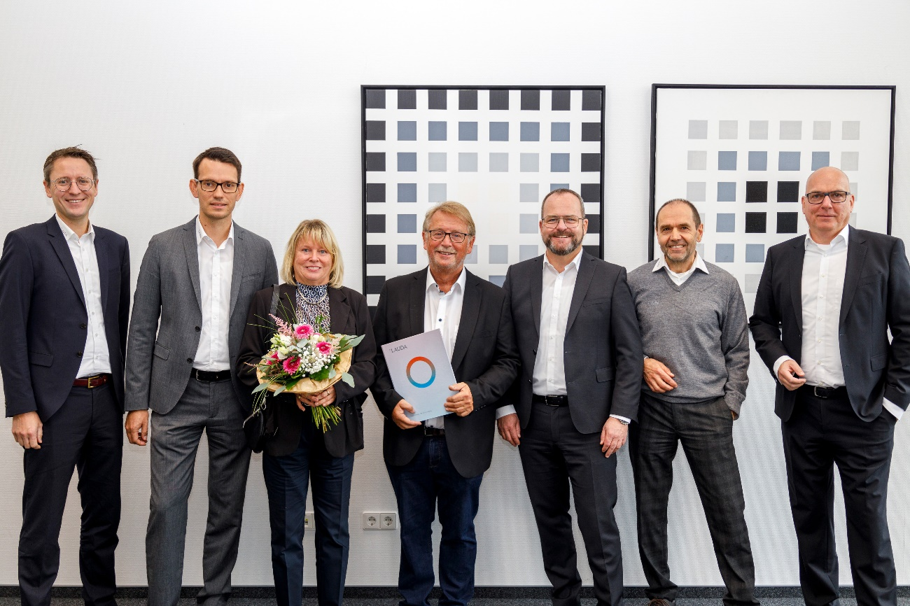

Fig.: Rainer Deinert (centre) was honored by LAUDA President & CEO Dr. Gunther Wobser (3rd from right) and Dr. Mario Englert (CFO, left) and Dr. Marc Stricker (COO, right) for 45 years of service. © LAUDA

We are LAUDA – the world leader in precise temperature control. Our constant temperature equipment and systems are at the heart of important applications, contributing to a better future. As a complete one-stop supplier, we guarantee the optimum temperature in research, production and quality control. We are the reliable partner for electromobility, hydrogen, chemicals, pharmaceuticals/biotech, semiconductors and medical technology. We have been inspiring our customers for almost 70 years with our expert mentoring and innovative solutions – every day anew and all over the world.

In our company, we always go one step further. We support our employees’ development and are constantly developing ourselves: to create a better future together.

Press contact
We are more than happy to make prepared information about our company, the LAUDA Factory Gallery and our projects in the area of innovation promotion, digitalization and idea management available to the press. We look forward to hearing from you – just give us a call!

CHRISTOPH MUHR
Director Corporate Communications
T + 49 (0) 9343 503-349
christoph.muhr@lauda.de

LAUDA DR. R. WOBSER GMBH & CO. KG, Laudaplatz 1, 97922 Lauda-Königshofen, Deutschland/Germany. Limited partnership: Headquarters Lauda-Königshofen, Registration court Mannheim HRA 560069. General partner: LAUDA DR. R. WOBSER Verwaltungs-GmbH, Headquarters Lauda-Königshofen, Registration court Mannheim HRB 560226. Managing Directors: Dr. Gunther Wobser (President & CEO), Dr. Mario Englert (CFO), Dr. Marc Stricker (COO)

