PRESS RELEASE
Schwaebisch Hall, May 11, 2022

Getting integrated pharmaceutical lines into production more quickly and safely
At its German headquarters, OPTIMA is investing in a state-of-the-art facility with over 4,000 square meters of space for assembly

As part of its 100th anniversary celebration on May 05, 2022, the Optima Group inaugurated the CSPE Center II. This way, the Optima Pharma Division is expanding its production area for assembling, commissioning, and qualifying pharmaceutical filling lines by over 4,000 square meters. Additional new office space has also been created. Minister-President Winfried Kretschmann traveled to the site especially for the inauguration. The first lines were installed just seven months after construction began. Optima Pharma is thus responding to customer requests and is further expanding the successful CSPE process for fast and safe production start-up of the integrated filling lines with isolators and freeze dryers. Optima is investing a double-digit million sum in the new building.
"Celebrating the company's 100th anniversary provides the perfect backdrop for the inauguration of CSPE Center II," says Hans Buehler, Managing Director/CEO of the Optima Group. The inauguration of the new building was held during the event which was attended by numerous guests from the world of business and politics. Baden-Wuerttemberg's Minister-President Winfried Kretschmann made a special trip to the inauguration and extended his congratulations on Optima's 100th anniversary. "This investment reaffirms our commitment to the Schwaebisch Hall site and is creating the conditions for continued growth with complete confidence", says Hans Buehler. Despite the COVID-19 pandemic and a shortage of materials in the construction industry, the new building was completed in a record time of only twelve months. "We would like to express our thanks and appreciation to our architect Rolf Blank, along with all the companies and authorities involved, for this masterful performance," Buehler stresses. Installation, commissioning and qualification of equipment was possible after a record time of only seven months, starting in December 2021.
CSPE 2.0: In best time to production start
"CSPE 2.0 enables an even higher level of integration. Work that typically took place on the customer's site will be carried out to an even greater extent in one of our CSPE centers", stated Gerhard Breu, Chairman of the Optima Pharma Division. The Comprehensive Scientific Process Engineering (CSPE) speeds up processes, from designing the system to launching production. An essential aspect is the comprehensive process simulations, along with integrated factory acceptance tests for complete systems. In addition to filling and closing systems, and isolators, freeze-drying systems can now also be set up and tested under realistic conditions, as a fully functioning overall unit. As a comprehensive system provider, Optima Pharma now handles further qualification measures in-house, including significant parts of cycle development. This significantly reduces the time that elapses between installation and the start of production at the customer's site, as well as a reduction in time from product development to market launch.
Bigger, more efficient and more convenient
The new buildling offers short distances, the pooling of strengths and efficient operating processes for Optima. The experience gained from operating CSPE Center I was incorporated into the design and led to further streamlining. The new building is 25 percent bigger and offers even more space for large turnkey lines. Optima Pharma's production area will expand by over 4,000 square meters. Including the adjoining three-story office building, the new structure covers 7,000 square meters.
Flooded with light, transparent and energy efficient
The working conditions for the employees meet the highest standards. The light-filled building with transparent glass facades provides comfortable temperatures all year round – both in the production area and in the office wing. An energy-efficient concrete core activation system heats and cools the production area, while a high-performance heating and cooling ceiling regulates the temperature in the office building. Spacious meeting rooms offer sufficient room for project meetings and conversations with clients. Soundproof rooms for telephone calls and video conferences are dispersed throughout the building to facilitate focused work. There is office space for up to 150 employees. As part of Optima's sustainability strategy, the energy-saving building was built in accordance with energy efficiency level 55 and, like the majority of company buildings in Schwaebisch Hall, is connected to the Schwaebisch Hall municipal district heating network. This provides Optima with regeneratively generated remote heating. Photovoltaic systems are installed on the roof and supply electricity to the public electric grid. The parking areas will be equipped with e-charging points.
Expansion in the pharmaceutical business sector
Optima Pharma inaugurated the first CSPE Center in June 2019 at its headquarters in Schwaebisch Hall. Ever since, CSPE Center I has been operating at full capacity. At Optima Pharma's site in Gladenbach-Mornshausen near Marburg (Hesse), the current area for assembling, commissioning and qualifying multi-story freeze drying systems has grown by over 50% in the past year. An expansion building with office and assembly space is planned at Optima's subsidiary Metall+Plastic in Radolfzell on Lake Constance. Metall+Plastic's isolators and cleanroom technology are essential for aseptically processing pharmaceutical products. This means Optima Pharma is capable of supplying integrated total solutions from a single source. Provided that this strong growth continues, another CSPE Center may be added to the south of the CSPE Center II.

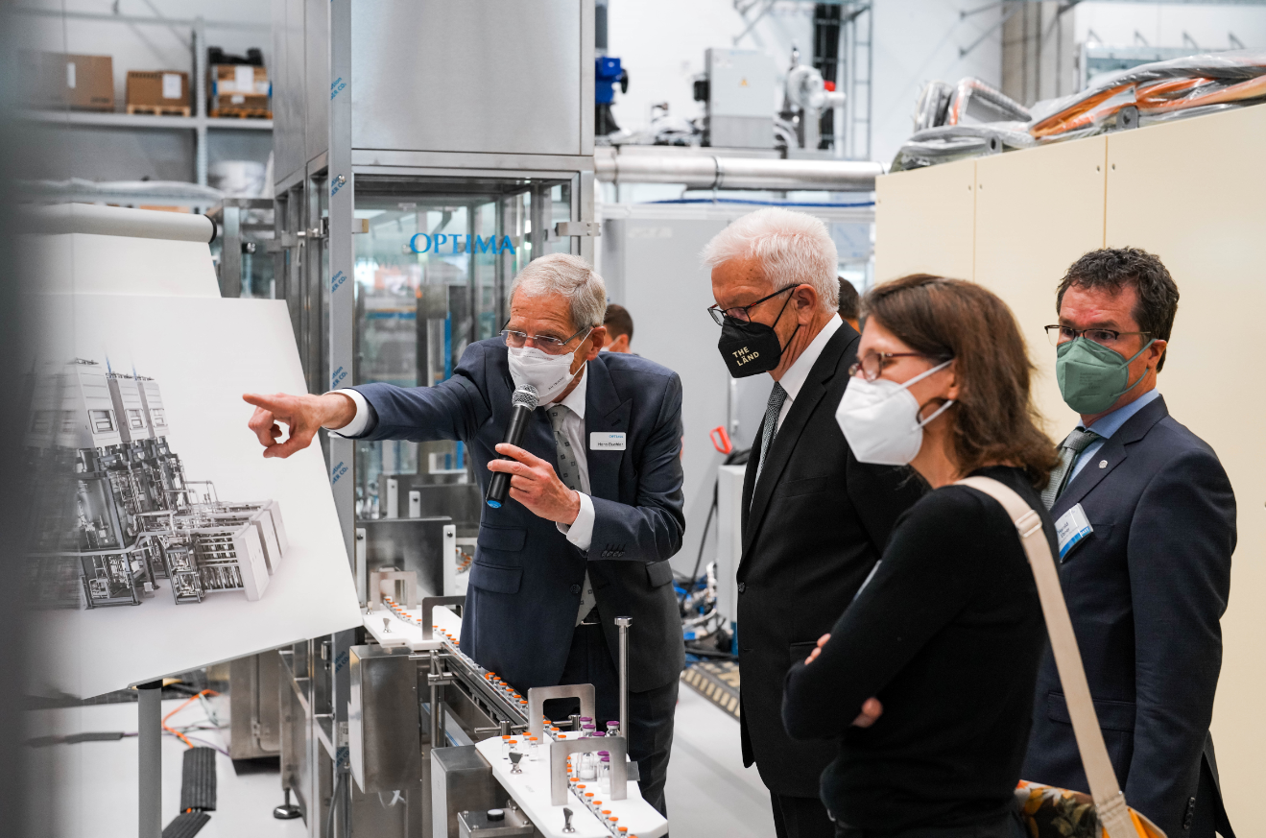
From left to right: Hans Buehler, Managing Director/CEO of the Optima Group, explains the operation of a pharmaceutical filling line to Winfried Kretschmann, Minister-President of Baden-Wuerttemberg, Jutta Niemann (Member of the State Parliament, Buendnis 90/Die Gruenen) and Harald Ebner (Member of the Federal Parliament, Buendnis 90/Die Gruenen). Numerous lines have been delivered to customers worldwide for the filling of COVID-19 vaccines with the highest priority at uncompromising quality. (Source: Optima)

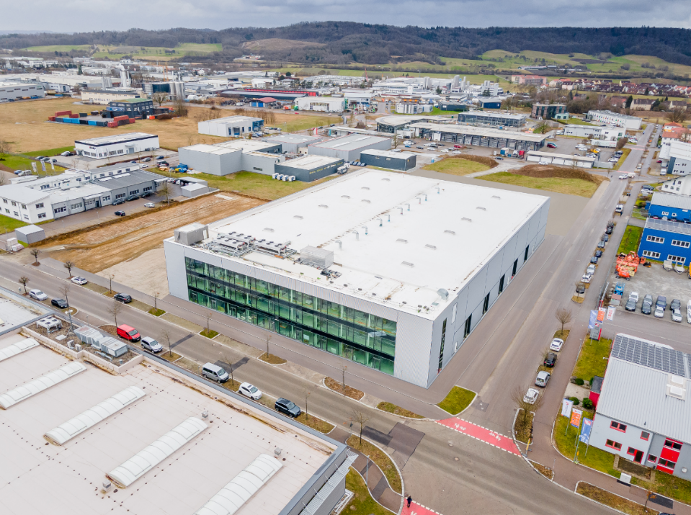
The opening of the new CSPE Center II (center) has increased Optima Pharma's production area in Schwaebisch Hall's Solpark business park by an additional 4,000 square meters. (Source: Optima)

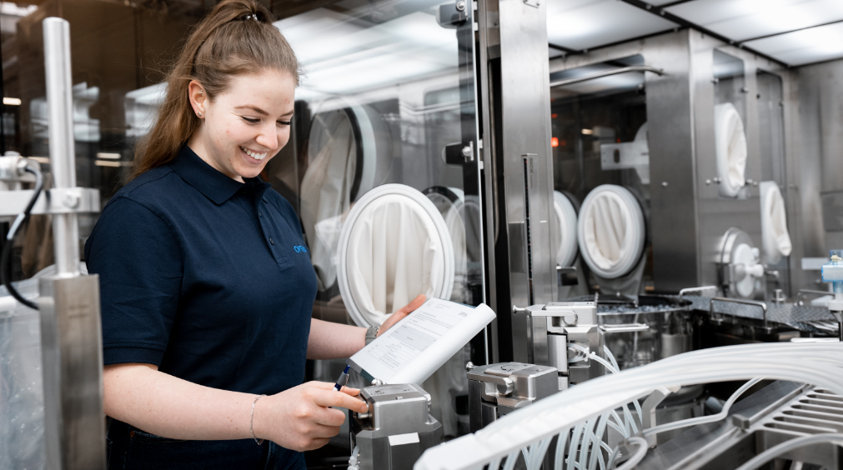
In the new CSPE Center II, an Optima Pharma employee carries out safety and qualification tests on a pharmaceutical line. (Source: Optima)

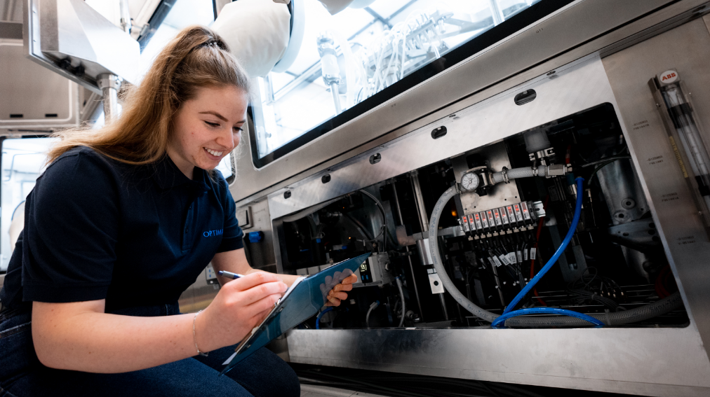
Optima Pharma is now able to carry out even more comprehensive qualification measures in-house as part of the enhanced CSPE process. This further reduces the time between installation and the start of production at the customer's site. (Source: Optima)

Characters (incl. spaces): 5,864

Press contact:
OPTIMA packaging group GmbH
Jan Deininger
Group Communications Manager
+49 (0)791 / 506-1472
jan.deininger@optima-packaging.com
www.optima-packaging.com

About OPTIMA
Optima supports companies worldwide with flexible and customer-specific filling and packaging machines for pharmaceuticals, consumer goods, paper hygiene and medical devices markets. As a provider of solutions and systems, Optima accompanies these companies from the product idea through to successful production and throughout the entire machine life cycle. Over 2,800 experts around the globe contribute to Optima's success. 20 locations in Germany and abroad ensure the worldwide availability of services. In 2022, Optima celebrates the company's 100th anniversary.
Exciting stories from 100 years of Optima: www.100-years-of-future.com

Thank you very much for your publication. We look forward to receiving a digital specimen copy.

