Höchst Industrial Park: Carbon capture pilot plant goes into operation – project by Infraserv Höchst and GEA

Frankfurt/Duesseldorf, June 11, 2025 – Infraserv Höchst has successfully commissioned a carbon capture pilot plant at Industriepark Höchst's sewage sludge incineration facility to gather data and experience on the feasibility of capturing CO₂ from flue gases. The pilot plant was supplied by GEA, a leading global provider of process technologies and sustainable industrial solutions. Infraserv Höchst is renting the plant for a period of three months.

Important contribution to the transformation of Industriepark Höchst

"Pilot plants of this kind are indispensable for testing the process and collecting the necessary data," explained Dr. Joachim Kreysing, Managing Director of Infraserv Höchst. This is the prerequisite for being able to operate our own, larger carbon capture plants at Industriepark Höchst in the future. "Carbon capture can make an important contribution to the site's sustainable transformation if the technical, economic and regulatory conditions are right." Carbon capture helps to reduce CO₂ emissions, conserve fossil resources and promote the circular economy. "We want to create the best conditions at Industriepark Höchst to enable our customers to move towards sustainability. That includes the various ways to use CO₂," said Dr. Kreysing. Infraserv is continuously exploring the market to identify potential customers for captured CO₂.

Separating CO₂ from flue gases is challenging

As part of the project, a partial flow of flue gas is extracted from the chimney at Infraserv Höchst's sewage sludge incineration plant in order to scrub out and separate the CO₂ it contains in the pilot plant. This poses a particular challenge because the flue gas from an incineration plant contains many different components. The test phase is therefore crucial in order to gain experience and test the feasibility of CO₂ separation with regard to various parameters. Data is collected on the capture rate, the purity of the CO₂, the decomposition of the scrubbing agent used to bind and capture the CO₂and the energy requirement. "Essentially, we are evaluating the energy requirements, efficiency and costs of a large-scale separation system at an incineration plant," explains Dr. Sirko Ogriseck, Project Manager at Infraserv Höchst. The sewage sludge incineration plant was deliberately chosen because part of the CO₂is of biogenic origin. In the future, Infraserv would like to supply this CO₂to startups so that they can use it in their syntheses together with low-carbon energies such as green hydrogen and green electricity. Biogenic CO₂ plays a key role in carbon capture and utilization (CCU), i.e. the chemical use of carbon dioxide, because unlike fossil CO₂, it is considered climate-neutral - it comes from renewable raw materials and was previously removed from the atmosphere by plants. As a result, biogenic CO₂ enables the climate-neutral production of chemical products, fuels and materials whose CO₂ balance would otherwise be negative,and supports the transformation of the chemical industry towards a greenhouse gas-neutral circular economy.
The process of CO₂ capture by the GEA pilot plant

"At the waste incineration plant, a partial flow of flue gas is extracted from the stack. This flue gas is fed into the pilot plant. During CO₂ capture with amines, the CO₂ is washed out of the flue gas," says Michael Schneider, R&D Engineer Carbon Capture Solutions at GEA, explaining the CO₂ capture process. "The flue gas is brought into contact with a liquid, an amine-water mixture, which absorbs the CO₂. This liquid is then heated so that the CO₂ is released again." The CO₂ separated from the flue gas is examined for its purity and operating data from the CO₂ separation is collected in parallel. "After separation in the pilot plant, the CO₂ could be purified and processed further, but this is not part of the project. Currently, after treatment in the pilot plant, the CO₂ is fed back into the chimney of the waste incineration plant," explains Schneider.

Captured CO₂ for the production of synthetic fuels
Carbon capture and utilization (CCU) is nothing new for Infraserv Höchst. Several years ago, the CO₂captured at the industrial park's biogas treatment plant was processed into emission-free oils and waxes in the ICO2CHEM research project in collaboration with partners. Infraserv now supplies this CO₂to INERATEC's largest power-to-liquid pioneer plant in Europe, which was recently put into operation. This plant converts CO₂ into synthetic fuels such as e-kerosene in combination with hydrogen.

Funding through EU project IS2H4C

The carbon capture pilot plant is largely funded by the EU-funded IS2H4C project (From Industrial Symbiosis to Hubs for Circularity). In four European regions, including Industriepark Höchst, concepts for a sustainable circular economy are being developed and tested as models. The project focuses on industrial symbioses in which companies share resources, energy and infrastructure in order to increase efficiency and reduce emissions.

Photos:

Photo 1:

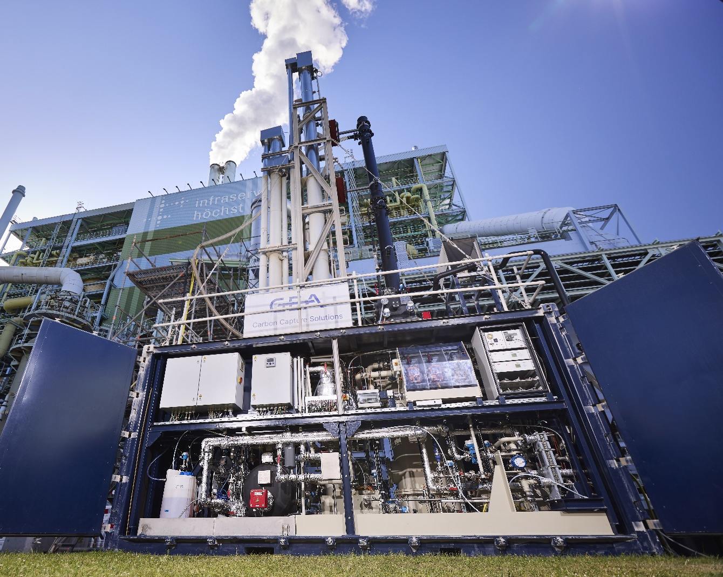

Photo 1, caption: The carbon capture pilot plant was connected to Infraserv Höchst's sewage sludge incineration plant, one of the largest and most modern of its kind in Germany. ©Infraserv GmbH & Co. Höchst KG, 2025

Photo 2:

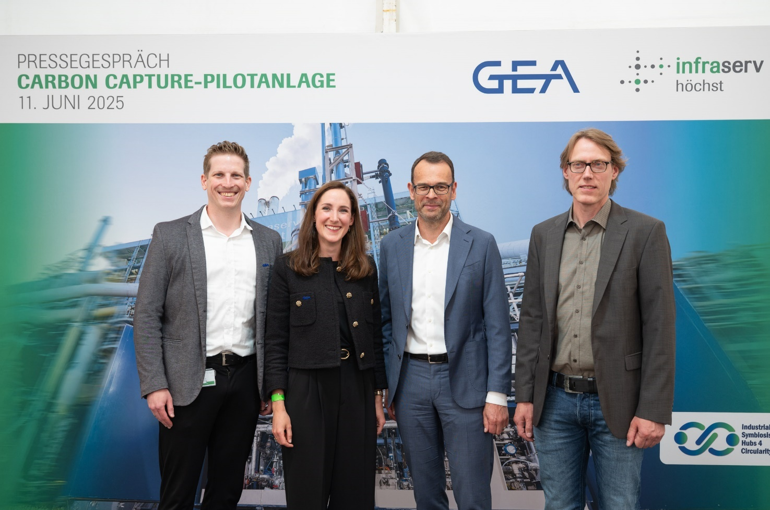

Caption, photo 2: The carbon capture pilot plant was officially handed over during a press conference on June 11, 2025. The photo shows Julia Keller, Head of Commercial Carbon Capture Solutions, GEA, Michael Schneider, R&D Engineer Carbon Capture Solutions at GEA, Dr. Joachim Kreysing, Managing Director of Infraserv Höchst, and Dr. Sirko Ogriseck, Project Manager at Infraserv Höchst (from left to right). ©Infraserv GmbH & Co. Höchst KG, 2025
Infraserv Höchst

Infraserv Höchst, headquartered in Frankfurt am Main, is an experienced partner in the development of research and production sites and offers sustainable, intelligent and efficient solutions for the chemical and pharmaceutical industries. The services provided by the company, which operates Industriepark Höchst, include energy supply, waste management, network operation, site services, occupational health and safety, environmental protection and facility management. The Infraserv Höchst Group's subsidiaries provide logistics, training and process engineering services.
Infraserv GmbH & Co. Höchst KG has about 2,100 employees and 200 trainees. The Infraserv Höchst Group has about 3,000 employees and 230 trainees. In 2024, Infraserv Höchst, including its subsidiaries Infraserv Logistics, Infraserv Höchst Prozesstechnik, Provadis Partner für Bildung und Beratung and Thermal Conversion Compound, generated revenue of around EUR 1.4 billion.
The 460-hectare Industriepark Höchst is home to some 90 companies in the pharmaceutical, biotechnology, basic and specialty chemicals, crop protection, food additives and services sectors. Around 20,000 people work here. Total investments since the year 2000 amount to approximately EUR 8.5 billion.

About GEA

GEA is one of the world's largest system providers for the food, beverage and pharmaceutical industries. Founded in 1881, the internationally active technology group focuses on machines and plants as well as sophisticated process technology, components and comprehensive services. For example, every second pharmaceutical separator for essential healthcare products such as vaccines or novel biopharmaceuticals is manufactured by GEA. In the food sector, every fourth packet of pasta or every third chicken nugget is processed with technology from GEA. With more than 18,000 employees, the Group generated sales of around EUR 5.4 billion in over 150 countries in the 2024 financial year. GEA's plants, processes and components improve the efficiency and sustainability of customers' production worldwide. They make a significant contribution to reducing CO2 emissions, the use of plastic and food waste. In this way, GEA is making a decisive contribution on the path to a sustainable future, in line with the company's mission statement: "Engineering for a better world".

GEA is listed on the German MDAX and the European STOXX® Europe 600 Index and is also included in the leading sustainability indices DAX 50 ESG, MSCI Global Sustainability and Dow Jones Best-in-Class World and Best-in-Class Europe.

Further information can be found on the Internet at gea.com.
If you do not wish to receive any further communications from GEA, please send an e-mail to .pr@gea.com

NOTES TO THE EDITORS

- Further information on GEA
- To the GEA press page
- To the GEA media library
- Background information on current topics can be found under Features
- Follow GEA at 

For media inquiries please contact:

Media Relations GEA Infraserv GmbH & Co. Höchst KG
Dr. Michael Golek Michael Müller
Peter-Müller-Str. 12, 40468 Düsseldorf Industriepark Höchst, Building C 770, 65926 Frankfurt
Phone +49 211 91361505 Phone: +49 69 305 7952
Phone: +491736205746 Mobile: +49 172 68 23 176
michael.golek@gea.com michael.mueller3@infraserv.com

