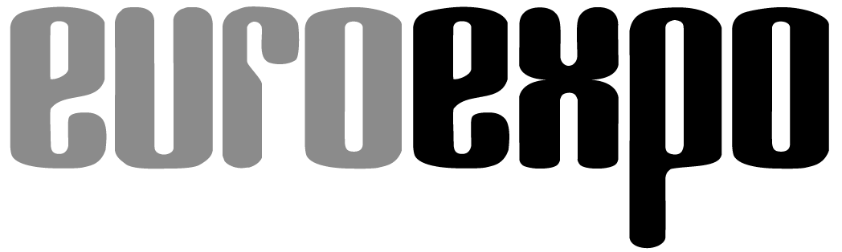
Messe- und Kongress-GmbH
Joseph-Dollinger-Bogen 7
D-80807 Munich, Germany
Phone: +49 (0)89 32391-259
Fax: +49 (0)89 32391-246
www.euroexpo.de/en
www.logimat-messe.de/en
www.tradeworld.de/en

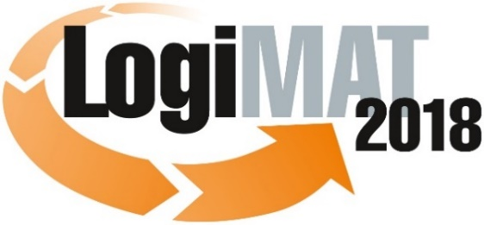

The 16th International Trade Show for
Intralogistics Solutions & Process Management
March 13–15, 2018 | Messe Stuttgart

Also featured at LogiMAT:
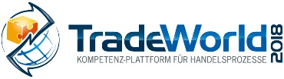

Munich, March 15, 2018

Press Release

LogiMAT 2018 in Stuttgart – Wrap-Up Report
LogiMAT 2018 Exceeds All Expectations

The 16th LogiMAT International Trade Show for Intralogistics Solutions and Process Management has come to an end and once again showed impressive double-digit growth on all fronts: visitors, exhibitors, and exhibit area.

The 16th LogiMAT International Trade Show for Intralogistics Solutions and Process Management has once again shattered all previous records, drawing 55,300 industry professionals (+10.2%) and 1,564 international exhibitors (+13%) to the three-day event and posting double-digit growth in both gross (+14.6%) and net exhibit area (+16.7%). This means that LogiMAT has seen its visitor numbers grow well over 50% in just three years, from 35,105 in 2015. The number of exhibitors climbed over 35% during the same period, from 1,152 to 1,564. “We are delighted that visitor numbers continue to show strong growth, building on the already high level of LogiMAT and exceeding expectations once again,” boasts Peter Kazander, Managing Director of EUROEXPO Messe- und Kongress-GmbH in Munich, which organizes LogiMAT. “The enduring popularity among industry professionals and exhibitors is what gives this type of event its value. With these latest results, LogiMAT in this 16th edition once again underscores its position as the world’s most important industry event for intralogistics.”

Exhibitors from nearly 40 countries – including some 360 first-time exhibitors and more than 50 major players from North America, Asia, Australia, and New Zealand – presented their products and solutions for efficient intralogistics processes across an exhibit area filling 117,000 square meters. Before the event even started, exhibitors had announced they would present 122 innovations never before exhibited anywhere in the world.

The event statistics were documented by the independent market research institute of Wissler & Partner from Basel, Switzerland. Their figures show that some 20% of visitors came from abroad to attend the event in Stuttgart – including 11% from Asia and the Americas. “Both the exhibitor portfolio and the growing share of international visitors reflect the ongoing internationalization of LogiMAT,” Kazander explains. “We will continue to reinforce and promote this arc of the LogiMAT brand through our activities in China and Iran.”

Some 41.3% of the industry professionals traveled more than 300 kilometers to attend the 16th LogiMAT. Broken down by sector, 59.3% of visitors came from industry and 14.7% from wholesale and retail. The overwhelming majority of industry professionals (84.1%) were decision-makers who came to get a picture of the intralogistics solutions currently available and compare offerings directly. A full 41.1% of visitors came with specific investment projects in mind. More than 5% of industry professionals awarded a contract during the show, and 17.4% plan to do so immediately afterward. “LogiMAT is a highly specialized information platform and business-oriented event,” emphasizes Kazander. “It’s a place where business deals are initiated and closed.”

TradeWorld – a strategic component integrated into LogiMAT – also showed continued growth. The professional platform for products and solutions focusing on retail logistics and omnichannel processes saw a nearly 10% rise in the number of exhibitors. TradeWorld 2018 also gained greater acceptance among the industry professionals: 68.3% of those surveyed gave TradeWorld the best or second-best rating overall.

Also, it was announced at LogiMAT that after this year, event director Peter Kazander will step back from his leading role. Michael Ruchty from the EUROEXPO team will take over as the “face of LogiMAT” to manage the International Trade Show for Intralogistics Solutions and Process Management. “I am aware that I have big shoes to fill,” said the new director of the 17th LogiMAT. “I have had the pleasure of assisting in the operational processes for quite some time now and welcome this new challenge. It will demand a lot of creativity, but I know that I have an expert at my side whom I can turn to, and I’m sure that the EUROEXPO team will continue the LogiMAT success story.”

4,177 characters (with spaces)
Munich, March 15, 2018 – This text may be reprinted free of charge, but please send a copy to EUROEXPO Messe- und Kongress-GmbH, Press and Public Relations Department, 80912 Munich.

Event organizer:
EUROEXPO Messe-und Kongress-GmbH
Joseph-Dollinger-Bogen 7 | 80807 Munich, Germany
Phone: +49 (0)89 32391-259 | Fax: +49 (0)89 32391-246

Learn more at: www.logimat-messe.de and www.tradeworld.de

About LogiMAT
The 17th International Trade Show for Intralogistics Solutions and Process Management will take place February 19–21, 2019, on the grounds of Messe Stuttgart, directly adjacent to Stuttgart International Airport. LogiMAT, the world’s largest intralogistics trade show, offers a comprehensive overview of everything driving the intralogistics industry, from procurement to production to shipping. International exhibitors gather early in the year to showcase innovative technologies, products, systems, and solutions for streamlining operations, optimizing processes, and cutting costs in a company’s internal logistics.
TradeWorld, the Professional Platform for Trade Processes embedded within LogiMAT, features products and solutions for e-commerce and omnichannel. The themes of TradeWorld underscore how closely trade and logistics processes are intertwined. Beyond the exhibitor booths, visitors to this combined event can also experience a different program of presentations each day covering a wide range of topics.
The next LogiMAT China will take place in April 2019 in Shanghai. The LogiMAT brand will also be represented with “Intralogistics Solutions by LogiMAT” from June 26 to 29, 2018, at AMB Iran in Teheran.

Statements from LogiMAT 2018 exhibitors

Importance of LogiMAT

“Despite everything that is possible digitally: Face-to-face contact with new and existing customers is essential. LogiMAT provides the ideal platform for this.”
Markus Berger, Managing Director, Kaiser+Kraft GmbH, Stuttgart

“More people visiting our booth, both current and prospective new customers: For us, LogiMAT 2018 was a great event. When it comes to technology, market dynamics, and networking, it offers everything you need to know. Everyone who’s anyone is here in Stuttgart.”
Michael Deininger, Director of Marketing EMEA, Crown Gabelstapler GmbH & Co. KG, Feldkirchen

“Veni, vidi, vici! It was our first time at LogiMAT, and we came, saw, and conquered new customers. We’ll be back for the 17th LogiMAT.”
Vanda de Motte, COO/CFO, dMT Ecotech GmbH, Grasbrunn

“For years, we’ve been very pleased with the results we get at LogiMAT. This year, we again saw a big uptick in traffic and lots of activity at our booth with many concrete inquiries. LogiMAT is our most important trade show by far.”
Lothar Hättich, Managing Director, Pierau Unternehmensberatung GmbH, Hamburg

“We saw a big improvement in the quality of leads this year. The number of actual opportunities increased noticeably.”
Jessica Heinz, Director of Marketing, Dematic GmbH, Heusenstamm

“Fantastic atmosphere. The visitors are more international each year, and people come to our booth with concrete investment projects in mind – most notably projects relating to next-generation industry and the internet of things. LogiMAT is at the very top of our exhibiting calendar as the most important trade show.”
Ralf Hoffmann, Marketing Manager, Miebach Consulting GmbH, Frankfurt/Main

“Twice as many solid leads as last year, and for very concrete projects. LogiMAT is an excellent networking forum, and it’ll stay on our calendar in the years ahead.”
Dr. Giovanni Prestifilippo, Managing Director, PSI Logistics GmbH, Berlin

“Things for us as a B2B manufacturer have gone very well at the show. We always have people at our booth and have had lots of interesting leads. Our expectations were more than fulfilled. We only present at LogiMAT now – no longer in Hannover.”
Gerald Schmitt, Marketing Manager, Kaup GmbH & Co. KG, Aschaffenburg

“We are very pleased with how things went at the show this year. Many decision-makers stopped by our booth for information and got back to us right away. We’ve already managed to book projects here. LogiMAT is number one when it comes to logistics.”
Christian Schulz, Marketing, Wanko Informationslogistik GmbH, Ainring

“We’ve had big crowds here on both days of the show. The number of visitors and quality of the concrete project inquiries for both software and systems have gotten even better. For an exhibitor, it’s fun to be here.”
Dr. Matthias Schweizer, Head of Marketing, Viastore-Gruppe, Stuttgart

“We’re encountering a large number of visitors from abroad, who bring international project proposals with them. The event organizers deserve great praise for how well LogiMAT has evolved. We’ll definitely be back.”
Claudia Signorelli, Head of Marketing, Toyota Material Handling Deutschland GmbH, Isernhagen

“The first day of the event was already good, but the second day can only be called excellent: Lots of new customer leads and specific inquiries for optimization projects that incorporate RFID and definitely call for highly individualized, customer-specific solutions.”
Jan Sünneker, Sales Manager, Georg Utz GmbH, Schüttorf

“In my opinion, LogiMAT is the leading trade show for logistics.”
Hans-Jörg Wildhagen, Managing Partner, Coglas GmbH, Wunsdorf

Importance of TradeWorld

“From an exhibitor’s perspective, TradeWorld has really come along. We’ve been here since the beginning. The best trade show: This is where industry customers, manufacturers, and wholesalers meet. This year, we had as many qualified leads on the first day as we’ve had in previous years on all three days.”
Raimund Bergler, CEO, Bergler Industrieservices GmbH, Gelnhausen

“Our family of companies covers two core themes – fulfillment and warehouse software – so we were able to cater to the various interests of the people who attended. We’ll go away with many stimulating conversations and promising leads.”
Jenny Clasen, Business Development, 4elements.the synergy group, Reinbek

“TradeWorld is attractive to part of our customer base. The same is likely true for other exhibitors. Integrating it into LogiMAT draws more visitors and potential customers.”
Lothar Hättich, Managing Director, Pierau Unternehmensberatung GmbH, Hamburg

“The marketing and implementation of TradeWorld are very professional. We were here for the first time. Besides meeting with many of our current customers, we were also able to network and make many good new contacts.”
Guido Müller, Sales / Project Management, ElectronicSales GmbH, Parsberg

“TradeWorld offers us a solid platform to enhance our visibility. We managed to generate a significant number of new contacts.”
Oliver Schmitz, Area Sales Manager, Paragon Customer Communications, Korschenbroich

“TradeWorld speaks to more visitor groups. This is an overall benefit for exhibitors.”
Dr. Matthias Schweizer, Head of Marketing, Viastore-Gruppe, Stuttgart

