PRESS RELEASE
Schwaebisch Hall, February 02, 2020

Practical innovations for isolators and RTP ports
Together at the Pharma Congress 2020: OPTIMA pharma, METALL+PLASTIC and castus®

Metall+Plastic, part of the Optima Group of companies and castus® GmbH & Co. KG (Ochsenhausen) will be presenting together on the first day of the Pharma Congress 2020. Key topics are the safe use of isolators and RTP ports and innovations in these areas. At the stand, Optima Pharma will also be providing information about its extensive portfolio for aseptic processing. The Pharma Congress is taking place in Düsseldorf on March 24 and 25.
Metall+Plastic supplies leading isolator technologies that lead to the highest safety and efficiency levels in pharmaceutical applications. Catalytic aeration is an essential element for quickly and permanently reducing to low residual concentrations the H₂O₂ used for bio-decontamination. When it is combined with DECOpulse®, the new decontamination system that has already had its successful market launch, there are even more advantages. With DECOpulse® the H₂O₂ evaporates at room temperature. Together, the extremely fine atomization and particularly uniform distribution of H₂O₂ are extremely effective, in difficult isolator configurations. Another advantage is the huge reduction in cycle times, which is due to the greatly reduced use of H₂O₂. At the Pharma Congress, DECOpulse®, other specific design features and their practical benefits will be demonstrated on an isolator model.
Perfect transfers in the sterile room
castus®, a company formed in 2011, has already made a name for itself in the industry as an RTP systems innovator. The third generation of systems used for introducing sterile materials into the isolator or cRABS-protected machines is now available. The latest generation has an optimized design for easy cleaning and sterilization. Any potential risks caused by the filter system have also been eliminated. This and the benefits of specific RTP port designs, for example for flush-floor installation in a machine plate, will be presented at the Pharma Congress. Other examples include transfer systems for stoppers or liquids.
castus®, an independent, owner-managed company, works together with Optima Pharma and Metall+Plastic, as well as with other well-known manufacturers of pharmaceutical plant technology. The joint presentation will be part of the "practical section" of the Pharma Congress, and it will be held in the "Current Aseptic Technologies" block.
A comprehensive portfolio for sterile processing
The trade fair Pharma Technica, where Optima Pharma will be participating with an information stand, is associated with the congress. Here, visitors will be able to learn all about the company's special turnkey expertise (filling and sealing technologies, isolators and freeze-drying systems), new highly flexible lines and technologies for small batches, as well as comprehensive services.
Joint presentation by Metall+Plastic and castus® at the Pharma Congress, Crowne Plaza Düsseldorf / Neuss: March 24, 2020, from around 2.30 pm

Optima Pharma at the Pharma Technica Düsseldorf, Crowne Plaza Congress Center Düsseldorf / Neuss, March 24 – 25, 2020: Booth no. 52

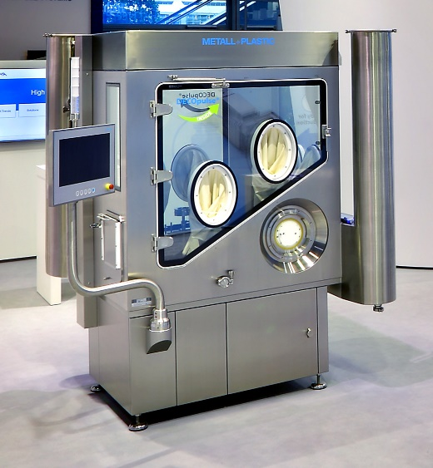

The isolator model from Metall+Plastic showcases unique design features, and it will be on display at the Pharma Congress. The DECOpulse® bio-decontamination system, which offers the highest levels of pharmaceutical safety and efficiency, will also be presented. (Source: Metall+Plastic)

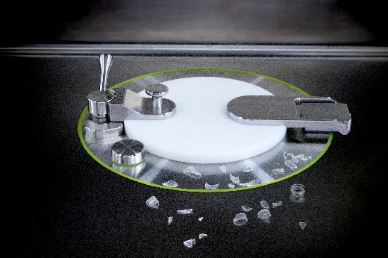
A flush-mounted RTP port for the machine plate has practical advantages. At the Pharma Congress, castus® will be presenting these and other aspects of sterile transfers into the isolator. (Source: castus®)

Characters (including spaces): 2,774

Press contact:
OPTIMA packaging group GmbH
Jan Deininger
Editor
+49 (0)791 / 506-1472
jan.deininger@optima-packaging.com
www.optima-packaging.com
Thank you for publishing this information. We would be pleased to receive a file copy.

