LAUDA Honors Elmar Mohr for 40 Years of Service

Decades of Commitment to the World Market Leader

Lauda-Königshofen, March 16, 2026 – LAUDA DR. R. WOBSER GMBH & CO. KG celebrated Elmar Mohr's 40th work anniversary with the company at a special ceremony. In the presence of the management team, the executive board, and several honored guests, the long-serving chairman of the works council was recognized for his exceptional commitment and loyalty to the family-owned company.

Elmar Mohr began his career at LAUDA on January 27, 1986, in the refrigeration department. Just one year later, the trained toolmaker moved to the toolmaking and prototype construction department of the development division, where he contributed his expertise for over two decades. He has served as chairman of the works council since March 2010, shaping the collaboration between management and the workforce. In addition to his role as chairman, he was a member of the editorial team of the employee magazine “WIR bei LAUDA” (WE at LAUDA) from 1995 to December 2017.

Dr. Gunther Wobser, President & CEO, praised the honoree's exceptional contributions in his laudatory speech: “Elmar Mohr combines skilled craftsmanship with outstanding business acumen. His creativity and versatility make him a valued partner for management. In negotiations, he impresses with his willingness to find solutions, remaining calm and objective while also demonstrating the necessary decisiveness and backbone. Even after his upcoming retirement, I hope to continue our dialogue.” In recognition of his many years of service, Elmar Mohr received the LAUDA Certificate of Honor.

As Chairman of the Works Council, Mohr guided the company through turbulent times and made a crucial contribution to constructive collaboration. “The tradition of toolmaking has remained important to me,” Mohr emphasized in his acceptance speech. “I have also brought this meticulous craftsmanship to my work as Chairman of the Works Council.”

Dr. Lukas Braun, Mayor of Lauda-Königshofen, conveyed the congratulations of the city and the Minister-President to the honoree. He emphasized that Elmar Mohr embodies social partnership in action and that his constructive work has significantly contributed to the positive working environment at LAUDA. This strengthens not only the company and the Lauda-Königshofen business location, but the entire region. The mayor presented him with a bottle of wine and a certificate from the State of Baden-Württemberg.

Uwe Stastny, Deputy Chairman of the Works Council, spoke on behalf of the workforce and praised the collaborative work within the council. He emphasized that Elmar Mohr had led the Works Council with foresight and a strong sense of responsibility for over 16 years. His continuous professional development and his commitment to the workforce had set a high standard.

Elmar Mohr's phased retirement begins on April 1, 2026. The passionate table tennis player and cyclist will then have more time for his hobbies.

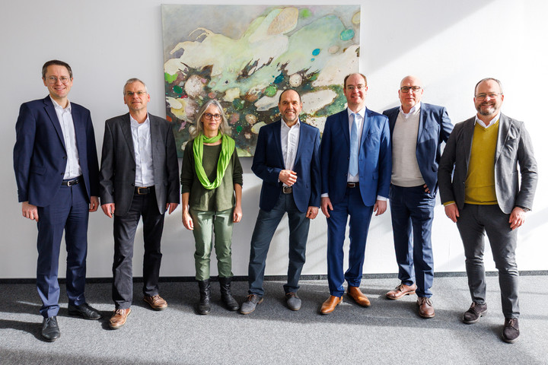

Picture: Elmar Mohr (center) was honored for 40 years of service at LAUDA by President & CEO Dr. Gunther Wobser (right). Those congratulating him were (from left to right): Dr. Mario Englert (CFO), Uwe Stastny (Deputy Chairman of the Works Council), Dr. Sabine Möhrlein, Mayor Dr. Lukas Braun (Mayor of Lauda-Königshofen), and Dr. Marc Stricker (COO). © LAUDA

We are LAUDA – the world leader in precise temperature control. Our constant temperature equipment and systems are at the heart of important applications, contributing to a better future. As a complete one-stop supplier, we guarantee the optimum temperature in research, production and quality control. We are the reliable partner for Aerospace, Electromobility, Hydrogen, Chemistry, Pharmaceuticals/Biotech, Semiconductors and Medtech. We have been inspiring our customers for 70 years with our expert mentoring and innovative solutions – every day anew and all over the world.

In our company, we always go one step further. We support our employees’ development and are constantly developing ourselves: to create a better future together.

Press contact
We are more than happy to make prepared information about our company, the LAUDA Factory Gallery and our projects in the area of innovation promotion, digitalization and idea management available to the press. We look forward to hearing from you – just give us a call!

CHRISTOPH MUHR
Director Corporate Communications
T + 49 (0) 9343 503-349
christoph.muhr@lauda.de

LAUDA DR. R. WOBSER GMBH & CO. KG, Laudaplatz 1, 97922 Lauda-Königshofen, Deutschland/Germany. Limited partnership: Headquarters Lauda-Königshofen, Registration court Mannheim HRA 560069. General partner: LAUDA DR. R. WOBSER Verwaltungs-GmbH, Headquarters Lauda-Königshofen, Registration court Mannheim HRB 560226. Managing Directors: Dr. Gunther Wobser (President & CEO), Dr. Mario Englert (CFO), Dr. Marc Stricker (COO)

