PRESS RELEASE
Schwaebisch Hall, October 4, 2023

New name, proven quality
OPTIMA underscores its position as a provider of holistic solutions

As of October 1, 2023, METALL+PLASTIC GmbH will operate under the name OPTIMA pharma containment GmbH. The company from Radolfzell has been part of the Optima Group since 2011. The Pharma Division thereby emphasizes its unique position in the market.
For many years now, the Optima Group has been developing integrated turnkey solutions for pharmaceutical and biotech products for companies worldwide at the Pharma Division's three sites in Schwäbisch Hall, Radolfzell and Mornshausen. This expertise in supplying a complete solution with filling and closing equipment, isolator and a freeze-drying system from a single source is unparalleled in the industry.

With the promise "Your home for turnkey" Optima Pharma is underscoring its unique market position. Customers can count on Optima as a reliable partner who provides holistic advice and support for their individual requirements. The integral and data-based CSPE approach also significantly shortens delivery times and commissioning of turnkey lines.

Absolute added value: all processes are consistently aligned with customer needs. With its long-standing expertise and competence, Optima offers consolidated know-how in all turnkey issues.

Another milestone aimed at enhancing this profile was reached on October 1, when METALL+PLASTIC GmbH became OPTIMA pharma containment GmbH. The name change is designed to reflect the unity of the Pharma Division with greater clarity.

However, it is purely strategic in nature. The address and contact person remain unchanged and all business relationships and contracts will continue as before.

For more information about the turnkey approach and Optima locations, please go to www.optima-packaging.com/pharma.

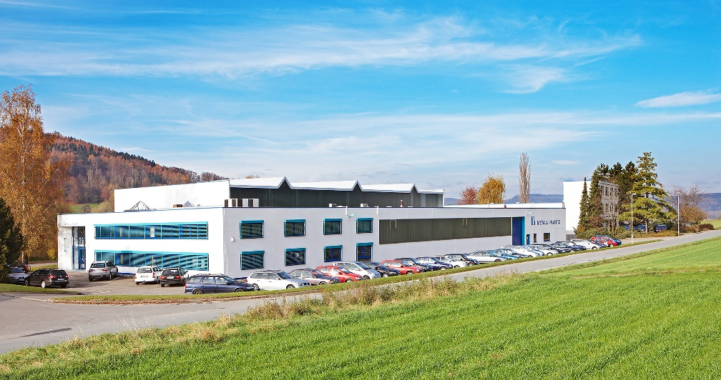
The company headquarters in Radolfzell on Lake Constance:
As of October 1, 2023, the company that was previously known as METALL+PLASTIC GmbH will operate under the name OPTIMA pharma containment GmbH. Nothing will change in terms of expertise. (Source: Optima)

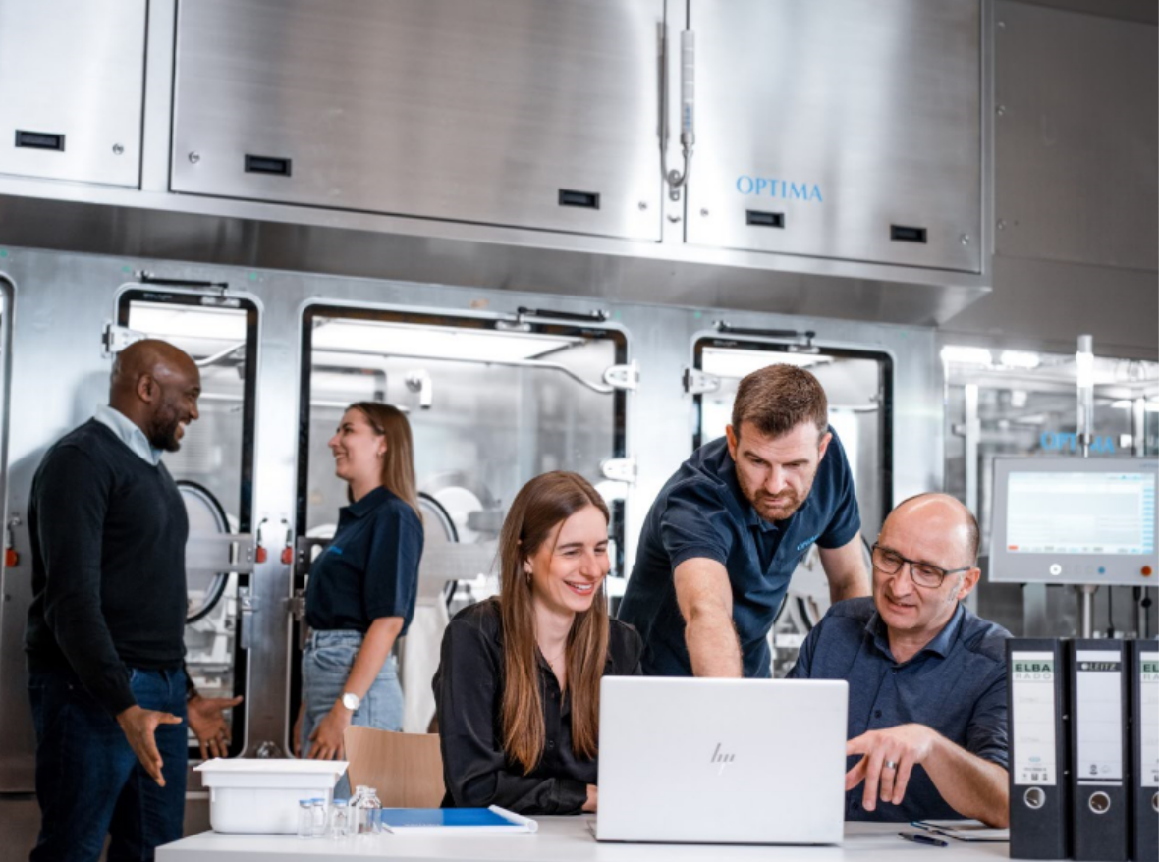
The Optima Pharma Division collaborates to find the best solution for the customer. By renaming METALL+PLASTIC GmbH to OPTIMA pharma containment GmbH, this unity has now been formally underscored. (Source: Optima)

Characters (incl. spaces): 1,799

Press contact:
OPTIMA packaging group GmbH
Denise Fiedler
Group Communications Manager
+49 (0)791 / 506-1472
pr-group@optima-packaging.com
www.optima-packaging.com

About OPTIMA
OPTIMA pharma containment GmbH develops and implements customized isolators and other cleanroom technologies. Founded in 1957 in Radolfzell on Lake Constance, the company has established a high level of expertise. It has been part of the Optima Pharma Division since 2011.

The Optima Pharma Division plans, develops and produces filling, closing and process technologies for pharmaceuticals requiring the highest cleanliness standards. This is characterized by high process reliability and flexibility. Its extensive turnkey portfolio is completed by pharmaceutical freeze-drying and isolators. As a technology partner for pharmaceutical companies, Optima Pharma improves the life of patients and users worldwide.

Optima supports companies worldwide with flexible and customer-specific filling and packaging machines for pharmaceuticals, consumer goods, paper hygiene and medical devices markets. As a provider of solutions and systems, Optima accompanies these companies from the product idea through to successful production and throughout the entire machine life cycle. Around 3,000 experts around the globe contribute to Optima's success. 20 locations in Germany and abroad ensure the worldwide availability of services.

Thank you very much for your publication. We look forward to receiving a digital specimen copy.

