LAUDA celebrates 45th company anniversary of Jutta Mark and Gabriele Wobser

Long-standing loyalty to the family business honored

Lauda-Königshofen, October 23, 2025 – LAUDA DR. R. WOBSER GMBH & CO. KG honored two exceptional employees for their 45 years of service to the company in a ceremony. Jutta Mark and Gabriele Wobser were honored in the presence of the LAUDA management for their decades of loyalty and outstanding achievements for the family-owned company.

Both jubilarians began their professional careers at LAUDA in 1980 and have helped shape the company's development over the past 45 years. Jutta Mark began her training as an office clerk on September 8, 1980, and built her career from the Export department to OEM Sales to Key Account Management, where she now takes care of key national and international customers. Gabriele Wobser, daughter of former LAUDA President & CEO Karlheinz Wobser, began her training as a technical draftswoman on September 15, 1980, and progressed from the Research and Development department to the Manager of Design in the Plant Engineering department. Her expertise in CAD design and project coordination makes her an indispensable pillar of the company. Both Jutta Mark and Gabriele Wobser have kept their knowledge up to date through continuous training and are valuable employees in their respective departments.

Dr. Gunther Wobser, President & CEO of LAUDA, praised the extraordinary achievements of both employees in his laudatory speech: “Jutta Mark and Gabriele Wobser embody the values of our family business in a special way. With their 45 years of loyalty and continuous professional development, they have played a decisive role in shaping LAUDA. Their expertise, commitment, and reliability make them indispensable pillars of our success.”

Dr. Wobser particularly highlighted Jutta Mark's international expertise, who cultivates global customer relationships through her language skills and many years of export experience, as well as Gabriele Wobser's technical expertise in CAD design and project coordination in plant engineering.

In recognition of their outstanding achievements, Jutta Mark and Gabriele Wobser received both the LAUDA certificate and the certificate of honor from the Chamber of Industry and Commerce. Dr. Wobser concluded by emphasizing: “Employees such as Jutta Mark and Gabriele Wobser demonstrate that loyalty, competence, and continuous development are the cornerstones of our family business. Their 45 years of service are impressive proof of the special bond between our employees and LAUDA.”

The double anniversary underscores the importance of long-standing employees for the continuity and success of the family-owned company LAUDA. Such extraordinary careers demonstrate the appreciation and trust that has grown between the company and its employees over decades. They also illustrate the stability and family atmosphere that characterizes LAUDA as an employer and forms the basis for sustainable corporate success.
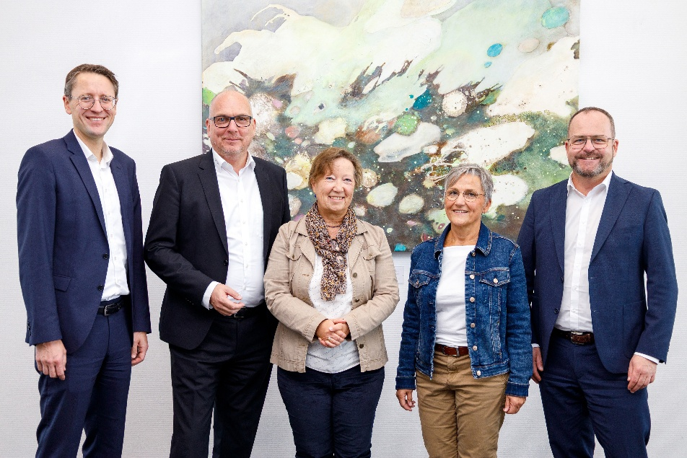

Picture: Dr. Gunther Wobser, President & CEO of LAUDA (right), together with the two managing directors – CFO Dr. Mario Englert (left) and COO Dr. Marc Stricker (2nd from left) – honored Jutta Mark (3rd from left) and Gabriele Wobser (2nd from right) for their 45th company anniversary. © LAUDA

We are LAUDA – the world leader in precise temperature control. Our constant temperature equipment and systems are at the heart of important applications, contributing to a better future. As a complete one-stop supplier, we guarantee the optimum temperature in research, production and quality control. We are the reliable partner for Aerospace, Electromobility, Hydrogen, Chemistry, Pharmaceuticals/Biotech, Semiconductors and Medtech. We have been inspiring our customers for almost 70 years with our expert mentoring and innovative solutions – every day anew and all over the world.

In our company, we always go one step further. We support our employees’ development and are constantly developing ourselves: to create a better future together.

Press contact
We are more than happy to make prepared information about our company, the LAUDA Factory Gallery and our projects in the area of innovation promotion, digitalization and idea management available to the press. We look forward to hearing from you – just give us a call!

CHRISTOPH MUHR
Director Corporate Communications
T + 49 (0) 9343 503-349
christoph.muhr@lauda.de

LAUDA DR. R. WOBSER GMBH & CO. KG, Laudaplatz 1, 97922 Lauda-Königshofen, Deutschland/Germany. Limited partnership: Headquarters Lauda-Königshofen, Registration court Mannheim HRA 560069. General partner: LAUDA DR. R. WOBSER Verwaltungs-GmbH, Headquarters Lauda-Königshofen, Registration court Mannheim HRB 560226. Managing Directors: Dr. Gunther Wobser (President & CEO), Dr. Mario Englert (CFO), Dr. Marc Stricker (COO)

