GEA presents the kytero® 10, the world's smallest single use disk stack centrifuge

Duesseldorf (Germany), March 12, 2025 – GEA introduces the kytero® 10, the world's smallest single use disk stack centrifuge. This mini centrifuge is used in the biopharmaceutical, food and new food industries for product development, which can often only provide small bioreactor sizes. Its task is the separation of bacteria, cell cultures and yeasts as well as applications in cell and gene therapy. The kytero® 10 is the smallest model in the GEA range for cell separation and recirculation and is suitable for volumes from one to 10 liters. Thanks to the low shear design, high cell viability with continuous cell harvesting and perfusion processes, by use of centrifugal separation, is possible from laboratory scale up to production size. The kytero® 10 separator is ideal for the smallest batch and perfusion fermenters.

Test users: upscaling makes it possible to overcome previous limits

Other models of the kytero® series cover ranges from 500 to 2,000 liters (batch).
Test users have found that this concept overcomes previous limitations. The results achieved can be scaled up to larger model variants and industrial production with classic stainless steel separators, which facilitates process transfer and validation.

Single-use offers high safety against contamination

The proven GEA disc stack centrifuge technology has been implemented in compact machines with easy-to-handle units that contain all parts that come into contact with the product. These units are exchanged after a production run, providing maximum safety against contamination. Gamma-treated exchangeable units are available as standard.

No complex CIP and SIP cleaning and innovative drive system

The new single use perfusion separators offer the same advantages as classic disk stack separators, but without the need for cleaning processes (CIP (cleaning-in-place) and SIP (sterilization-in-place). They are ready for the next process run in just a few minutes and require no media other than electricity and air. The compact design and the easy and self-explanatory operability enable simple operation in any system. The non-contact drive system breeze Drive® ensures safe operation under high biocontainment requirements.

First single use disk stack centrifuge for perfusion on a laboratory scale

The new kytero® 10 separators enable continuous operation over the perfusion period and continuous clarification of the fermentation broth. The clarified liquid, which usually contains the product, is continuously removed from the process and fed to the next process stages. Exceptions are bacterial processes and new food applications, where the cells are the valuable product. The concentrated biomass is gently returned to the bioreactor, ensuring high vitality and productivity.

Continuous processing reduces costs

Continuous processing reduces the size of the bioreactor and significantly lowers costs. Operators no longer have to wait for the end of a batch run to separate cells and recover the target protein. Instead of discarding or harvesting cells at the end, they are returned to the bioreactor and only discharged partially so that production can run continuously for weeks. This makes it possible to bring new products to market faster and more cost-effectively.

The important role of kytero® 10 in the production of vaccines and mAbs

GEA developed the kytero® 10 separators to provide the biopharmaceutical industry with robust and scalable upstream processes. The demand for vaccines and monoclonal antibodies (mAbs) is continuously increasing. These separators are designed for high-intensity, continuous cell separation and round off the kytero® series at the bottom. Monoclonal antibodies are successfully used for the treatment of cancer and other serious diseases.

kytero® 10 in the new GEA machine design

The kytero® 10 will be introduced in the new GEA machine design, which emphasizes a clear recognition effect and the affiliation to the GEA product portfolio.

Photos:

Photo 1:

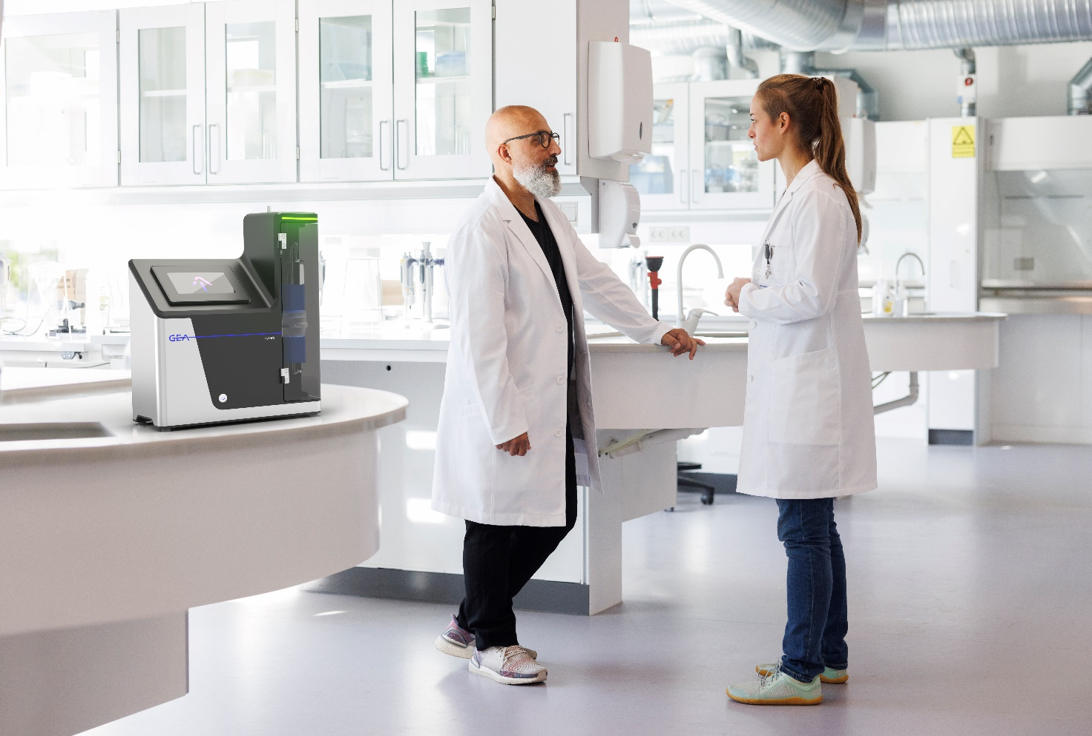

Photo 1: With the kytero® 10, GEA introduces the world's smallest single use disk stack centrifuge. This mini centrifuge is particularly suitable for use in the biopharmaceutical, food and new food industries. (Photo: GEA)
Photo 2:
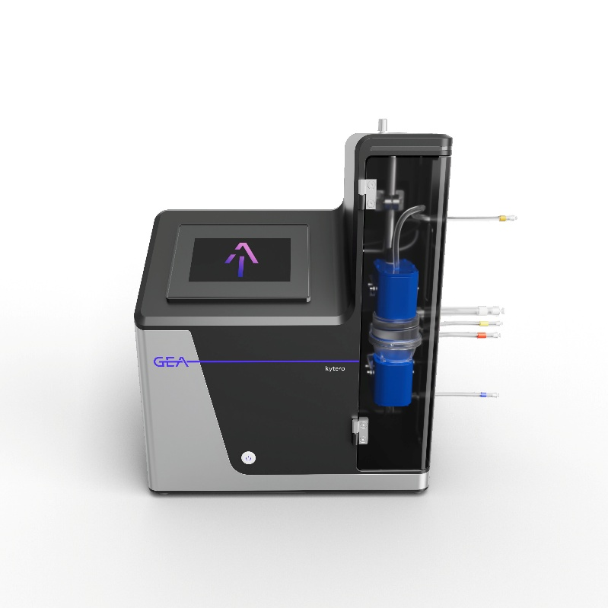

Photo 2: GEA kytero® 10 - the world's smallest single-use disk stack centrifuge (Photo: GEA)

NOTE TO EDITORS

- Further information about GEA
- To the GEA Press page
- To the GEA Media Center
- Background information on current topics can be found at Features
- Follow GEA on  

About GEA
GEA is one of the world’s largest suppliers of systems and components to the food, beverage and pharmaceutical industries. The international technology group, founded in 1881, focuses on machinery and plants, as well as advanced process technology, components and comprehensive services. For instance, every second pharma separator for essential healthcare products such as vaccines or novel biopharmaceuticals is produced by GEA. In food, every fourth package of pasta or every third chicken nugget are processed with GEA technology. With more than 18,000 employees, the Group generated revenues of about EUR 5.4 billion in more than 150 countries in the 2024 fiscal year. GEA plants, processes, components and services enhance the efficiency and sustainability of customers’ production. They contribute significantly to the reduction of CO2 emissions, plastic usage and food waste. In doing so, GEA makes a key contribution toward a sustainable future, in line with the company’s purpose: ”Engineering for a better world.”

GEA is listed on the German MDAX, the European STOXX® Europe 600 Index and is also a constituent of the leading sustainability indices DAX 50 ESG, MSCI Global Sustainability and Dow Jones Best-in-Class World.

More information can be found online at gea.com.
If you do not wish to receive any further information from GEA, please send an e-mail to pr@gea.com.

Media Relations GEA
Dr. Michael Golek
Peter-Müller-Str. 12, 40468 Düsseldorf
Phone +49 211 91361505
Tel. +491736205746
michael.golek@gea.com

