PRESS RELEASE
Schwaebisch Hall, April 17, 2024

Dr. Stefan König is the new CEO of the OPTIMA Group
The Optima Group, one of the world’s leading manufacturers of packaging machines, has appointed Dr. Stefan König as its new Chief Executive Officer (CEO). He takes over the role of Hans Bühler, Managing Partner, who moves to the position of Chairman.
In April 2024, Hans Bühler handed over the role of Chief Executive Officer (CEO) to Dr. Stefan König, who has been with the company as Managing Director since 2021. König brings with him over 25 years of experience from various fields of mechanical engineering. Prior to joining Optima, he was CEO of the former Bosch Packaging Technology GmbH.
"Dr. Stefan König combines a wealth of experience in mechanical engineering with a pragmatic approach. In this way, he will specifically help Optima to drive forward and establish us as a partner for increasingly demanding projects", says Hans Bühler. "His expertise and high standards of results will contribute to leading the Group successfully into the future."
Bühler himself, who has been spokesman for the Management Board for over 35 years, will focus as Chairman on future topics, strategic decisions and the circle of shareholders.
Stefan König has great respect for what has been achieved: “Mr. Bühler has made Optima the company it is today. I am pleased to be able to continue the more than 100-year success story. We operate in highly attractive industries, have broad process and technology knowledge and experienced, committed employees. In other words, the best prerequisites for making an effective contribution to the success of our customers.”

As CEO, König will coordinate the management as well as take and implement initiatives and decisions to achieve the goals. He shares responsibility with Dr. Johannes-Thomas Grobe for the four business units Pharma, Consumer, Nonwovens and Life Science, including the sector for hydrogen economy, as well as the cross-company topics digitalization, sustainability and marketing. The central units such as personnel and finance are managed by Jan Glass. He will hand over his responsibilities to his designated successor Marco Beyl later this year.

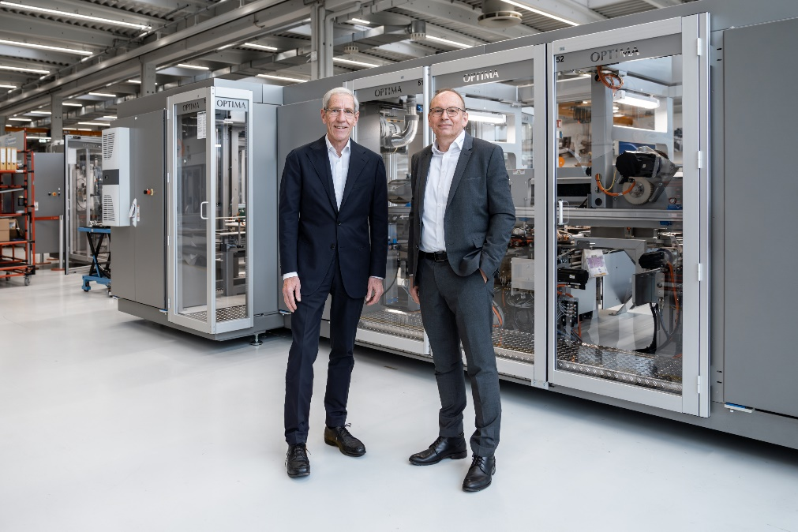Hans Bühler (left) hands over the CEO position to Dr. Stefan König. (Photo: Optima)

About OPTIMA
Optima supports companies worldwide with flexible and customer-specific filling and packaging machines for pharmaceuticals, consumer goods, paper hygiene and medical devices markets. As a provider of solutions and systems, Optima accompanies these companies from the product idea through to successful production and throughout the entire machine life cycle. More than 3,150 experts around the globe contribute to Optima's success. Over 20 locations in Germany and abroad ensure the worldwide availability of services.

Press contact:
OPTIMA packaging group GmbH
Denise Fiedler
Group Communications Manager
+49 (0)791 / 506-1472
pr-group@optima-packaging.com
www.optima-packaging.com

Thank you very much for your publication. We look forward to receiving a digital specimen copy.

