Press release
Schwaebisch Hall, April 10, 2017

From a Trade Show Gimmick to a Must for Hidden Champions
VR and AR Expert Round-Table for the future machinery industry

Virtual reality doesn't only excite gamers. At Optima, several departments are exploring the possibilities of virtual and augmented reality as part of Total Care. In conversations with VR champion Dr. Christoph Runde, four Optima representatives discuss how planners, workforce and service personnel can be part of the digital infrastructure. The unanimous opinion of the team is that the hidden champions of tomorrow are data-driven – and today they are ready to innovate and invest.

New technologies often raise doubts. Is this just a gimmick? Is there an actual benefit? Will it still be applicable in twenty years? Or is it just hype that nobody will remember in a few years? In the case of virtual reality (VR) and augmented reality (AR), there is one more genuine question: Is there any benefit to the machine packing industry?

The answer is perfectly clear: Yes! AR/VR applications offer advantages for many industries. Initially, it was primarily large enterprises like oil production, aircraft manufacturing companies and the automotive industry that used AR/VR methods commercially (and still do). Meanwhile, people wearing VR and AR glasses are encountered more frequently at technological trade shows. For example, at Interpack in spring 2017, a handful of manufacturers of specialty machinery displayed their VR and AR applications. People wearing VR glasses whispering commands and waving their hands as if wanting to turn a switch, was a common sight on these booths. What is the business model behind it? Optima realizes a great benefit for three different applications: for engineering, service and part of training sessions. This was the bottom line at our round-table discussion in July of 2017 it was seconded by the VR expert Dr. Christoph Runde, Director of the “Virtual Dimension Center” in Fellbach, Germany.

“Mixed reality – natural for service personnel”

Michael Wratschko, Team Leader of the Service Department at Optima Nonwovens, predicts a great future for mixed reality applications in the specialty machine industry. At Interpack in Düsseldorf, Germany, he and some team members demonstrated how enhanced reality will support service personnel and customers in the future. “At first we thought a HoloLens is a great gimmick for a trade show. It will stop people and make them look”, Michael Wratschko admits. “We focused on mixed-reality applications for tablets. However, an adaptation for the HoloLens, providing support through manuals and instructional videos during maintenance tasks drew enormous interest among many visitors. Many customers are motivated to try it,” reports Michael Wratschko. “For one of our major customers, we already started introducing a mixed-reality service application using the HoloLens.”

All the same, Michael Wratschko views the technology as being in its infancy. “But the infant is growing,” says his colleague Arne Sanwald: “It will take a few years until mixed reality will be of importance as a tool for service personnel. People will put on their glasses, probably a more sophisticated version than today’s, in the morning and at noon, their colleagues will remind them that they are still wearing their glasses.” Dr. Christoph Runde is sure that manufacturers of specialty machinery like Optima are now profiting from the investment of large-scale OEMs in the automotive and aviation industry that began experimenting with VR, AR and mixed-reality systems in the mid-1990s, requiring huge budgets. “In the product development process, virtual quality gateways are already established. Today, medium sized machine manufactures have not advanced that far, even though many companies are already using VR methods to support their developments.”

"The digital twin becomes the virtual prototype”

Gustav Marwitz from Optima engineering confirms: “We are using VR to have a closer look at our designs. Thus, we discover possibilities to improve the machine design before they are cast in steel. For instance, using the so-called digital twin, we ensure that access options for maintenance personnel are present on the virtual prototype.” Since December 2015, organizers have been able to use the virtual wall (power wall) at the VR center of the Packaging Valley Germany Association in Schwäbisch Hall. “Five years ago, we began working on the logic simulation. At that time the systems were not suitable to be used by machine builders due to high cost and applicability,” Gustav Marwitz remembers. A lot has happened since then. Optima does not exclusively focus on the development process for engineering; customers are virtually integrated, at the opportunity stage and during the design reviews. Dr. Runde asserts: “Anything that can be done before the actual machine is built is less expensive than rework at a later date.”

In addition, the motivational effect of the new technologies cannot be under-estimated. This holds true internally and at the end-user. Optima’s customer support representatives report on the enthusiastic responses of customers who have virtually experienced their machine at the VR center for the first time. The willingness to deal with detailed questions from the perspective of an operator or maintenance personnel at the planning stage has increased. Arne Sanwald noticed the motivational effect, particularly with the younger generation. According to him, leaving a HoloLens at the design office will automatically draw employees to explore its possibilities. Arne Sanwald expects significant improvement in the technology, while Gustav Marwitz already considers it to be satisfactory today. Dr. Runde even believes the possibility that the new edition of Google Glasses, not to long ago declared dead, will bring a vast change to the market, with a focus on industrial applications. He also expects another version of the HoloLens. “It is already impossible to imagine accessing data and information without the extra interface of these glasses while the operator or maintenance employee walks through the assembly hall or around the machine,” says Dr. Runde.

“High-performance WLAN as an investment in the future”

One obstacle still has to be overcome. “The most important benefit for our customers is the bandwidth of data transmission,” Gustav Marwitz warns with regard to the integration of industry 4.0 applications. The participants of the round-table believe that technological infrastructure, such as the provision of a high-performance WLAN, is an investment in the future. The willingness to use cloud applications and security investments are imperative. “Then, these services will also be feasible for specialty machines – with respective paybacks, for instance reduced downtime or a faster start-up,” says Michael Wratschko.

The director of the service group at Optima Nonwovens remembers a time when his own company made the decision in favor of VR/AR technology. “Five, six years ago, we began collecting feedback from customers. They were interested, but the market was not developed sufficiently for them to join-in,” he recalls. “But if you want to be 100 percent sure, you will be 100 percent late. If you want to be a front-runner, you have to invest early. This is our motto at Optima Nonwovens.” These days, Michael Wratschko receives numerous inquiries – even from other industries, for example, the pharmaceutical or the consumer industry.

"VR meetings for the development of project ZERO”

Now the goal is not to fall behind! The Engineering 3.0 research and development method has shaped the basis at Optima through digitization and simulation. At first, without virtual technology; this changed in late 2016, when the HoloLens became available to developers. “We have transferred the simulation of logic to the glasses,” tells Gustav Marwitz, “thus we are now able to put the machine virtually on the desktop and connect it to a control unit – and the machine is running.” The Optima engineers used the VR environment for the development of project ZERO to drastically reduce the format changeover times of a fem-care stacker. Among other items, the focus was on ergonomics. “Our complete development team participated in the VR meetings,” Gustav Marwitz remembers, “and some designers had ‘eureka’ moments.” Avatars were used to simulate the heights of future users. For example, Asian women are approximately four feet, five inches tall and Northern European men stand six feet, three inches tall and therefore have quite different demands. Using the avatar, Central European designers can slip into different “bodies” and visualize the stress on specific muscle groups.

Does this imply time savings during the design phase? No, says Gustav Marwitz, but the optimization stage will be reached earlier so that the machine can be completed faster. “In the past, design engineers continued to work on a machine even after the machine had actually been completed.” According to Dr. Runde, it is difficult to measure the time savings using error-prevention technology. “I need to know what errors I would have made without the VR method.” At the same time, it is difficult to accurately analyze the application potential of mixed reality for service and maintenance. At best, one can only estimate. “How many service cases can I solve with a simple phone call? In how many cases is that not possible and can a mixed reality application keep me from putting a service technician on a flight to New Zealand? Could the technology even be used for assisting operators?” says Dr. Runde as he sketches out possible scenarios. It is possible to make predictions while taking corresponding statistics into account, he says, “but it probably makes more sense to simply gather experience and try it.”

“Forgoing the mock-up requires force feedback”

It would be a contribution to the ROI of the VR applications if manufacturers of specialty machinery could forgo the mock-up, as it is standard at Optima Pharma for many machines. “To some extend this is already possible however, the current technology at the VR center does not yet provide optimal support for the customer. Gustav Marwitz explains: “We expect that within one to two years, virtual haptics will become reality due to a digital glove.” He believes that force feedback, while virtually projecting a component on the system's virtual wall, will result in a greater acceptance by the end users. This was the learning from a user centered HMI development project – the PEBeMA (cross-phase development of user interfaces in mechanical and systems engineering) research project, in which Optima took part.

Dr. Runde, still remains skeptical: “If you push against a wall, you also need to feel force feedback in your arms, not only your fingertips.” He mentions user-guided folding arms that result in force feedback in case of a haptic problem and exoskeletons used for VR games. “I imagine that one day it will become available”, says Michael Wratschko, “and then the building of mock-ups will no longer be state-of-the-art.”

“Is the creation of the database too overwhelming?”

Michael Wratschko is very pleased with the large interest in the augmented and mixed reality applications since the Interpack show. However, he warns: “The topic is more complex than many imagine, simply acquiring a set of AR glasses isn't enough, a database must be available first. Optima is happy to provide support if customers feel that things are getting too complicated. The HoloLens can support maintenance activities even if no bill of materials, 3D models, maintenance plans, data sheets and installation manuals are available. “Our service technician will check the machine through the eyes of the customer wearing the glasses,” explains the service manager. “This is a great entry-level application for the technology.”

To utilize additional applications, a specialized team in the IT department at Optima provides assistance. The team takes care of data processing and provides the complete back end in order for the user to apply it through a tablet or a HoloLens. In addition, customer documents can be integrated. Arne Sanwald states: “There are only a few things a customer appreciates more than to discover their existing maintenance schedule is already integrated into our TCAM Total Care system.” Nevertheless, it is necessary to adapt the data at the AR front end – it does not make any sense to display entire PDF pages in the visual range of a HoloLens user. Dr. Runde advocates for simple dialogs and icons: “An orientation to blended learning or responsive web design is preferable. For example, it is also necessary to adapt the voice control navigation. The preparation of the back end is a development need that requires immediate attention.”

“VR tools for training”

Training is another significant application for VR and AR systems. Alexander Hermann, Training Manager at Optima Pharma, says: “For me as a teacher, clarity is most important, and that's what we have at the VR center.” He also indicates that the mere presence of a power wall is not sufficient. He states, the preparation for any training is essential. A common thread is important, we need a concept capable of integrating different media and options. This concept must be adaptable to different levels of learning and to different target groups, like operators, validation personnel and maintenance employees. “The integration of VR technologies creates incredible opportunities. Simply said, we have an extra tool at our disposal,” Alexander Herrmann says. The first training phase is about terminology and technical understanding. In the next levels of the training, the VR center can be used to create videos with the customers to be integrated in Power Point training documentation. “However, a three-day training course cannot be based on VR/AR alone,” he reflects. “The eureka effect fades after two hours and no one wants to wear 3D glasses that long anyway. After a couple of hours, it is necessary to switch to 2D mode.” He also sees the possibilities of meeting the special challenges of clean room applications. “I cannot go into a clean room and disassemble a machine for training purposes. Therefore, I have invited operators of clean room systems that are in operation to our VR center. Let's see what happens!” Alexander Herrmann says with excitement.

Which front end? Setting standards as a leader

What will the future bring? Dr. Runde is extremely curious about the “battle for environment systems.” Will it be like smartphones, where apps work either with iOS or an Android-based device? Or will browser-based solutions that run on all systems prevail? “The race for environment systems is in full swing,” says Dr. Runde. Gustav Marwitz indicates that Optima uses web-based, platform-independent systems because: “We cannot dictate what devices our customers have to use.” The participants of the round-table expect that in addition to the Microsoft HoloLens, Vive (by HTC and Valve), the new system by Apple (presumed to be called the iGlass), Oculus Rift and the recently announced forthcoming version of Google's VR glasses will play a role in the market.

Users cannot be expected to keep five pairs of glasses because they operate machines made by five different manufacturers. This is a scenario that cannot happen, says Dr. Runde. Michael Wratschko comments: “It is important that we are on the front line during the development of VR and AR technology. As leaders, we will have fewer adaptation processes to carry out – whether the system is platform-independent or not. “He emphasizes the strengths of the HoloLens, saying that its tracking is unbeatable for AR applications. The existing Android solutions cannot keep up. In light of these facts, he believes it is justified to use one or the other device-specific features if the majority of applications remain platform-independent. “Whatever the front end market will show tomorrow, we will decide tomorrow. Our focus is on the back end, the database and our customers can already use this infrastructure. For those users that want it, mixed reality using tablets and AR glasses will play a major role in the future. I have no doubt that the hidden champions of tomorrow will be data-driven companies. Therefore, the companies of today will have to show readiness to invest and take risks.”

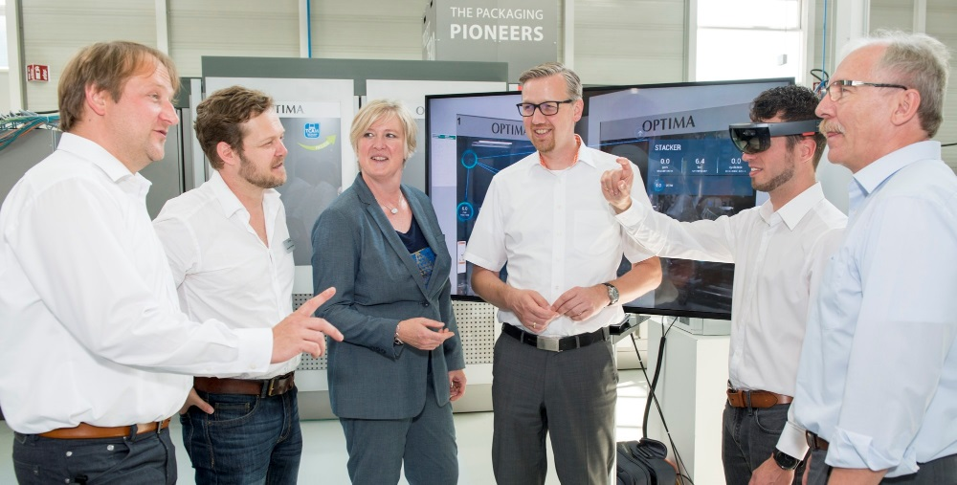
Virtual and mixed reality impress the round-table participants at Optima. The first applications are here – and the future looks promising. The participants from left to right: Michael Wratschko, Alexander Herrmann, Dr. Ulla Reutner, Dr. Christoph Runde, Arne Sanwald, Gustav Marwitz.

Dr. Christoph Runde, VDC Fellbach: “Users cannot be expected to keep five pair of glasses because they operate machines made by five different manufacturers.”

Characters (incl. spaces): 16,431

Contact:
OPTIMA packaging group GmbH
Sabine Gauger
Marketing Group Leader
sabine.gauger@optima-packaging.com
www.optima-packaging.com
Thank you very much for your publication. We look forward to receiving a specimen copy.

