Production Intelligence and resource efficiency - Siempelkamp introduces at LIGNA Conference 2018 in China its recent technologies within the wood-based panel industry
智能生产，资源高效-辛北尔康普在中国广州举行的2018汉诺威林业木工大会上介绍了该集团在人造板行业的最先进的技术。
Guangzhou, 4th and 5th December 2018 – Siempelkamp granted a detailed overview of the recent state-of-the-art technology and an outlook to future development to the participants of the LIGNA Conference. This congress was organised by the Deutsche Messe AG, provided an appropriate platform, at which importers of the machining technology could take up direct contact with the Chinese furniture industry.
2018年12月4日至5日，辛北尔康普在广州汉诺威林业木工大会上，通过聆听与会单位的精彩演讲，深入了解了当今最前沿的行业科技以及未来展望。德国汉诺威展览公司为这次盛会提供了共享平台，在这里机械设备进口商实现了与中国家具行业的零距离交流。

“Integrated Woodworking – Customized Solutions”, the topic at the LIGNA conference, which thereby took up one of the focus topics at LIGNA 2018 that will take place from 27th to 31st May in Hannover. This guiding principle is also one of the factors that initiated many recent Siempelkamp’s product innovations. Especially in the current developments, digitization plays a central role, as through this technology a tool is available that constitutes an enormous growth potential, particularly presented in the production of wood-based panel industry.
“集成木工制造 - - 订制化解决方案”是本届汉诺威林业木工大会的主题，也是明年5月27日-31日即将在德国汉诺威举行的工业博览会期间一个重要的主题。辛北尔康普当前产品的创新灵感也是源自于此。当今世界的发展，数字化扮演着非常核心的角色，因为有了数字化技术这样一个工具，我们才能将巨大的发展动能，尤其是人造板工业生产智能制造领域的发展潜力充分整合和挖掘出来。

Intelligent Production – the intelligent wood-based panel production with IQ, more specifically Prod-IQ®, is Siempelkamp’s development goal, in order to economize energy and raw materials, such as adhesive or wood. Further development goals of the intelligent production take aim on the continuous high production quality and on the elimination of rejected boards. But not only the consumption of production materials or use of required energy is reduced in the intelligent production, Siempelkamp’s Condition Monitoring ensures, for instance, which is likely that all
wear-susceptible components of ContiRoll®, the continuous wood-based material press Siempelkamps, could be used to the longest their possible component lifetimes. This avoids increasing maintenance work also as unplanned production loss and provides plant operators a security that maintenance intervals are scheduled precisely. The intelligent production at Siempelkamp is not a vision, but a reality today.
智能生产 - - 智能数字化人造板生产，即Prod-IQ®，是辛北尔康普集团的发展目标，以实现对能源和原材料的高效利用，比如胶粘剂和木材。智能生产更深层次的发展目标是高质量连续运行生产合格板材，同时减少直至消除废板。智能生产不仅可以降低生产原料或能耗，配套辛北尔康普的智能生产状况监测系统，可以保证连续压机易损部件达到最大化的使用寿命，从而避免了频繁的维修作业和计划外生产损失，同时工厂运营所需的定期维护保养可以根据计划精确安排。辛北尔康普的智能生产已不再仅仅是设想，而已经成为现实。

Already in 1989, the first ContiRoll® was delivered and installed in China, for the production of particle boards. Since 2004 Siempelkamp produces its plant components for the local needs in Wuxi. Siempelkamp opened another local production facility in Qingdao, in order to meet the increased demands of the Chinese market on environmental and industrial safety norm or the growing demand production quality. By this Siempelkamp can provide its Chinese customers customized product solutions and top spare part service.
早在1989年，辛北尔康普向中国提供了第一条连续压机生产线，是用于刨花板的生产。2004年，随着我们无锡工厂的投产，实现了部分工厂组件的本地化生产制造。为了满足中国市场对环保、工业安全以及产品质量日益严格的要求，辛北尔康普在青岛建设了另一个本地化工厂。至此，辛北尔康普可为中国客户提供定制化的产品解决方案，最全面的本地化技术技术支持、售后服务和最快捷的备品备件服务。

As the rapidly growing Chinese market has developed into innovation motor of the Asian wood-based panel industry, Siempelkamp also offers solutions for the usage of alternative resources in the production wood-based panels. These solutions include die usage of rapidly growing plants, such as rice or bamboo for the production of MDF, particle boards or OSB with best product properties. A first complete plant for the production of MDF boards, produced of 100% rice straw, is currently in installation in South-Carolina, USA.
中国人造板市场的迅猛发展已经成为亚洲乃至世界人造板行业的创新推动力。辛北尔康普可提供使用多种替代性原材料生产人造板的解决方案，包括使用水稻秸秆、竹材等一年生和多年生植物生产产品性能最佳的中密度纤维板、刨花板或定向刨花板。在美国南卡罗莱州正在建设安装的100%以水稻秸秆为原材料的中密度板生产线目前正在建设安装。

Siempelkamp will present also these topics and further fascinating product innovations at upcoming May at the LIGNA 2019, the global trade fair for the wood-based panel industry in Hannover.
辛北尔康普将会在2019年5月即将召开汉诺威木工博览会，人造板行业的全球盛会上，围绕这些主题，为全球客户呈现更加精彩纷呈的创新产品。

>>> P H O T O <<<
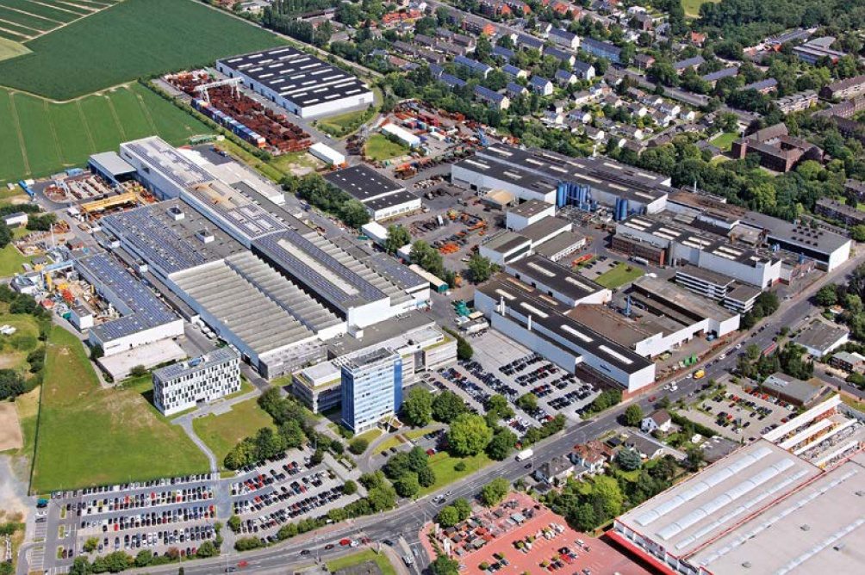
Siempelkamp in Krefeld位于德国克莱菲尔德市的辛北尔康普集团总部
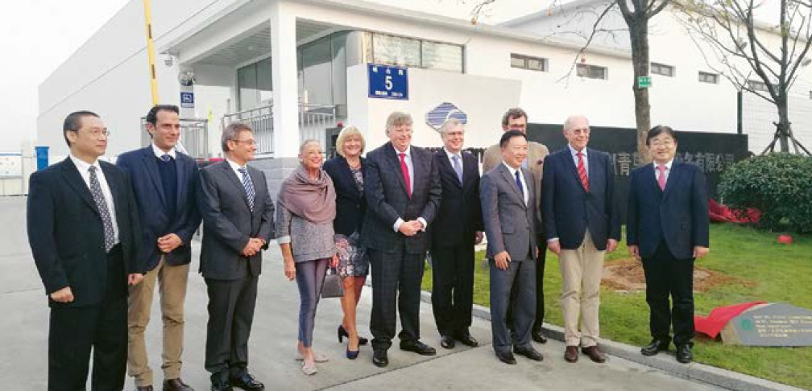
Siempelkamp in Qingdao, China辛北尔康普青岛公司

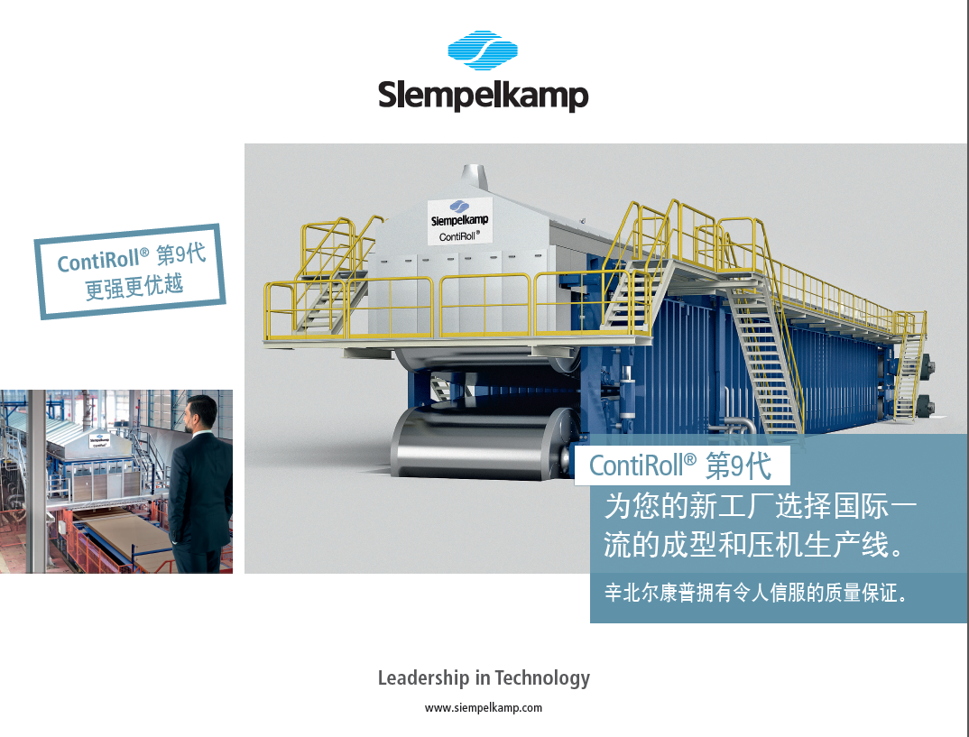
Siempelkamp ContiRoll® Generation 9 NEO 辛北尔康普第九代连续压机

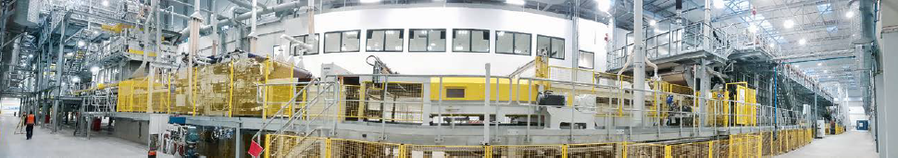
Siempelkamp forming and press line 辛北尔康普成型和连续压机生产线

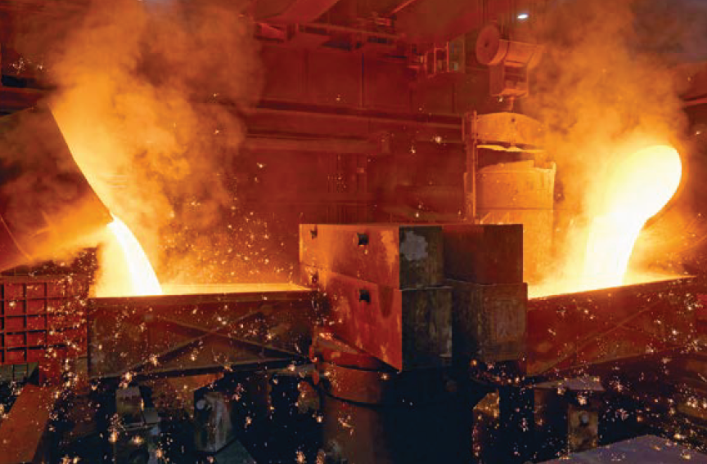
Ductile cast iron球墨铸铁
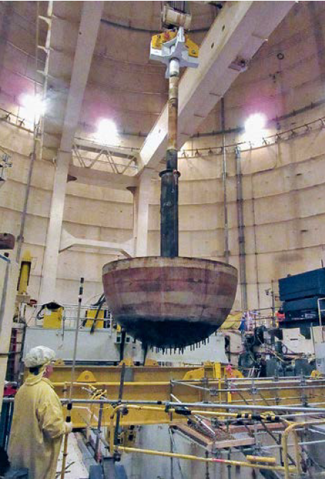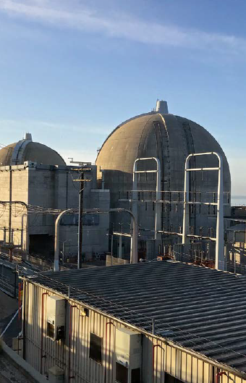
Lifting out the hemispherical head (Left) 取出核电厂半球型反应堆封头（左）
Nuclear Power Plant in USA (Right) 美国核电站（右）

About Siempelkamp辛北尔康普简介
The Siempelkamp Group is a technology supplier operating internationally and consisting of three business units: the machine and plant engineering, the foundry technology, and the engineering and service business unit. Siempelkamp machine and plant engineering is a systems supplier of press lines and complete plants for the wood-based panel industry, the metal forming industry as well as the composite and rubber industry. The Siempelkamp foundry is the world’s largest hand-molding foundry producing castings with a weight of up to 320 t (353 US tons). Siempelkamp engineering and service is a specialist for dismantling nuclear facilities and a supplier of transport and storage casks for radioactive waste.
辛北尔康普是一家为全球客户提供设备和服务的技术供应商，公司核心业务涵盖：机器设备工程、铸造技术及核工业服务三大板块。其中机器和设备工程主要为人造板行业、金属成型行业和橡胶行业提供压机和整厂生产线；铸造技术业务板块拥有世界上最大的手工造型铸造厂，能够生产重达320吨的铸件。辛北尔康普也是核电工业领域产品和服务的专家，核工业技术致力于为客户提供核设施拆卸服务以及放射性废料运输和储存设备等。

