PRESS RELEASE
Schwaebisch Hall, April 18, 2019

The cobots are here
Looking back – OPTIMA at IDEA 2019

Three characters, three perspectives. At IDEA 2019 in Miami, Optima Nonwovens looked through the lenses of an operations manager, a plant manager, and a machine operator: Tom, Lisa, and Carl all want to create efficient and robust processes for packaging of paper hygiene products – and yet they each have their own specifications. The animated characters quickly won over hearts and attracted a crowd of visitors to Optima Nonwovens’ trade show booth. Optima Nonwovens had the right new solutions in its trade show package. The result: new contacts, more leads, and many specific inquiries for its Smart Services just as much as its “traditional” machine projects.
Changing market requirements that need to be implemented quickly and increasingly complex packaging processes are only two out of the many challenges that paper hygiene product manufacturers have to face today. Labor costs and the physical strain on machine operators also need to be considered. A new solution to this problem are cobots, collaborative robots that can take care of the strenuous, repetitive tasks and are easy to program. Optima Nonwovens uses them to supply machinery with packaging materials in an automated process. The relevant presentations convinced a great many IDEA visitors, meaning that several quotations will be drawn up after the trade show.
Optima Nonwovens solves the matter of maintaining an overview of flexible, automated processes with the line management software OPAL. OPAL analyzes the performance of systems and evaluates common errors systematically and across different manufacturers – for entire production plants if required. This highlights any opportunities for improvement. Visitors were also inspired by Optima’s TCAM tool. Using a HoloLens and augmented reality features, comprehensive information such as servicing videos are presented very clearly right next to the machine. This and other digital Smart Services increase operational efficiency.
Many of the conversations and presentations at Optima Nonwovens’ trade show booth revolved around specific machine projects. The leading packaging technology for nonwoven products and traditional first-response servicing remain the fundamental elements of Optima Nonwovens’ portfolio.
The concept behind the trade show booth – leading machine technology combined with new digital solutions and the personable tone struck by the three “virtual” characters Tom, Lisa, and Carl – has proven itself to be successful. Optima Nonwovens also made new contacts at IDEA in Miami including a number from other countries, which underlines the importance of the trade show. The increased number of contacts compared to last year as well as the many in-depth conversations confirmed the trade show’s positive outcome.
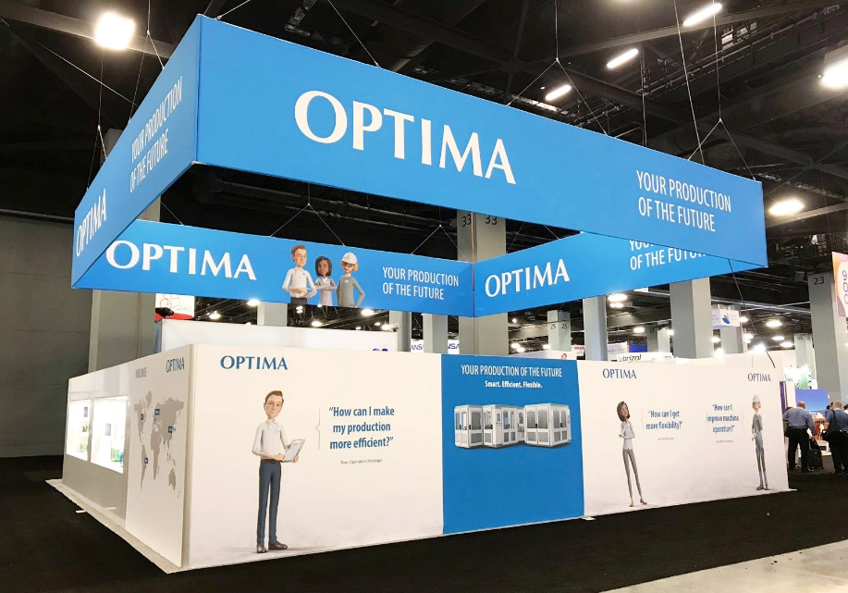
Three characters with different needs: Optima Nonwovens had something special to offer operations manager Tom, plant manager Lisa, and machine operator Carl at IDEA 2019. Cobots, which automatically feed packaging materials into the packaging process, were a topic at Optima’s trade show booth.

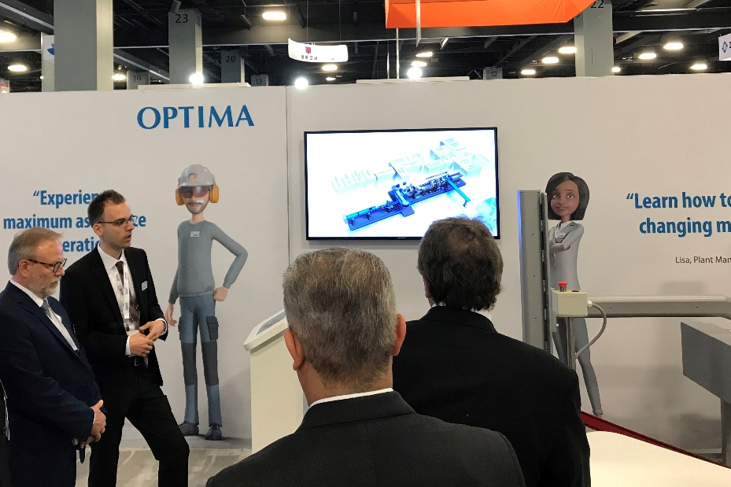
The leading packaging technology, a cobot, Smart Services and much more besides: Optima Nonwovens’ trade show booth drew in the visitors at IDEA 2019.

Characters (incl. spaces): 2,821

Press contact:
OPTIMA packaging group GmbH
Jan Deininger
Editor
+49 (0)791 / 506-1472
jan.deininger@optima-packaging.com
www.optima-packaging.com
Thank you very much for your publication. We look forward to receiving a specimen copy.

