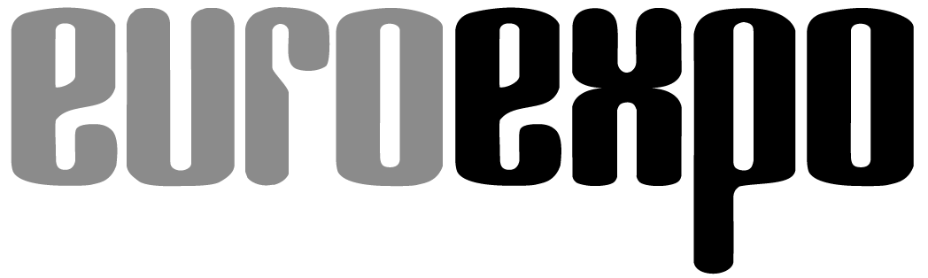
Messe- und Kongress-GmbH
Joseph-Dollinger-Bogen 7
D-80807 Munich, Germany
Phone: +49 89 32 391 259
Fax: +49 89 32 391 246
www.logimat-messe.de/en
www.logimat-international.com
www.logimat-iw.com
www.logimat.cn

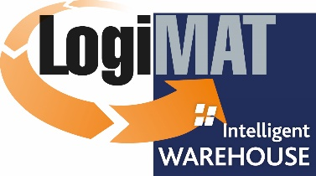

International Trade Show for Intralogistics
Solutions, Warehouse & Process Management

Munich, May 25, 2020

“LogiMAT | Intelligent Warehouse”, Bangkok postponed due to the Corona pandemic
New date: July 7 - 9, 2021

In view of the continuing uncertainty in the industry because of the coronavirus disease, “LogiMAT | Intelligent Warehouse” is being postponed to July 7 - 9, 2021. In setting a firm date, the aim of the organizers is to deliver a trade fair to everyone involved, which is free from concerns and provides a platform for establishing profitable contacts with southeast-Asia’s industrial leaders.

“The decision to postpone “LogiMAT | Intelligent Warehouse” to July 2021 has been made in close consultation with our exhibitors, supporters and partners“, states Phusit Sasitaranondha, Managing Director of Expolink Global Network Ltd, Bangkok. “Our aim is to hold a successful and professional trade fair – an event where we can welcome the material handling industry without any concerns and provide a platform for people to establish profitable business contacts with others. From today’s point of view, this is not something we are able to achieve in summer 2020.”

“LogiMAT | Intelligent Warehouse is to be a high-quality international business platform. We are proud that, together with our partner Messe Stuttgart, we have been able to organize the German Pavilion supported by the German Federal Ministry for Economic Affairs and Energy for our first show in Bangkok,” adds Peter Kazander, Managing director of EUROEXPO Messe und Kongress-GmbH, Munich. “Unfortunately, under the given circumstances we could not guarantee our German exhibitors and speakers a trouble-free entry into Thailand without limitations”.

Although the numbers drawn by the corona pandemic are developing positively in both Southeast Asia and Europe, there are still many uncertainties regarding the planned date in August 2020. A trade fair with restricted admission or with hardly any international attendees is simply not an option for the management team.

We thank our exhibitors and partners for the confidence they have placed in us, and we are looking forward to making “LogiMAT | Intelligent Warehouse 2021” happen in a way that business can be done without extensive limitations and restrictions.

Organizer: EUROEXPO Messe- und Kongress-GmbH
Joseph-Dollinger-Bogen 7 | 80807 Munich, Germany
Phone: +49 89 32 391 259 | Fax: +49 89 32 391 246
www.logimat-international.com
2,184 characters (with spaces)

This text may be reprinted free of charge, but please send a copy to EUROEXPO Messe- und Kongress-GmbH, Press and Public Relations Department, 80912 Munich.

