Spray drying / Food safety

New valve technology from GEA reduces microbiological risks in spray drying process

Düsseldorf (Germany), September 16, 2024 – GEA, a leading global provider of food and dairy processing solutions, introduces its patented CONTA dual block valve technology for spray dryers. Continuing its commitment to improving the safety, efficiency and environmental sustainability of food and dairy processing, this new system is designed to reduce microbiological risks, ensuring safer and more efficient processing operations.

Improved sanitary design enhances product safety
The CONTA dual block valve receives feed from the feed supply system and distributes it to multiple atomizer nozzles, which then spray the feed into the drying chamber. Compared to traditional designs, this new design reduces the areas where feed can accumulate by up to 96 percent, allowing for more efficient cleaning in place (CIP) and reducing microbiological risks. The CONTA dual block valve system improves sanitary operation and provides greater process and product safety.

Supporting continuous operation and operator safety
Each valve weighs approximately half the weight of traditional systems, making it easier and safer to handle. The design eliminates the use of external welded manifolds, allowing manual inspection and maintenance with simple tools. This simplified inspection and maintenance supports 24/7 operation and reduces plant downtime.

Fast configuration and installation
The standardized CONTA dual block valve unit can be easily configured for both new and existing spray drying systems. This ensures minimal disruption and quick installation, allowing plants to resume operations quickly. Retrofitting to existing spray dryers is straightforward, often requiring only minor programming changes.

gea.com

Picture

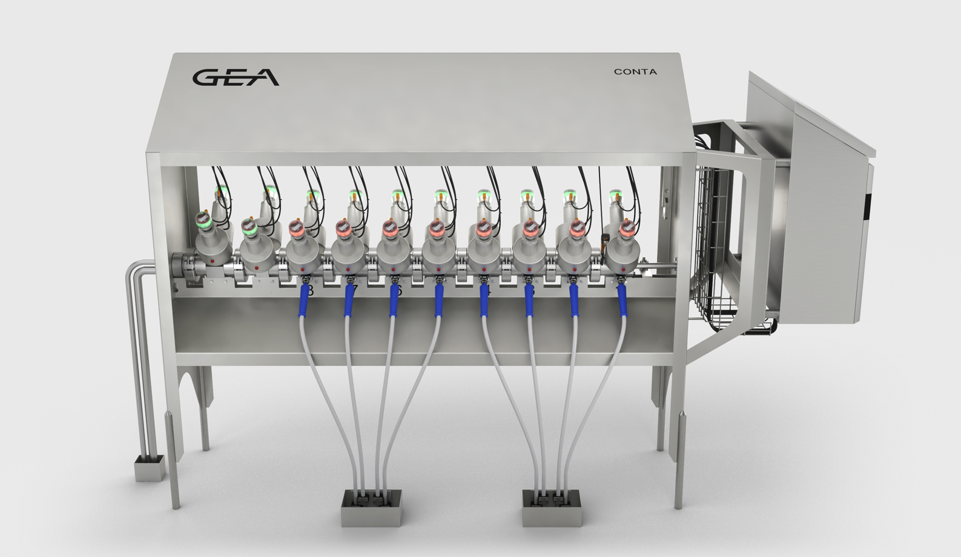

Pic. 1: The GEA CONTA dual block valve technology reduces microbiological risks, ensures safer and more efficient processing in spray drying operations. Source: GEA

NOTES TO THE EDITORS
- Further information about GEA
- To the GEA Media Library
- Features on current topics
- Overview press events
- Follow GEA on  

Media Relations
GEA Group Aktiengesellschaft
Nicole Hoffmann
Peter-Müller-Str. 12, 40468 Düsseldorf, Germany
Phone +49 211 9136-1503
nicole.hoffmann@gea.com

About GEA
GEA is one of the world’s largest suppliers of systems and components to the food, beverage and pharmaceutical industries. The international technology group, founded in 1881, focuses on machinery and plants, as well as advanced process technology, components and comprehensive services. With more than 18,000 employees, the group generated revenues of about EUR 5.4 billion in more than 150 countries in the 2023 fiscal year. GEA plants, processes, components and services enhance the efficiency and sustainability of customer’s production. They contribute significantly to the reduction of CO₂ emissions, plastic usage and food waste. In doing so, GEA makes a key contribution toward a sustainable future, in line with the company’s purpose: ”Engineering for a better world“.

GEA is listed on the German MDAX the European STOXX® Europe 600 Index and is among the companies comprising the DAX 50 ESG, MSCI Global Sustainability as well as Dow Jones Sustainability World and Dow Jones Sustainability Europe Indices.

More information can be found online at gea.com.
If you do not want to receive any further information from GEA, please send an e-mail to pr@gea.com.

