Messe- und Kongress-GmbH
Joseph-Dollinger-Bogen 7
D-80807 Munich, Germany
Phone: +49 (0)89 32391-259
Fax: +49 (0)89 32391-246
www.euroexpo.de/en
www.logimat-messe.de/en
www.tradeworld.de/en

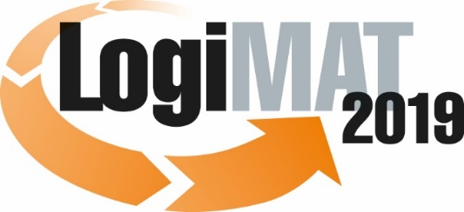

The 17th International Trade Show for
Intralogistics Solutions & Process Management
February 19–21, 2019 | Messe Stuttgart

Also featured at LogiMAT:

Munich, January 10, 2019

Invitation to PRESS EVENT at 17th LogiMAT
Tuesday, February 19, 2019 | Messe Stuttgart | Germany

Dear press representative,

We are proud to present LogiMAT 2019 with this year’s theme “First-Hand Intralogistics: Intelligent – Efficient – Innovative” featuring over 1,600 international exhibitors filling 120,000 square meters in all exhibit halls of the Stuttgart Messe convention center. Regarded as the world’s premier trade show for intralogistics solutions and process management, LogiMAT gives industry professionals insights into winning ideas and emerging trends and a sneak peek at exciting innovations, many never before seen anywhere else in the world.

Industry professionals can expect a comprehensive overview of current intralogistics products and innovations, including many not yet seen anywhere else, from an exciting mix of smaller players and global giants. LogiMAT 2019 focuses on the key drivers and challenges of intralogistics Industry 4.0, human-to-machine communication, big data, end-to-end digitization of supply chain processes – along with the integration of intralogistics, production, and trade.

Visitors benefit from an excellent accompanying program, making LogiMAT a trade show with the added value of an industry conference. Over 100 speakers from the business and academic communities will offer a program of 31 presentations in forums held right in the exhibitor halls. Live events also offer real-world insights into trends and solutions on the issues that move today’s markets.

For the sixth time, LogiMAT will also host TradeWorld, featuring innovative solutions for the development and deployment of e-commerce processes. The exhibitors – especially those participating in the TradeWorld expert forum with its own series of presentations in Hall 2 – will focus on the design, control, and integrated digitization of procurement, software, online shops, fulfillment, parcel services, and returns.

We would be delighted if you would join us to experience the many brand-new innovations debuting at LogiMAT 2019 and celebrate the winners of the BEST PRODUCT award to be presented at the opening ceremony.
– Page 2, press invitation to LogiMAT/TradeWorld 2019 –

We would like to personally invite you to three special events:

Opening ceremony of LogiMAT 2019
followed by presentation of BEST PRODUCT awards

Tuesday, February 19, 2019 | 9:30 - 10:30 a.m. | Forum A, Hall 1 (German/English)

Opening remarks: Michael Ruchty, Exhibition Director of LogiMAT 2019

Keynote:
“Artificial intelligence. When will the machines take over?”

Prof. em. Dr. Klaus Mainzer, Mathematician and philosopher

Presentation of award for BEST PRODUCT 2019 in three categories:
1. Software, communications, IT
2. Order picking, conveying, lifting, and storing technology
3. Identification, packaging and loading technology, load securing

Presenter: Prof. Johannes Fottner (Dr.-Ing.), Chair of the Institute for Materials Handling, Material Flow, Logistics at the Technical University of Munich

LogiMAT 2019 press conference

When: Tuesday, February 19, 2019 | 1:00–2:00 p.m.

Moderator: Michael Ruchty, Exhibition Director of LogiMAT 2019
EUROEXPO Messe- und Kongress-GmbH
Featuring industry representatives and the winners of the BEST PRODUCT award

Where: Press Center at Messe Stuttgart, East Entrance (German/English)

Get-Together 2019

Tuesday, February 19, 2019 | 5:00 p.m. | ATRIUM, East Entrance

Join the exhibitors to wind down at the end of day one at our traditional get-together featuring free beer and finger food.

We look forward to your visit!

Best regards from Munich,
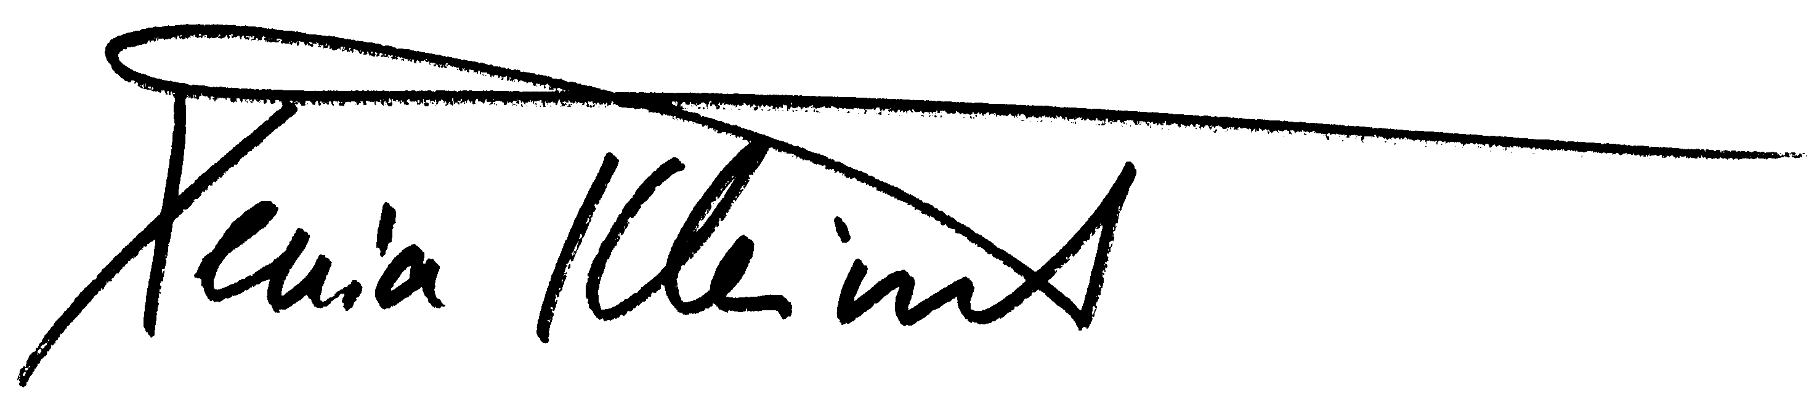

Xenia Kleinert
Head of Press and Public Relations

