PRESS RELEASE
Schwaebisch Hall, November 15, 2021

OPTIMA supplies 50th bundler to Hayat
Efficient multi-unit packer for paper hygiene
products and more

Hayat, one of the leading FMCG companies (Fast Moving Consumer Goods) based in Turkey, offers products in the hygiene, home care, tissue, and personal health categories that reach over 100 countries. Optima and Hayat have worked closely together since 2003, and in 2021 this culminated in the delivery of the 50th Optima bundler.
A focal point of Hayat's product portfolio are paper hygiene products made by the company since 1998. Today, Hayat is the world's fifth largest branded baby diaper manufacturer. Hayat ordered an Optima bundler for the first time in 2003 – the first model offered through the world leader for packaging paper hygiene products. This year the 50th bundler was supplied to Hayat – a special occasion that both companies are proud of.
Ibrahim Güler, Vice President Operations at Hayat, says looking back: “When we entered the market for baby diapers and sanitary napkins, we were looking for a world-class partner for packaging. Of all the potential partners, Optima stood out with its high standards and clever solutions. Today, Optima also meets the requirements of our high speed production lines, which are Industry 4.0 compatible, perfectly.” Ivair Santos, Sales Director South America at Optima do Brasil, adds: “Hayat expects the best technologies to ensure maximum efficiency. With valuable feedback, Hayat has played a part in the success story of the Optima bundler over the years.” Other multipackers are already in production for Hayat.
18 years of successful partnership with Hayat
During the 18 years of close partnership, Optima has continued to optimize the bundlers and adapt them to customer requirements. Today, for example, the welded seams of the multi-unit packs, which consist of PE film, are formed with a servo-controlled unit. This makes format changes significantly quicker. Hayat is also able to accommodate the almost tool-free format change. The Optima bundler can be switched to a new format in 15 to 30 minutes.
Production at the Brazilian site Vinhedo
Pre-packed paper hygiene products are fed inline to the OPTIMA BD12 bundler during production. For multi-line packaging, the bundler creates single or multi-layered formations. The bags are made in the machine from the PE film roll, then the product formations are inserted into the bags and closed with a welded seam. The multi-unit packs have a width of up to 800 mm, a length of up to 1,200 mm and a height of up to 400 mm. The output is twelve multi-unit packs per minute, which almost entirely covers the market requirements. All Optima bundlers are produced at the Brazilian site Vinhedo and comply with the high standards of the international special-purpose machine manufacturer based in Schwaebisch Hall.
The Optima bundlers are used at various Hayat locations worldwide. The company employs over 9,000 employees across 21 plants.
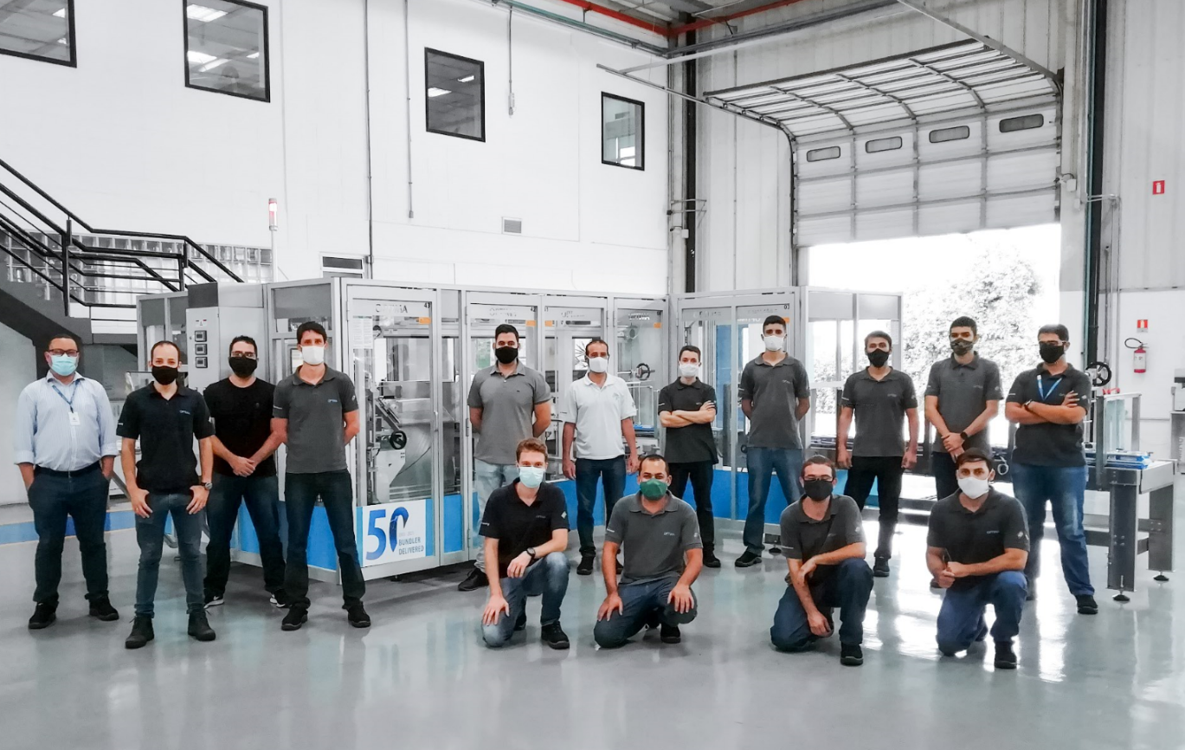
The project team of Optima do Brasil with the 50th bundler for Hayat. (Source: Optima)

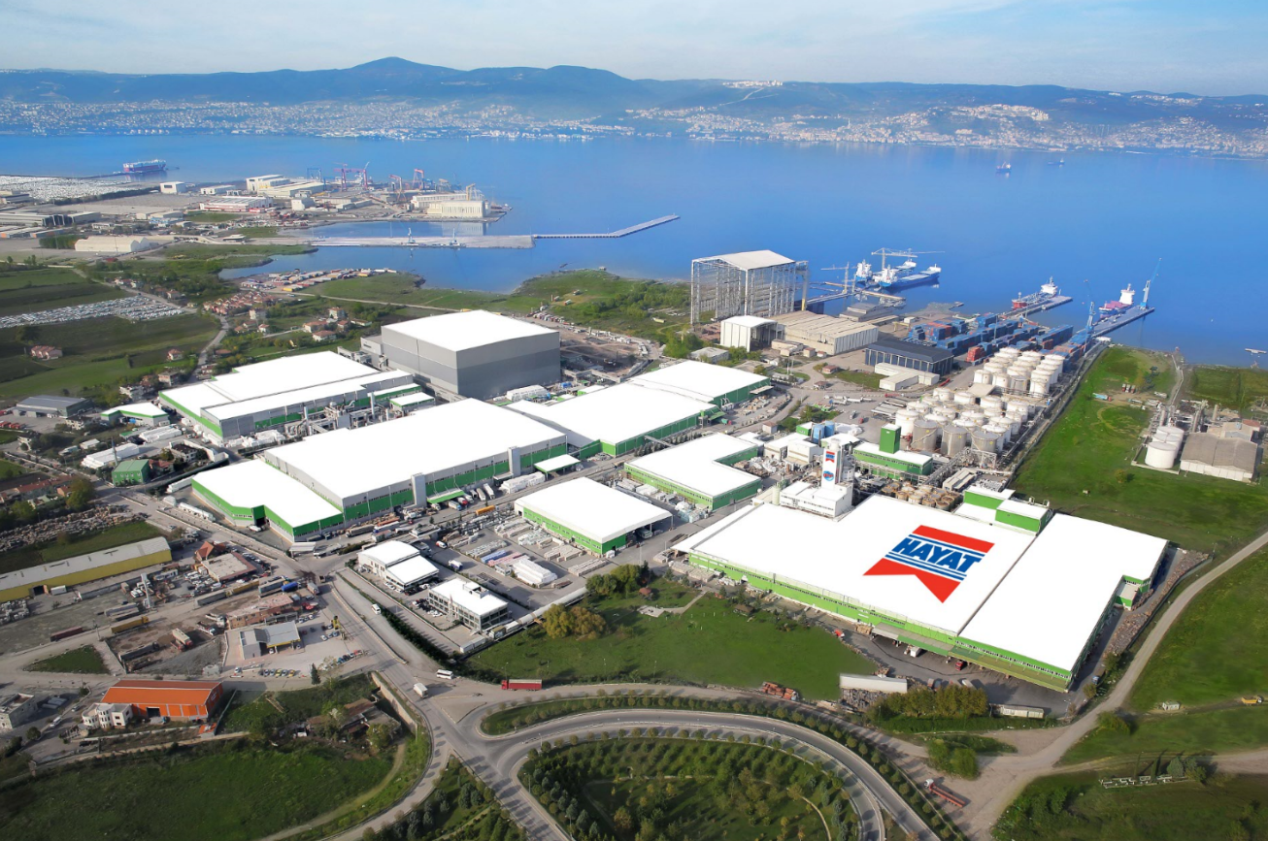
Hayat and Optima have enjoyed a partnership that has lasted for years. (Source: Hayat)

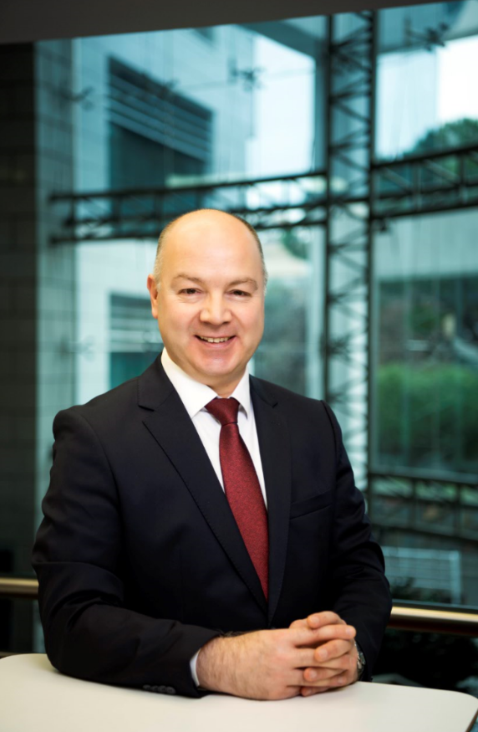
Ibrahim Güler, Vice President Operations at Hayat (Source: Hayat)

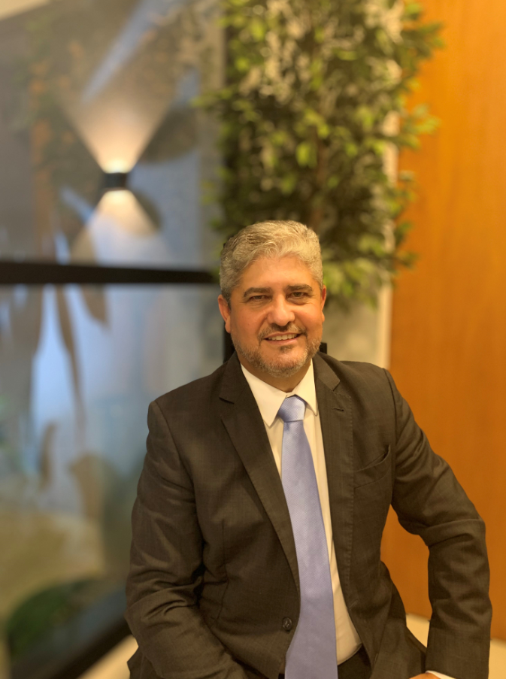
Ivair Santos, Sales Director South America at Optima do Brasil (Source: Optima)

Characters (incl. spaces): 2,946

Press contact:
OPTIMA packaging group GmbH
Jan Deininger
Group Communications Manager
+49 (0)791 / 506-1472
jan.deininger@optima-packaging.com
www.optima-packaging.com

About OPTIMA
Optima supports companies worldwide with flexible and customer-specific filling and packaging machines for pharmaceuticals, consumer goods, paper hygiene and medical devices markets. As a provider of solutions and systems, Optima accompanies these companies from the product idea through to successful production and throughout the entire machine life cycle. Over 2,650 experts around the globe contribute to Optima's success. 19 locations in Germany and abroad ensure the worldwide availability of services.

Thank you very much for your publication. We look forward to receiving a digital specimen copy.

