PRESS RELEASE
Schwaebisch Hall, May 11, 2020

Experience digital products firsthand
OPTIMA Digital Innovation Center starts operations

Optima has taken a major step toward becoming a digitalized company. The Optima Digital Innovation Center is up and running. The Optima Group's central digitalization center provides a firsthand experience of digital products and is available for all of its divisions. The facility sets new regional benchmarks for functionality, state-of-the-art technology and visitor-friendliness.
Interpack – the most important trade show in the packaging industry – was to have taken place on May 7-13. As with all major events, it had to be postponed due to the Covid-19 pandemic. Optima had, however, laid a lot of groundwork for creating a unique experience for future visitors to Schwaebisch Hall even after the trade show. In mid-March, the new Additive Innovation Center – a development center for producing parts using 3D printing technologies – opened at the Steinbeisweg location.
At the end of April, the Digital Innovation Center in the Solpark industrial park in Schwaebisch Hall-Hessental commenced operations without an official opening event due to the Covid-19 pandemic. Just as the Additive Innovation Center's will promote 3D printing technology, the Digital Innovation Center will play a significant role within the Optima Group as a think tank and in further developing and presenting digital solutions.

Focus on customer experience
Optima's own Smart Services will be presented in the Digital Innovation Center in addition to digital technologies and applications relating to augmented and virtual reality. The new showroom will make digitalization tangible for customers and visitors. Customer webinars will be an added feature in the future.
Experience digital products firsthand
"Our goal is to provide our customers around the world with an opportunity to experience Optima's digital products firsthand," explains Joachim Dittrich, Chairman of the Optima Consumer Division. Optima employees, customers and partners will now have an opportunity in their own way to see, discover, experience and test Optima's new digitalized solutions. The Digital Innovation Center will be able to impart and enhance knowledge. "Especially in the digital sector, it is important to understand the added value and then be able to communicate this to the customer," according to Michael Weber, Director Service at OPTIMA consumer GmbH.
Digital support during the entire machine life cycle
Digital products and services will be presented in the innovation and exhibition area. The so-called Smart Services developed at Optima in recent years are part of the OPTIMA Total Care comprehensive life cycle management program. Smart Services effectively complement the so-called Basic Services, namely traditional services such as installation, calibration, spare parts service, training and retrofits. The digital services support all stages of the machine life cycle – from planning to commissioning to retrofitting. For example, at the beginning of a project during the design review, i.e. at the first inspection of the design, the system can be displayed digitally and in three dimensions on a virtual screen. On request, customers will be able to experience the system up close using virtual reality glasses. This will facilitate early corrections.
Augmented reality technology support
Customers will also receive digital support on all conceivable end devices, including augmented reality glasses, when resolving problems in production or when changing formats. Customers will be able to access these and many other Smart Services 24/7 via a central user-friendly Optima platform. The continuous availability of Smart Services means that agile, digital operation of machinery is becoming a reality. Customers will be able to test all products in the new center.
"The Digital Innovation Center has been designed in such a way that visits – whether they are a customer's first visit, during the planning of a project or after commissioning – are based on the customer's needs," explains Holger Frey, who leads the Smart Services team there. The showroom can be customized for each customer visit within a few minutes.
The same building to house first co-working space in the region
"Collaborations have become even more important since the beginning of the Covid-19 crisis. We are therefore delighted that the same building also houses the first co-working space in the Schwaebisch Hall region. We will share the lobby as well as the common area with our new neighbors," Frey says. He sees great potential here: "In the so-called 'hello SPACE', freelancers and small start-ups will be able to develop new ideas. We are delighted to be part of an inspirational neighborhood."
The new Optima Digital Innovation Center is located at Geschwister-Scholl-Straße 77 in the Solpark industrial park in Schwaebisch Hall-Hessental.

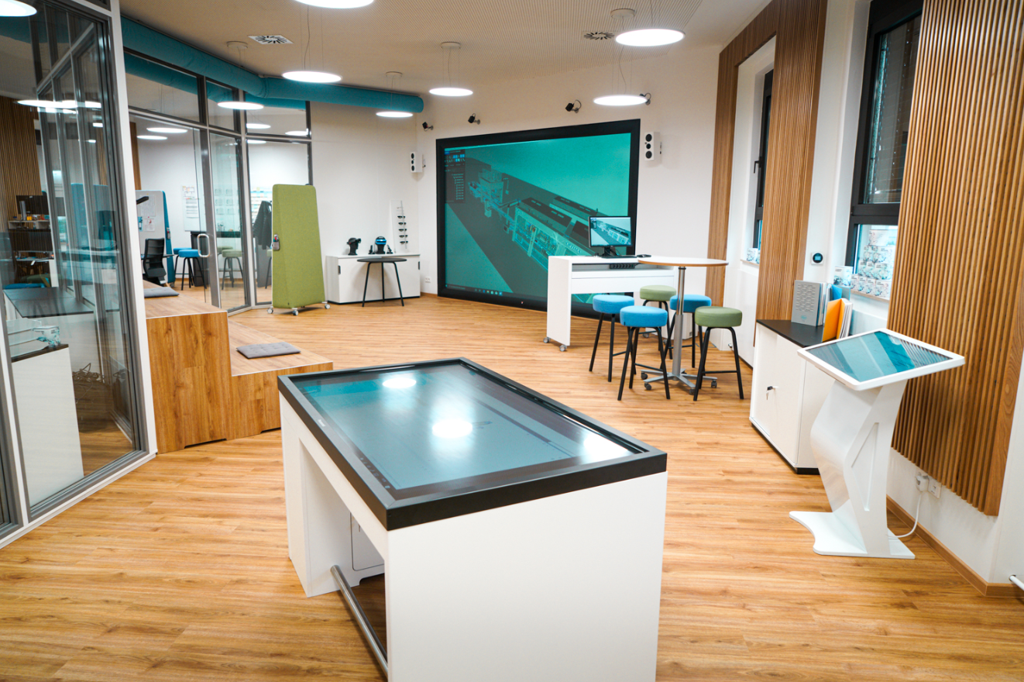
The new Optima Digital Innovation Center will make it possible to experience digital products firsthand. (Source: Optima)

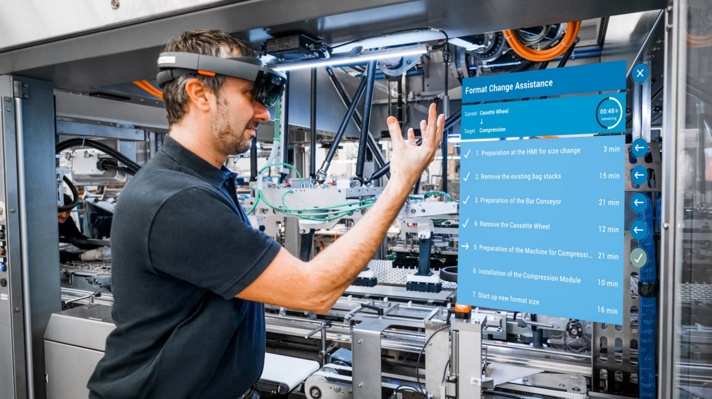
At Optima, digital products are part of the OPTIMA Total Care life cycle management program. This includes, for example, format change support using augmented reality glasses. (Source: Optima)

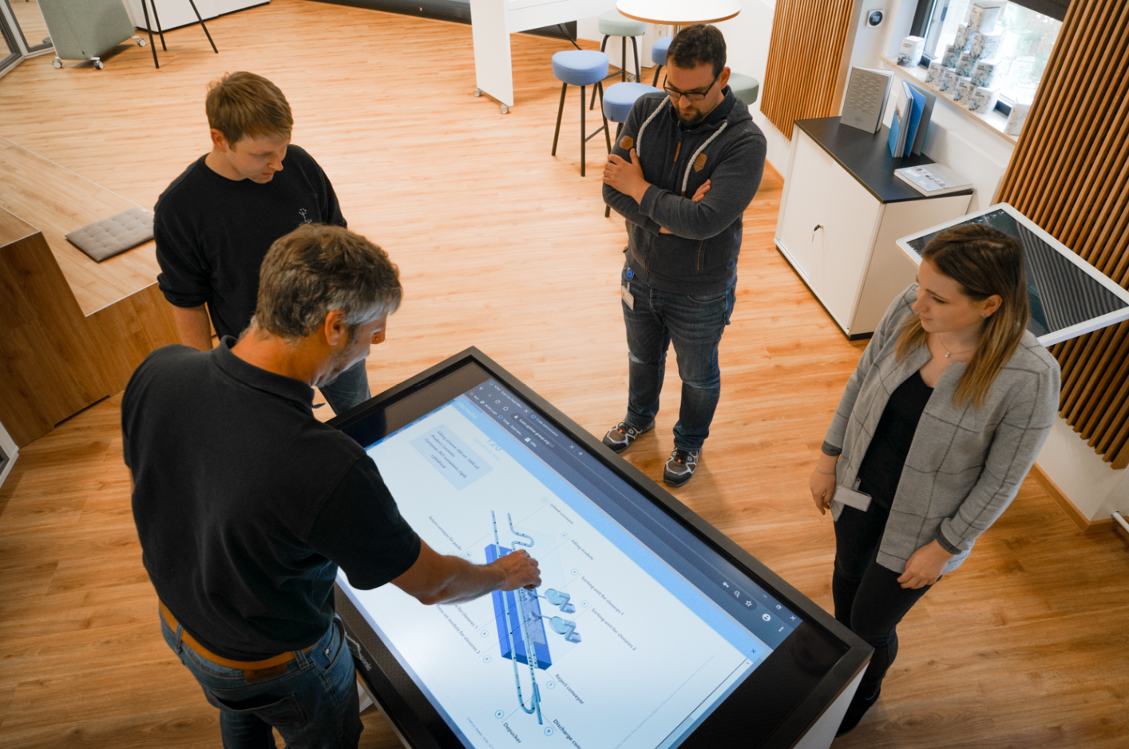
Touch screens explain the advantages of digital technologies. (Source: Optima)

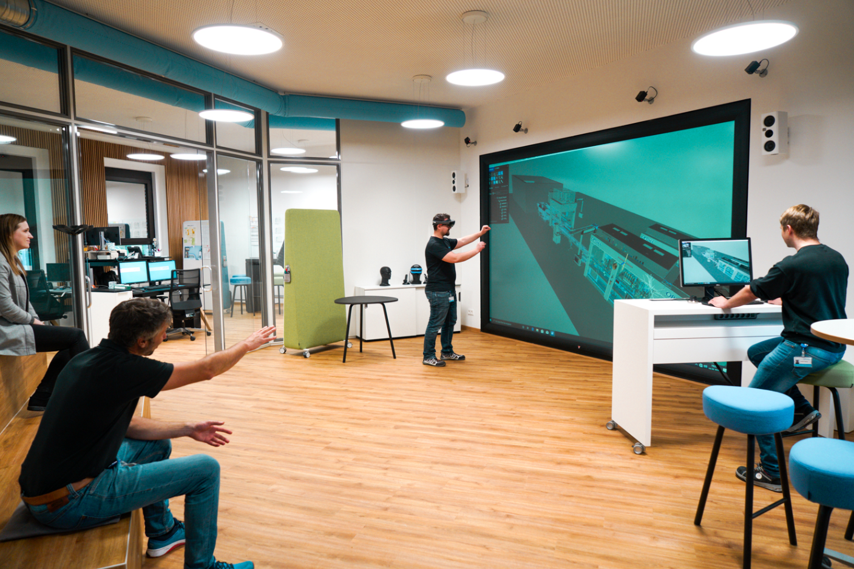
Proven virtual reality technology continues to be used in machine projects. (Source: Optima)

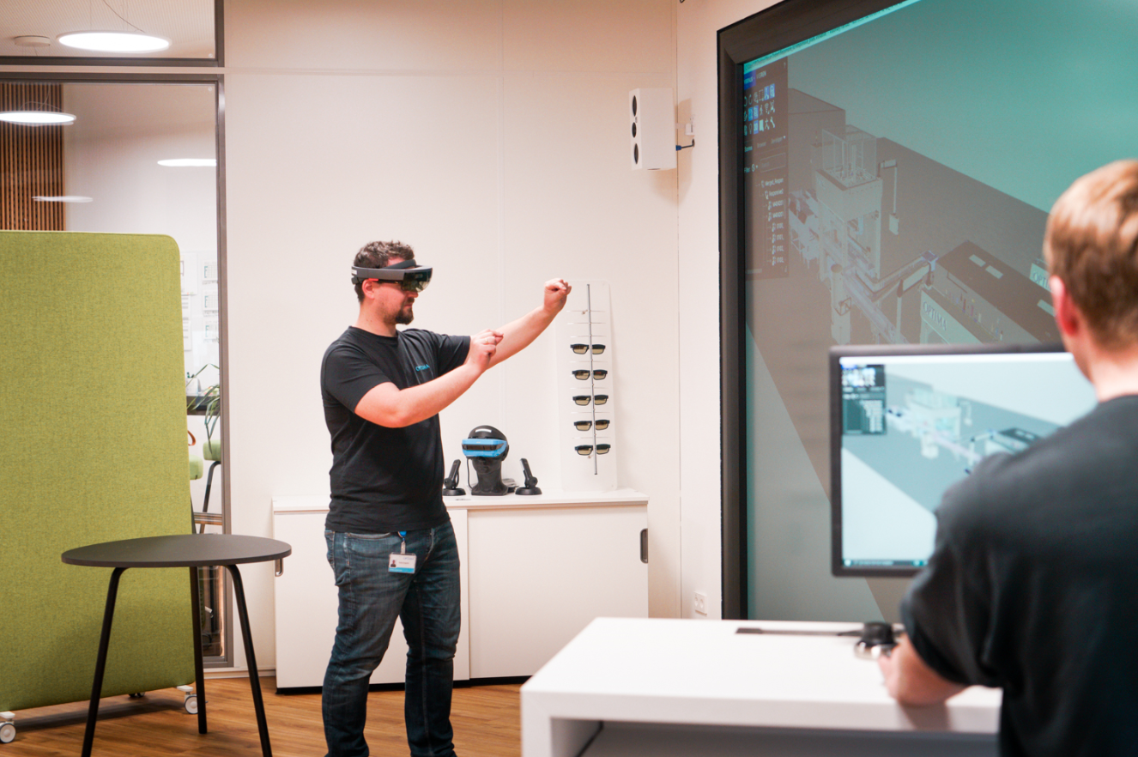
Using virtual reality technology, visitors will be able to maneuver through their system and identify changes at an early stage before the system is built. (Source: Optima)

Characters (incl. spaces): 4,894

Press contact:
OPTIMA packaging group GmbH
Jan Deininger
Editor
+49 (0)791 / 506-1472
jan.deininger@optima-packaging.com
www.optima-packaging.com
Thank you very much for your publication. We look forward to receiving a specimen copy.

