GEA and AS Utilitas Drive Clean Heat Innovation in Tallinn

Duesseldorf (Germany), June 10, 2025 – GEA and Utilitas are driving Tallinn’s clean energy transition with the installation of four high-efficiency heat pumps at the Väo energy complex, including the first commissioned innovative GEA Grasso L XHP screw compressor based heat pump. Supporting the city’s goal of net-zero emissions by 2050, the system recovers waste heat from biomass CHP to reduce fossil fuel use, cut CO₂ emissions, and deliver reliable heating to 8,000 homes and businesses.

Reliable Partner for High Efficiency Solution

With 60% of Estonia’s buildings relying on district heating, ensuring a reliable, affordable, and environmentally responsible heat supply is critical. “We provide heat to 400,000 people, about one-third of the population,” says Robert Kitt, CEO of Utilitas Tallinn. “Our challenge is to secure supply during cold winters, keep prices stable, and minimize environmental impact.” “Also, We’ve set an ambitious target to become carbon neutral by 2030“, Kitt continues. “The Väo energy complex is a crucial step towards that goal, utilizing biomass at highly efficient CHPs, sun, waste heat from the production of green hydrogen and GEA heat pump technology to optimize efficiency and sustainability. Choosing to work with GEA for this installation is entirely in line with that strategy: We knew we had a reliable partner who would offer an efficient and sustainable solution.”

GEA ammonia heat pumps at the heart of the system

The four heat pumps from GEA are a significant addition to the already highly efficient biomass CHP system. The system comprises three GEA Grasso LT screw compressors (model XB) and the new 70 bar GEA Grasso L XHP screw compressor, which is based on GEA Grasso technology that has been developed over decades. "These heat pumps ensure optimum performance by dynamically adjusting temperatures: 65°C in summer, 85°C in winter and up to 95°C if required," emphasizes Mindaugas Lazdauskas, Director Sales Baltics at GEA Heating & Refrigeration Technologies. "With the new GEA Grasso L XHP, we offer high temperature performance and efficiency that make large decarbonization projects like the one in Tallinn a reality. Its efficiency and capacity at high pressure make it the ideal solution for Utilitas' ambition for a cleaner and more efficient district heating network," adds Ron Hoffmann, Product Manager for Screw Compressors at GEA Heating & Refrigeration Technologies. "With the second-stage flue gas condensers, we are making the cogeneration plant more efficient," explains Indrek Sang, Project Team Leader at Utilitas Tallinn. "We take the excess low-temperature heat of up to 35 °C and use the heat pumps to raise it to a stable 82 °C for the district heating network." This process significantly improves energy recovery and reduces reliance on back-up boilers, cutting emissions while optimizing resource consumption.

Sustainability of heat pumps is improved by natural refrigerant ammonia

The natural refrigerant ammonia further improves the sustainability of GEA heat pumps. "Ammonia has been a safe and effective refrigerant for over 150 years," says Kenneth Hoffmann, Manager Heat Pumps at GEA Heating & Refrigeration Technologies. "Its thermodynamic properties and long service life make it a long-term solution that is in line with evolving refrigerant regulations," says Hoffmann.
Proven Ecological and Economic Benefits

Since their installation in 2023, the GEA heat pumps have shown significant environmental and economic benefits. "In the first heating season, we produced around 80,000 MWh of heating energy," says Sang. "Thanks to the heat pumps, we use less natural gas and reduce CO₂ emissions by 20,000 tons per year." In addition to the reduction in emissions, the efficiency gains are also remarkable. "We have achieved a coefficient of performance (COP) of more than four," adds Sang. “These successes make the Väo energy complex a model for other cities that want to modernize their district heating infrastructure.”

A Global Blueprint for Urban Heat Transformation

Tallinn’s achievement is part of a growing portfolio of more than 50 GEA-supported district heating projects across Europe and North America. From seawater heat in Copenhagen to mine water in Gateshead and waste heat from the London Underground, GEA’s heat pump solutions are key enablers to cities’ decarbonization efforts worldwide.
“The European transition towards resource-efficient energy starts with the cities,” Hoffmann says. “As urban populations grow and energy demands rise, projects like Väo set the standard for district heating’s future and stand as a powerful example of how innovation and collaboration can drive meaningful change.” With a focus on efficiency, reliability and environmental responsibility, GEA remains a trusted partner in engineering solutions that not only heat homes but also reduce CO₂ emissions.

Photo 1:
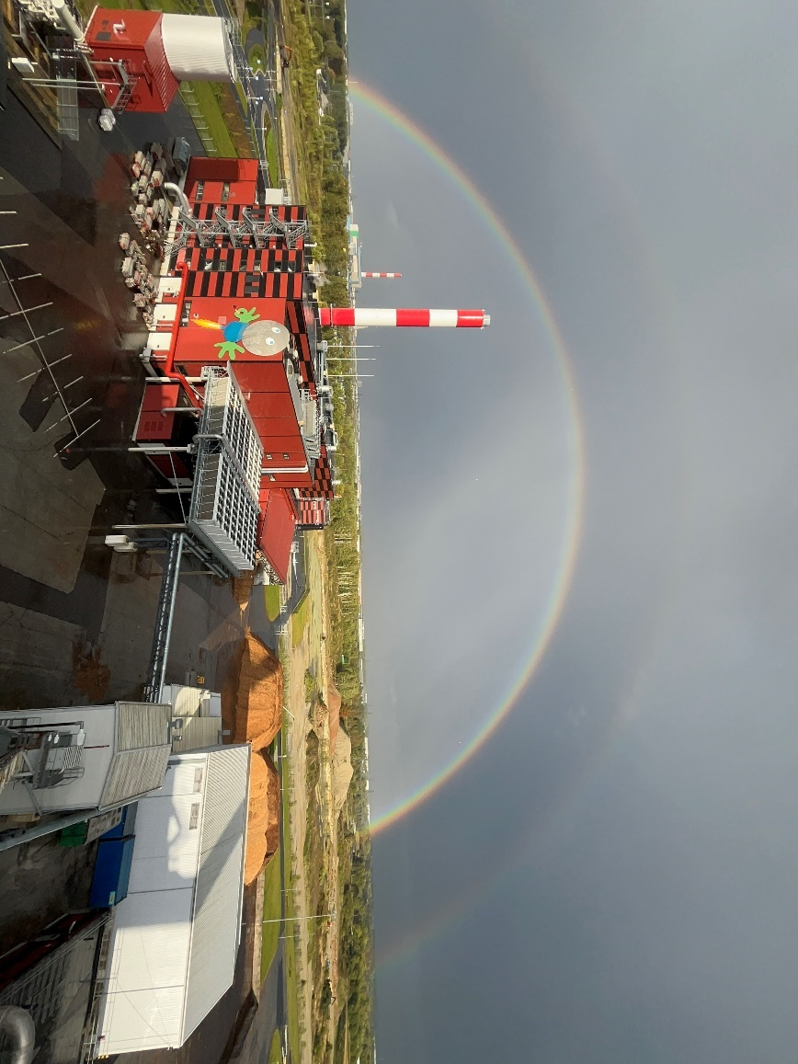
Photo 1, caption: The Utilitas Väo energy complex uses a highly efficient biomass CHP plant and four GEA heat pumps to supply district heating to around 8,000 homes and businesses in Tallinn, Estonia. (Photo: AS Utilitas)

Photo 2:
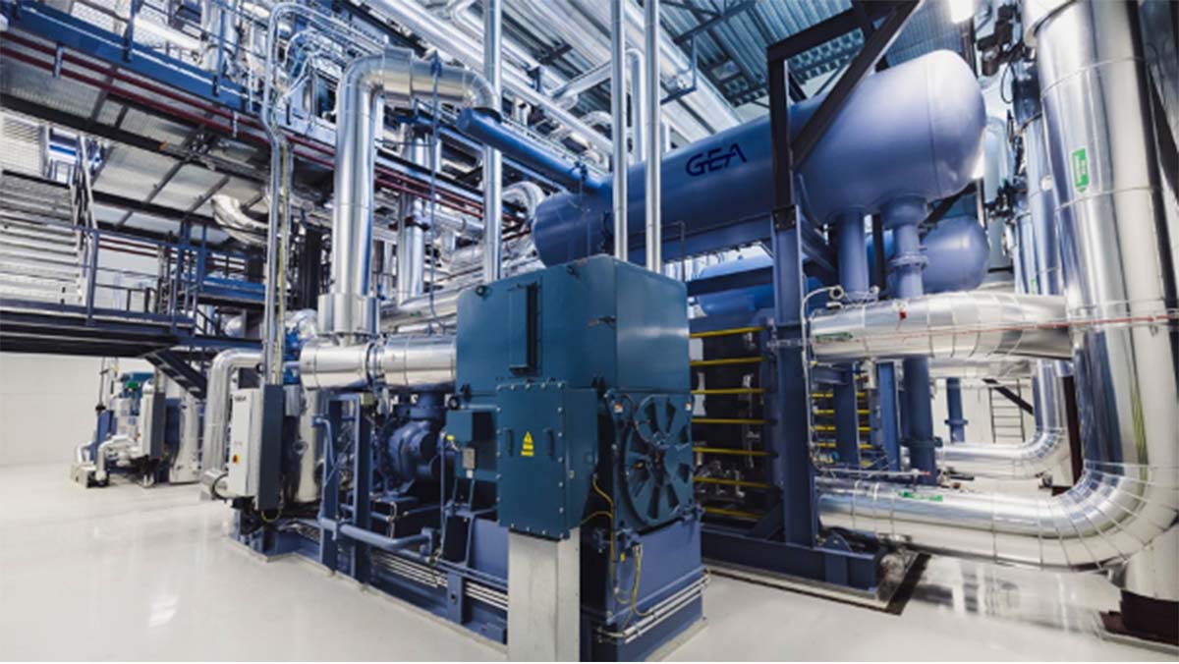
Photo 2, caption: GEA heat pump plant at Utilitas Väo energy complex, Tallinn, Estonia. (Photo: GEA)

Photo 3:
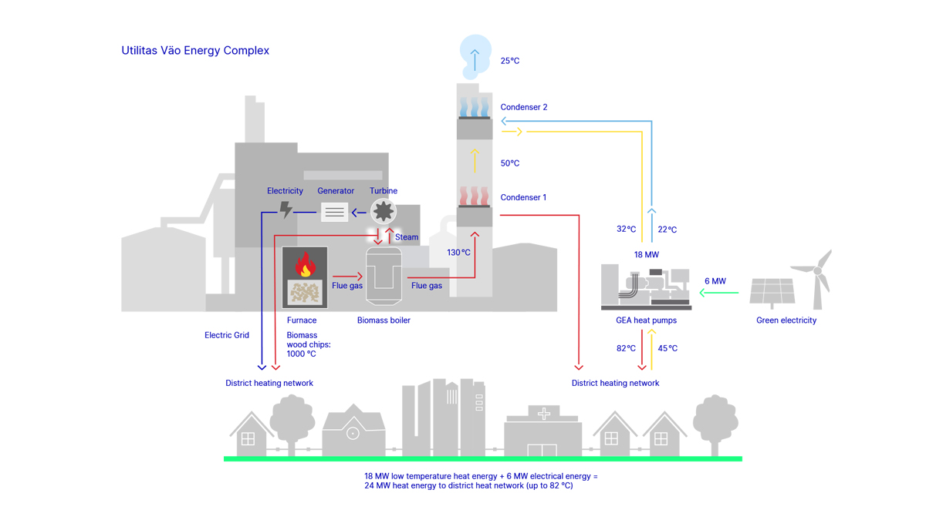

About GEA
GEA is one of the world’s largest suppliers of systems and components to the food, beverage and pharmaceutical industries. The international technology group, founded in 1881, focuses on machinery and plants, as well as advanced process technology, components and comprehensive services. For instance, every second pharma separator for essential healthcare products such as vaccines or novel biopharmaceuticals is produced by GEA. In food, every fourth package of pasta or every third chicken nugget are processed with GEA technology. With more than 18,000 employees, the Group generated revenues of about EUR 5.4 billion in more than 150 countries in the 2024 fiscal year. GEA plants, processes, components and services enhance the efficiency and sustainability of customers’ production. They contribute significantly to the reduction of CO2 emissions, plastic usage and food waste. In doing so, GEA makes a key contribution toward a sustainable future, in line with the company’s purpose: ”Engineering for a better world.”

GEA is listed on the German MDAX, the European STOXX® Europe 600 Index and is also a constituent of the leading sustainability indices DAX 50 ESG, MSCI Global Sustainability and Dow Jones Best-in-Class World.

More information can be found online at gea.com.
If you do not wish to receive any further information from GEA, please send an e-mail to pr@gea.com.

NOTE TO EDITORS

- Further information about GEA
- To the GEA Press page
- To the GEA Media Center
- Background information on current topics can be found at Features
- Follow GEA on  

GEA
Media Relations GEA
Dr. Michael Golek
Peter-Müller-Str. 12, 40468 Düsseldorf
Phone +49 211 91361505
Tel. +491736205746
michael.golek@gea.com

