PRESS RELEASE
Schwaebisch Hall, August 25, 2022

OPTIMA at FachPack 2022
Filling and packaging more sustainably and efficiently with turnkey solutions and digital services

At FachPack 2022, Optima Consumer will demonstrate why the company is a specialist in filling and dispensing sophisticated products. Cutting-edge technologies, comprehensive services, digitalization and sustainability are all key factors for the success of the customers. In addition, the company will be showcasing the OPTIMA CFR, a machine for filling and sealing capsules that enables an especially rapid market entry.
The OPTIMA CFR for filling and closing capsules that will be presented at FachPack at the end of September is a proven system that targets fast market entry and small series production. The modular concept can be adjusted to individual requirements and is therefore quickly available to minimize time-to-market. The compact rotary machine is very accessible and easy to clean. The precise dosing systems are used to process coffee, tea or instant powder, for example. Then the capsules are sealed with foil. Up to 220 capsules are produced per minute.
Optima takes sustainability very seriously. In light of this, the Optima group acquired a stake in Weyhmueller (Neu-Ulm), which visitors can find out more about at FachPack. Weyhmueller manufactures special machines for producing cups and cans made of paper. With these machines, Optima can offer holistic and sustainable turnkey solutions – from packaging development, inline production of sustainable paper packaging, packing and closing to resource-saving operation of systems.
Climate-neutral delivery of machines and systems starting in 2023
The official CO₂-neutral company label of the Baden-Wuerttemberg Climate Protection Foundation confirms that all German Optima locations are operating net climate-neutral as of this year. Starting in 2023, Optima will be able to determine the individual climate footprint of customer projects, implement reduction measures together with customers and deliver machines and systems in a climate-neutral way by means of residual compensation. Visitors to FachPack will be provided information about this as well.
In addition, the comprehensive digital services portfolio supports sustainable solutions. Optima will present these solutions at FachPack. The main focus is on maximum system availability and a high degree of production reliability. This means machine users maintain an overview of their production and identify potential for improvement, can access knowledge about the system at any time, boost system availability and get support quickly and directly when needed. An example of this: the award-winning software solution Remote Assist.
Optima will also provide information at FachPack about all of its filling and packaging systems in the medium and high output range for the food, cosmetics, beauty care and chemical industries.
Optima Consumer at the FachPack trade show in Nuremberg, September 27-29, 2022: Booth no. 334, Hall 3C (shared booth, Packaging Valley e.V.)

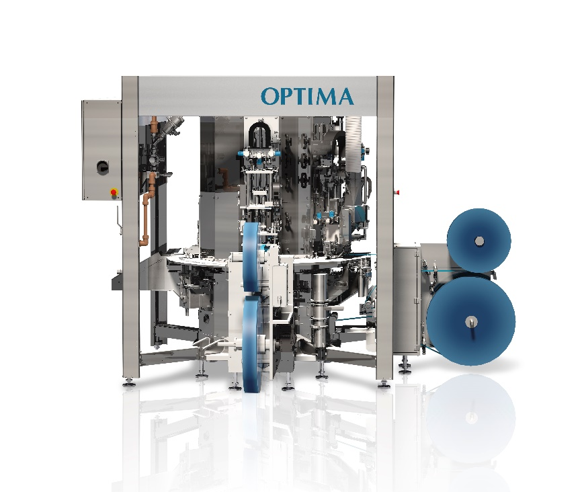
The OPTIMA CFR is a very compact machine that dispenses, for example, coffee, tea or instant powder into capsules. The machine is available very quickly for a short time-to-market. (Source: Optima)

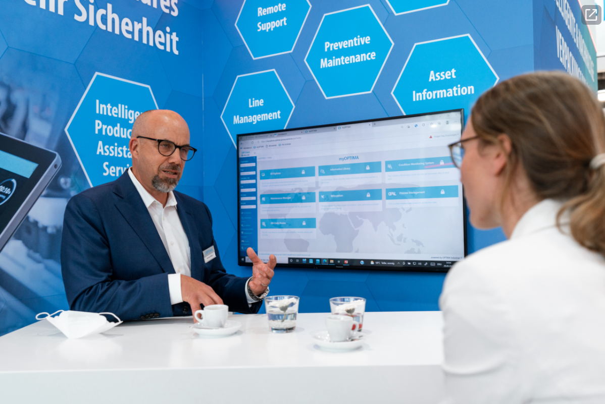
At FachPack, Optima will demonstrate how digitalization can increase the efficiency of systems. (Source: Optima)

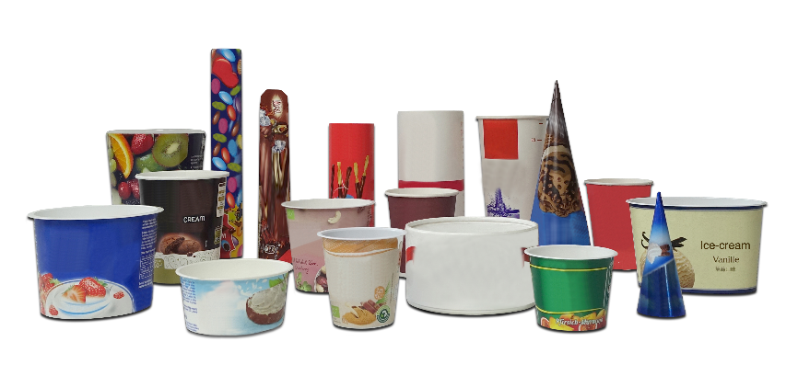
By acquiring a stake in Weyhmueller, Optima is expanding its turnkey portfolio for sustainable packaging solutions. (Source: Weyhmueller/Optima)

Characters (incl. spaces): 3,018

Press contact:
OPTIMA packaging group GmbH
Jan Deininger
Group Communications Manager
+49 (0)791 / 506-1472
jan.deininger@optima-packaging.com
www.optima-packaging.com

About OPTIMA
Optima supports companies worldwide with flexible and customer-specific filling and packaging machines for pharmaceuticals, consumer goods, paper hygiene and medical devices markets. As a provider of solutions and systems, Optima accompanies these companies from the product idea through to successful production and throughout the entire machine life cycle. Over 2,800 experts around the globe contribute to Optima's success. 20 locations in Germany and abroad ensure the worldwide availability of services. In 2022, Optima celebrates the company's 100th anniversary.
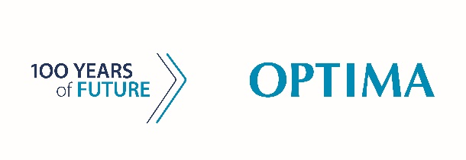
Exciting stories from 100 years of Optima: www.100-years-of-future.com

Thank you very much for your publication. We look forward to receiving a digital specimen copy.

