PRESS RELEASE
Schwaebisch Hall, June 29, 2018

OPTIMA nonwovens develops future technologies together with customers
ONTEX visited OPTIMA nonwovens during the in house show “Partnering with the Packaging Pioneers”

To engage in dialog with customers at the earliest possible stage. To get feedback. To find out whether you are on the right track with your thoughts and developments for the future. This is what the in-house exhibition “Partnering with the Packaging Pioneers” at Optima Nonwovens is all about. From June to August 2018, customers learn about cutting-edge technologies and the latest solutions in Schwaebisch Hall. They will gain inspiration in the fields "next level of modularity", "reduction of the last user interface through automation" and "communication and service in the context of digitization". The feedback from exhibition visitors will have a decisive influence on further developments.

Very impressed by the Cobot

Early visitors were impressed by the exhibition concept: "I highly recommend in-house exhibitions, as the focus is more on the customers and their needs than on trade shows, where you can just have a quick hello and not really go deep," said Martin Gärtner, Group Manufacturing Director at Ontex, a leading manufacturer of hygiene products. Over the coming months and years, he wants to pursue some of the approaches he learned about at the exhibition. "It is always interesting to be inspired by new ideas," said Martin Gärtner. He was particularly impressed by the Cobot in action – an approach worth considering in times of rising labor costs.

About OPTIMA nonwovens

Optima Nonwovens develops leading-edge technologies for packaging paper hygiene articles. The packaging lines take over diapers, sanitary napkins and bathroom tissue rolls from the production machines in a synchronous manner and package them in plastic film. The flexible systems can accommodate everything from the smallest packages to jumbo packs. Inspection functions and secondary packaging capabilities are integrated to achieve automated complete lines. In addition to high-volume systems, the product range also includes machines of small to medium capacity. The division guarantees quick, professional service with 14 international locations. OPTIMA nonwovens GmbH is a member of the OPTIMA packaging group GmbH (Schwaebisch Hall), which employs a workforce of 2,250 around the globe.

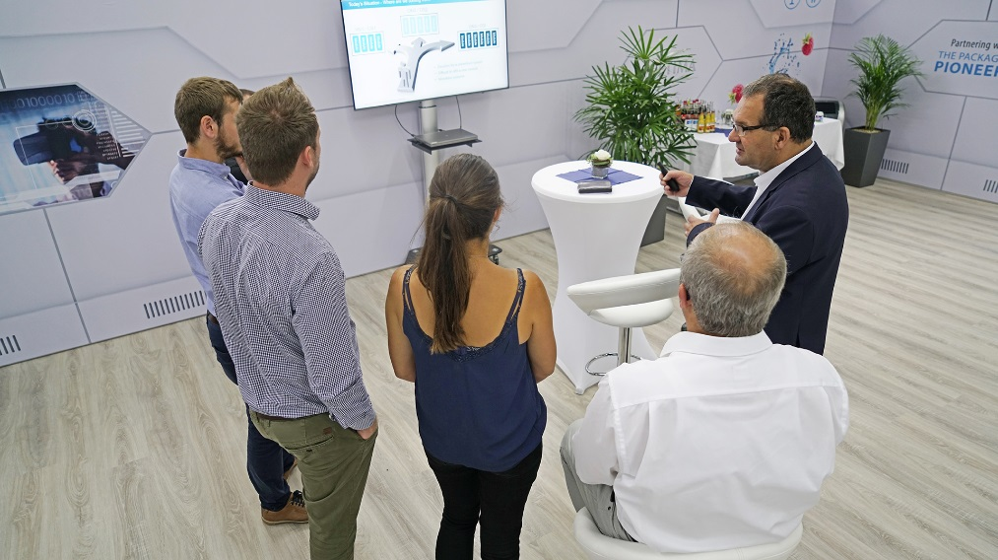
Martin Gärtner and his team listen while Wilfried Laser, Key Account Manager at Optima Nonwovens explains how modular packaging machines are flexible adjustable to new market requirements.
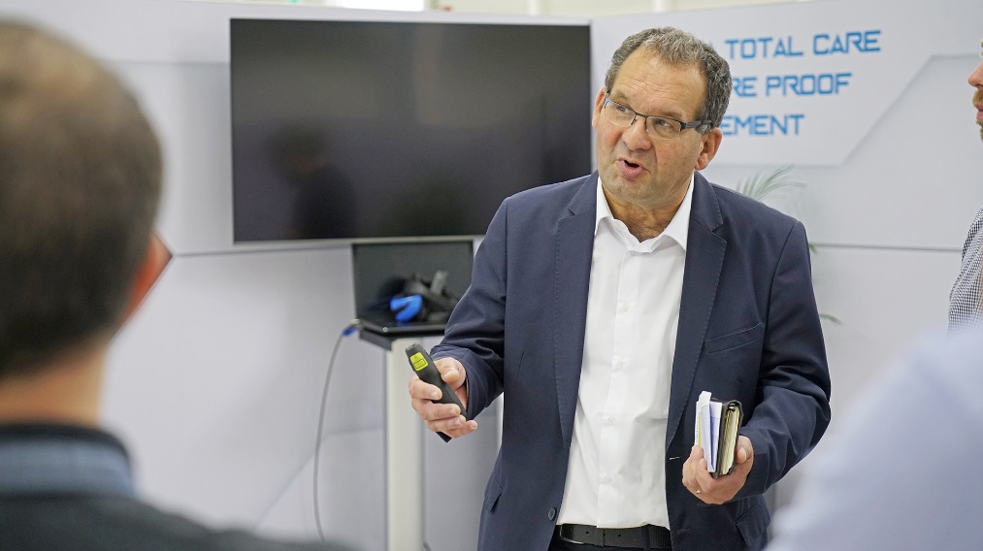
The requirements of users are changing constantly. So users don’t need a complete line every time the requirements change, Optima Nonwovens developed the modular design.

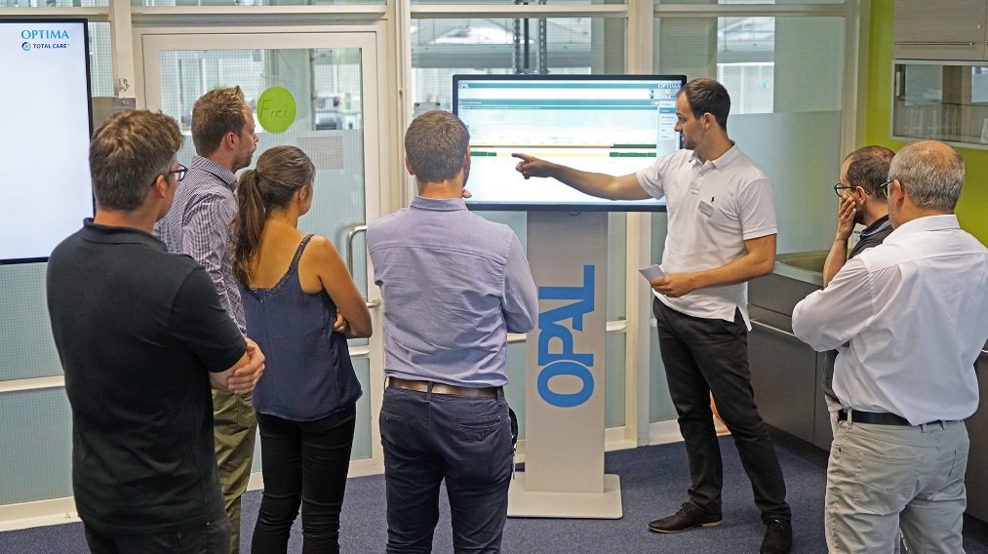 Dominik Roll, Project Manager at Optima Nonwovens explains the line management software OPAL. The digital product from Optima creates an efficient production line and has the customer react fast to deviations in the OEE (Overall Equipment Efficiency).

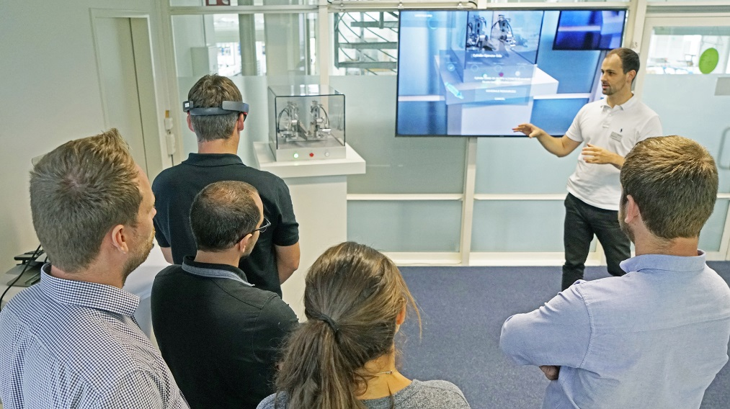
How does the communication of the future look? First answers are offered by Dominik Roll. One possibility: Augmented Reality.

Characters (incl. spaces): 1,536

Contact:
OPTIMA packaging group GmbH
Sabine Gauger
Marketing Director
sabine.gauger@optima-packaging.com
www.optima-packaging.com
Thank you very much for your publication. We look forward to receiving a specimen copy.

