PRESS RELEASE
Schwaebisch Hall, February 6, 2020

A pairing of innovation and sustainability
AMOTEK at INDEX 2020

Amotek is carefully preparing its participation at INDEX 2020, the biggest Nonwovens show, with a “dual concept” machine, IS81 PERFORMANTE in a new corporate design. The new AMOTEK IS 81 PERFORMANTE features several environmentally friendly innovations for the fully automated packaging of incontinence products with higher performance, smaller footprint, and new Industry 4.0 service functions to round off the machine concept. The integrated system, which will be presented for the first time at the INDEX show, handles different packaging materials including paper bags, bio-plastics bags, and other ecological material.
The birth of the IS81 PERFORMANTE led to a significant increase in performance compared to the previous model. At the same time, the packaging format flexibility is increased and the footprint of the stacker is reduced by about 30 percent compared to a double exit stacker. In the new model, the machine frame was reinforced and an overall more robust machine design was achieved.
The simplified usability and ease of service was another development goal for the Amotek engineers. This was achieved with a new Human Machine Interface (HMI) with improved user guidance, which can also display expanded content such as the spare parts catalog digitally. The AMOTEK IS 81 PERFORMANTE offers entry into preventive maintenance. The state of the machine is continuously recorded using integrated sensors and operators are warned of impending failure of a component at an early stage. Further Industry 4.0 technologies have been integrated, for example to simplify the remote access service or to offer extended remote monitoring.
Sustainability never stops
The environmental compatibility requirements for packaging are continuously increasing. To answer this, the pneumatic system of IS81 PERFORMANTE has been revised, reducing air consumption significantly. This is especially true in the area of paper hygiene products where new, eco-friendly packaging materials are required. AMOTEK first started in tissue, giving paper hygiene producers the freedom to process a wide variety of materials. AMOTEK then continued its researches in the consumer and nonwovens sectors as well. Today in collaboration with big bag makers, AMOTEK can propose to its partner’s versatile machines in terms of various materials run ability. During the exhibition, at the AMOTEK booth, perfectly executed packs with innovative eco-friendly materials will be visible and even touchable to leave manufacturers free to decide which sustainable packaging to use.
Amotek has been offering leading packaging technologies for nonwovens products including diapers for babies and adults, feminine care and other paper hygiene products as well as consumer products for more than 40 years. Over 1,300 Amotek machines have been installed worldwide. As part of the Optima Group in Germany, Amotek has access to the latest research and development results from the technology leader in the nonwovens segment.
Amotek at INDEX, Geneva, March 31 to April 03, 2020: Hall 2, stand no. 2679

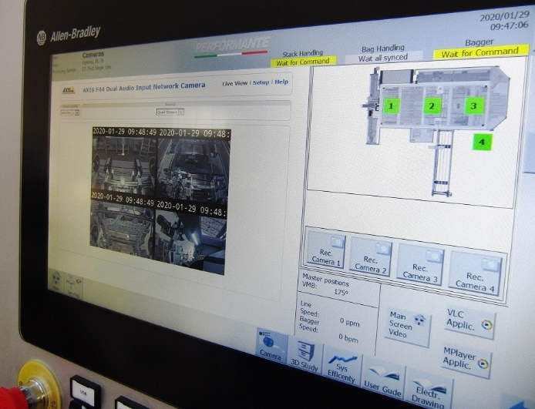
With its new HMI, the innovative AMOTEK IS 81 stands for maximum user friendliness. The machine packs incontinence products in various sustainable packaging materials and flexibly replaces PE film.
Source: Amotek.

Characters (incl. spaces): 2,988

Press contact:
OPTIMA packaging group GmbH
Jan Deininger
Editor
+49 (0)791 / 506-1472
jan.deininger@optima-packaging.com
www.optima-packaging.com
Thank you very much for your publication. We look forward to receiving a specimen copy.

