Freeze Drying / Fi Europe 2024

# GEA presents next generation batch freeze dryers for food applications

Düsseldorf (Germany), October 30, 2024 – GEA, a global leader in food and dairy processing solutions, launches its next generation batch freeze dryers, the RAY® Plus series. Building on 70 years of freeze dryer design experience, the new RAY® Plus series offers advanced technology that delivers benefits in terms of energy efficiency and hygiene, providing a more flexible and efficient solution for the food industry.

Freeze-drying is a highly effective method to preserve a wide range of fresh foods, from fruit and vegetables, pet food, meat and seafood to probiotics, convenience foods, instant coffee and ready meals. Health-conscious consumers value the convenience of freeze-dried smoothies and snacks, which have an extended refrigerator-free shelf life and retain their nutritional quality, taste, texture and appearance.

**Flexible and Energy-Efficient Solutions**

The RAY® Plus series offers a cabinet size range of 45m² to 180m², with heating plates in layers of 10, 15, or 20, and condensers on both sides. These cabinets can be combined in groups of up to six, sharing a common control and support system to improve operational efficiency and ensure even load distribution across the production floor.

In designing the GEA RAY® Plus freeze dryer GEA developed a proprietary Computational Fluid Dynamic (CFD) model. The model precisely calculates the flow dynamics and pressure losses under deep vacuum within the freeze dryer cabinet, ensuring optimal performance and efficiency.

The result is a nearly 50 percent reduction in pressure drop within the cabinet compared to previous models, achieved by installing vapor traps on both sides of the cabinet and allowing vapor to enter from both the top and bottom.

The new series can be integrated with existing RAY® freeze dryers and connected to various cooling and heating solutions, including the latest heat pump technologies. Operating at lower temperatures with higher batch loads, the RAY® Plus achieves the same daily capacity with reduced energy consumption. The system’s flexibility allows for high sublimation rates (>3 kg/m²h) or higher capacity at low vacuum (<0,15mBar) with standard refrigeration solutions.

From the RAY®125 Plus model onward, the freeze dryers are equipped with four condensers (three in operation, one in de-icing), providing a larger condensing surface and enabling operations at a condenser temperature approximately 6 °C warmer. This configuration also allows for operation at lower vacuum levels with higher sublimation rates.

**Hygiene and Ergonomics**

The RAY® Plus cabinets are designed for efficient washdown, with all water running to drain points at the bottom of the circular cabinet. Residual water can be removed by applying a brief vacuum to the cabinet. The design also includes an internal camera to monitor the status inside the cabinet during operation.

**User-friendly Interface**

The new series features an intuitive user interface on the front of the unit, making it easy to operate and offering remote access. The comprehensive PC-based control system remains available for detailed operation and troubleshooting.

**Proven rail system and trolley configurations**

The RAY® Plus uses trolleys running on GEA’s proven rail system with 80mm stainless steel pipes. Trolleys are available in 20, 30, or 40 tray configurations, with the 30-tray solution compatible with RAY® cabinets. Optional solutions for automatic loading and unloading, as well as tray filling and cleaning, are also available.

**Fi Europe in Frankfurt (Germany)**

The new RAY® Plus series will be one of GEAs focus themes during the Fi Europe fair, which takes place in Frankfurt (Germany), from November 19 to 21, 2024. (GEA booth: Hall 3, Booth #3.0J62). Additionally, a GEA expert will be on stage to explain the new technology in detail. He shows how freezer dryer operation is affected by water vapor flow and pressure losses in the cabinet, and by the efficiency of ice formation on condensers. The presentation will take place at Exhibitor Showcase Theatre (Hall 3 - 3.0K2), November 19th, 01:00 pm.

[gea.com](https://www.gea.com/en/index.jsp)

Picture Overview

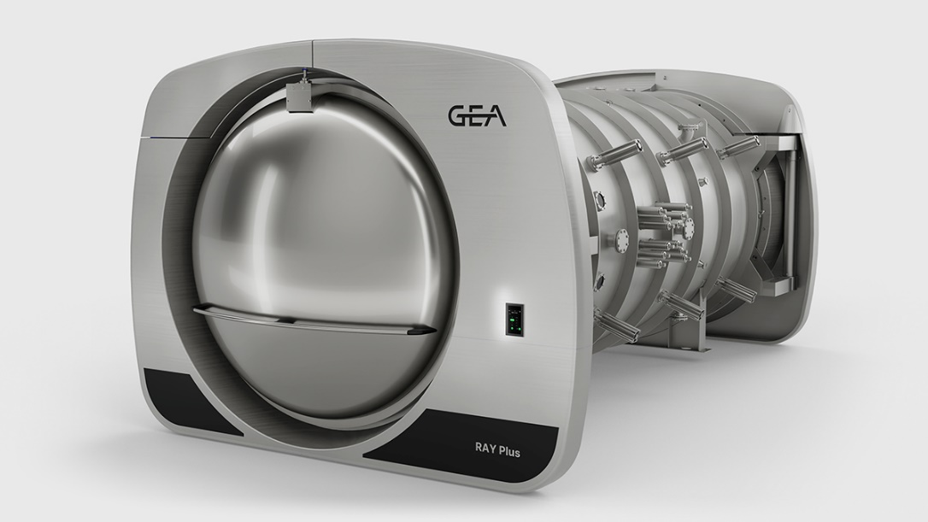

Pic. 1: The new RAY® Plus series from GEA offers benefits in terms of energy efficiency and hygiene, providing a more flexible and efficient solution for the food industry. Source: GEA

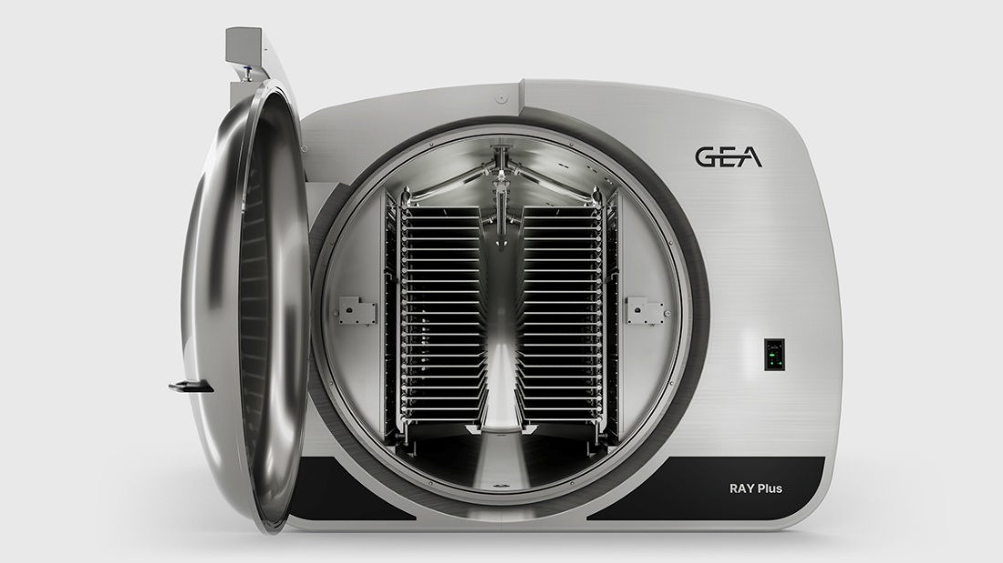

Pic. 2: The new GEA RAY® Plus series offers a size range of 45m² to 180m² per cabinet with heating plates in layers of 10, 15, or 20, and condensers on both sides. Source: GEA

NOTES TO THE EDITORS

* Further [information](https://www.gea.com/en/index.jsp) about GEA
* To the GEA [Media Library](https://www.gea.com/en/company/media/media-center/index.jsp)
* [**Features**](https://www.gea.com/en/company/media/features/index.jsp) on current topics
* Overview [press events](https://www.gea.com/en/company/media/events/index.jsp)
* Follow GEA on [](https://www.linkedin.com/company/geagroup/) [](http://www.youtube.com/user/TheGEAGroup)

Media Relations

GEA Group Aktiengesellschaft

Nicole Hoffmann

Peter-Müller-Str. 12, 40468 Düsseldorf, Germany

Phone +49 211 9136-1503

nicole.hoffmann@gea.com

**About GEA**

GEA is one of the world’s largest suppliers of systems and components to the food, beverage and pharmaceutical industries. The international technology group, founded in 1881, focuses on machinery and plants, as well as advanced process technology, components and comprehensive services. With more than 18,000 employees, the group generated revenues of about EUR 5.4 billion in more than 150 countries in the 2023 fiscal year. GEA plants, processes, components and services enhance the efficiency and sustainability of customer’s production. They contribute significantly to the reduction of CO2 emissions, plastic usage and food waste. In doing so, GEA makes a key contribution toward a sustainable future, in line with the company’s purpose: ”Engineering for a better world“.

GEA is listed on the German MDAX the European STOXX® Europe 600 Index and is among the companies comprising the DAX 50 ESG, MSCI Global Sustainability as well as Dow Jones Sustainability World and Dow Jones Sustainability Europe Indices.

More information can be found online at **gea.com**.  
If you do not want to receive any further information from GEA, please send an e-mail to **pr@gea.com**.