Digitalization – Service by Performance Partnership

# GEA introduces a new digital condition monitoring solution for the dairy and beverage industry

Düsseldorf (Germany), September 11, 2025 – GEA has launched its new digital service product, **GEA InsightPartner® EvoHDry**, an advanced condition monitoring tool designed to improve production reliability and operational efficiency in dairy and beverage plants. The system has been engineered specifically for complex industrial environments, where uninterrupted operation is essential for producing high-quality products such as infant formula, cream, evaporated milk, condensed milk, and cheese.

**Condition-based monitoring of critical plant components**

[GEA InsightPartner® EvoHDry](https://www.gea.com/en/products/evaporators-crystallizers/condition-monitoring-insightpartner-evohdry/) applies real-time condition monitoring, a maintenance approach based on continuous collection and analysis of machine data to detect early warning signs of equipment degradation. Parameters such as temperature, pressure, vibration, and flow are tracked in real time, giving operators a clear view of system performance. The solution offers an App and web-based component status to receive real-time information on machine health. In the dairy sector, one of the most frequent causes of unplanned downtime is a gradual loss of suction pressure in vacuum pumps within evaporation systems. This condition reduces evaporator efficiency, causing output to fall below target performance thresholds and potentially forcing an unplanned shutdown. Failures of this kind are commonly linked to dry running, wear in pump components, or lubrication loss when product contamination occurs. GEA InsightPartner® EvoHDry employs predictive analytics to recognize these patterns early and generate pre-alarm notifications that prompt intervention before a critical failure takes place.

**Tackling industry-wide maintenance challenges**

Beyond specific equipment failures, many dairy and liquid plants face broader operational challenges. Modern process plants rely heavily on SCADA systems (Supervisory Control and Data Acquisition) to monitor operations, but the number of alarms generated can overwhelm operators, making it difficult to filter and prioritize issues. At the same time, shortages of skilled technicians mean fewer personnel are available to interpret alarms or carry out diagnostics. Traditional manual checks consume time and resources, while the absence of an integrated view of machine health often forces teams into reactive, emergency-driven maintenance. GEA InsightPartner® EvoHDry addresses these problems by combining expert maintenance guidance with data-driven decision-making. Through real-time insights and predictive trends, operators can focus on the most critical issues, optimize maintenance schedules, and keep production on track.

**State of the art technical setup**

The technical setup of GEA InsightPartner® EvoHDry is designed for both accuracy and security. It includes market-leading sensors for vibration, flow, and pressure, as well as links, cables, and an edge gateway – a local computing device that collects and preprocesses data before sending it to the cloud. By processing data locally, the gateway ensures rapid response times and reduces dependence on external networks. The system operates independently of the customer’s IT infrastructure, so no direct access to plant networks is required, minimizing cybersecurity risks. Once preprocessed, data is transferred securely to the GEA Cloud and GEA Portal, where GEA’s proprietary modeling algorithms evaluate equipment condition. Certified vibration specialists then validate diagnostics, adding human expertise to automated analysis.

**According to Angela Yeung, Digital Portfolio and Strategy Lead for Liquid & Powder Technologies at GEA, the system offers significant operational benefits: *“Unplanned downtime remains the biggest challenge for dairy processors. By using predictive insights, customers can intervene before failures occur, reducing costs and improving efficiency. With* GEA InsightPartner® EvoHDry*, operators gain clear insight into machine health. Instead of reacting to unexpected shutdowns, they can plan maintenance based on reliable diagnostics—keeping production stable and output consistent.”***

**Seamless integration of OEM expertise**

The solution draws on GEA’s role as an Original Equipment Manufacturer (OEM), embedding decades of equipment and process expertise directly into its digital services. GEA InsightPartner® EvoHDry has been tailored for evaporators, , spray dryers, pumps, and rotating equipment, with monitoring extending from the vacuum stage through to CIP (Clean-in-Place) cycles, providing full coverage of peripheral systems. By aligning maintenance schedules with predictive recommendations, operators can extend equipment lifespan, minimize costs linked to downtime, and stabilize long-term production performance.

**GEA Service – Performance Partnership**

GEA InsightPartner® EvoHDry is part of the broader GEA Service Performance Partnership, which integrates digital tools with GEA’s service expertise to support plant operators in improving availability, productivity, and sustainability. By embedding advanced diagnostics and predictive analytics into dairy and beverage production, GEA aims to give manufacturers a more proactive, data-based pathway to operational reliability.

**GEA at drinktec in Munich**

At drinktec in Munich GEA customers and interested parties will have the opportunity to discuss this new digital solution and its advantages with technology experts.

**GEA at drinktec in Munich (Germany)**

**September 15 - 19, 2025**

**Hall B5 | Booth 539**

[gea.com](https://www.gea.com/en/)

Picture Overview [(Download link)](https://assets.gea.com/gea/action/viewDownloadSharedAsset?shareId=dd412aa5-767e-48c3-b122-949a86ed203a)

**Pic. 1:** GEA InsightPartner® EvoHDry – The new digital service delivers real-time diagnostics, pre-alarm notifications, and expert maintenance guidance to reduce unplanned downtime in evaporation, drying, and liquid systems. Source: GEA / Getty Images

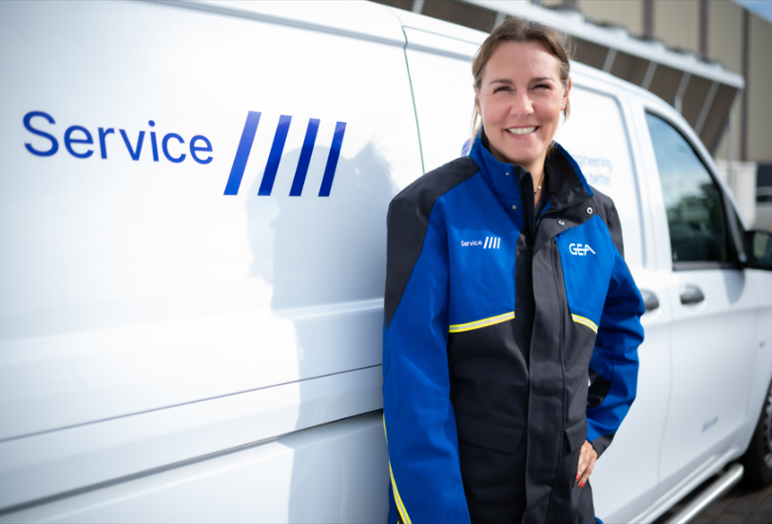**Pic. 2**: GEA InsightPartner® EvoHDry is part of the broader GEA Service Performance Partnership, which integrates digital tools with GEA’s service expertise to support plant operators. Source: GEA

NOTES TO THE EDITORS

* Further [information](https://www.gea.com/en/index.jsp) about GEA
* To the GEA [Media Library](https://www.gea.com/en/company/media/media-center/index.jsp)
* [**Features**](https://www.gea.com/en/company/media/features/index.jsp) on current topics
* Overview [press events](https://www.gea.com/en/company/media/events/index.jsp)
* Follow GEA on [](https://www.linkedin.com/company/geagroup/) [](http://www.youtube.com/user/TheGEAGroup)

Media Relations

GEA Group Aktiengesellschaft

Nicole Hoffmann

Ulmenstraße 99, 40476 Düsseldorf, Germany

Phone +49 211 9136-1503

nicole.hoffmann@gea.com

**About GEA**

GEA is one of the world’s largest suppliers of systems and components to the food, beverage and pharmaceutical industries. The international technology group, founded in 1881, focuses on machinery and plants, as well as advanced process technology, components and comprehensive services. For instance, every second pharma separator for essential healthcare products such as vaccines or novel biopharmaceuticals is produced by GEA. In food, every fourth package of pasta or every third chicken nugget are processed with GEA technology. With more than 18,000 employees, the group generated revenues of about EUR 5.5 billion in more than 150 countries in the 2024 fiscal year. GEA plants, processes, components and services enhance the efficiency and sustainability of customers’ production. They contribute significantly to the reduction of CO2 emissions, plastic usage and food waste. In doing so, GEA makes a key contribution toward a sustainable future, in line with the company’s purpose: ”Engineering for a better world.”

GEA is listed on the German MDAX, the European STOXX® Europe 600 Index and is also a constituent of the leading sustainability indices DAX 50 ESG, MSCI Global Sustainability and Dow Jones Best-in-Class World.

More information can be found online at **gea.com**.  
If you do not want to receive any further information from GEA, please send an e-mail to **pr@gea.com**.

**About the GEA Foundation**

The GEA Foundation, established in 2025 by GEA Group, supports global and local projects in STEM education, child poverty reduction, infrastructure access and disaster relief. Through its Mission 30 strategy, GEA commits to donating one percent of annual net profit to build resilient communities.

More information can be found online at [gea.com/foundation](https://www.gea.com/en/company/gea-foundation/).