PRESS RELEASE
Schwaebisch Hall, September 5, 2022

OPTIMA develops fuel cell manufacturing technology further
The state of Baden-Wuerttemberg is funding the construction of a new test system in Schwaebisch Hall with the “Future Program Hydrogen BW”

Fuel cells generate electricity from hydrogen through an electrochemical process. Efficient manufacturing processes for fuel cells are a crucial topic. Optima Life Science, a specialist in the field of web processing technologies, is currently developing a test converter specifically for the development and testing of innovative manufacturing processes for fuel cells. Therefore, the company receives considerable funding from the state of Baden-Wuerttemberg.
Optima Life Science already offers production systems for fuel cells with a high output. Building on this experience, the company is currently developing a modular test converter. Innovative ideas and process optimizations, as well as product developments can thus be implemented quickly and easily. In the future, production processes for fuel cells will first be verified in a development environment and then transferred to high-performance systems.

Test converter: Implement ideas, accelerate development

Further developments in fuel cell technology will foreseeably always require new structures and dimensions of the fuel cells and thus also of the membrane electrode assembly (MEA). The need for development and refinement of manufacturing processes is in high demand. The OPTIMA MTC (Modular Test Converter) is just designed for this purpose. The adaptable arrangement of the different processes, the reconfiguration and the addition and removal of process steps become reality. Individual processes and complex process sequences, up to the finished MEA for the fuel cell can be tested.

Another benefit is the reduced economic risk when product development and manufacturing process development can go hand-in-hand. Ideas for process and product optimization can also be implemented quickly and validated in the course of product development. The knowledge gained can quickly be implemented into production. Last but not least, sampling and small series production can take place on the OPTIMA MTC system.

Complex processes

The heart of the fuel cell is the membrane electrode assembly. Hydrogen and oxygen are present and electrical energy and water are produced in an electrochemical reaction. The individual components such as membranes, frame material and gas diffusion layers are each fed from the roll in Optima systems. Individual parts are cut to size and assembled into the MEA in the complex, continuous web process. In order for the fuel cells to achieve the desired level of efficiency, all process steps require maximum precision.

In addition to the manufacturing technologies required for MEA production, Optima offers the traceability of each individual MEA with its digital solutions.

Experiences from projects that have already been implemented and inquiries from the hydrogen industry showed that there is an enormous need for product and process development. Optima Life Science responds to this request by developing and building the OPTIMA MTC test converter.

Funding from the “Future Program Hydrogen BW”

To exploit the full potential of production methods and to support the rapid growth of this future technology, Optima received funding from the state of Baden-Wuerttemberg. As part of the "Future Program Hydrogen BW", the Ministry of the Environment, Climate Protection and the Energy Sector has been funding a total of 20 projects of hydrogen and fuel cell technologies since the beginning of 2022. The state government is providing budgetary funds of 26.4 million Euros for the development of this technology.

At the f-cell in Stuttgart, the leading international trade show and conference for hydrogen and fuel cell technologies, Optima will present current solutions for fuel cell and electrolysis production on October 4 and 5, 2022 (booth no. 2A37 in hall C2).

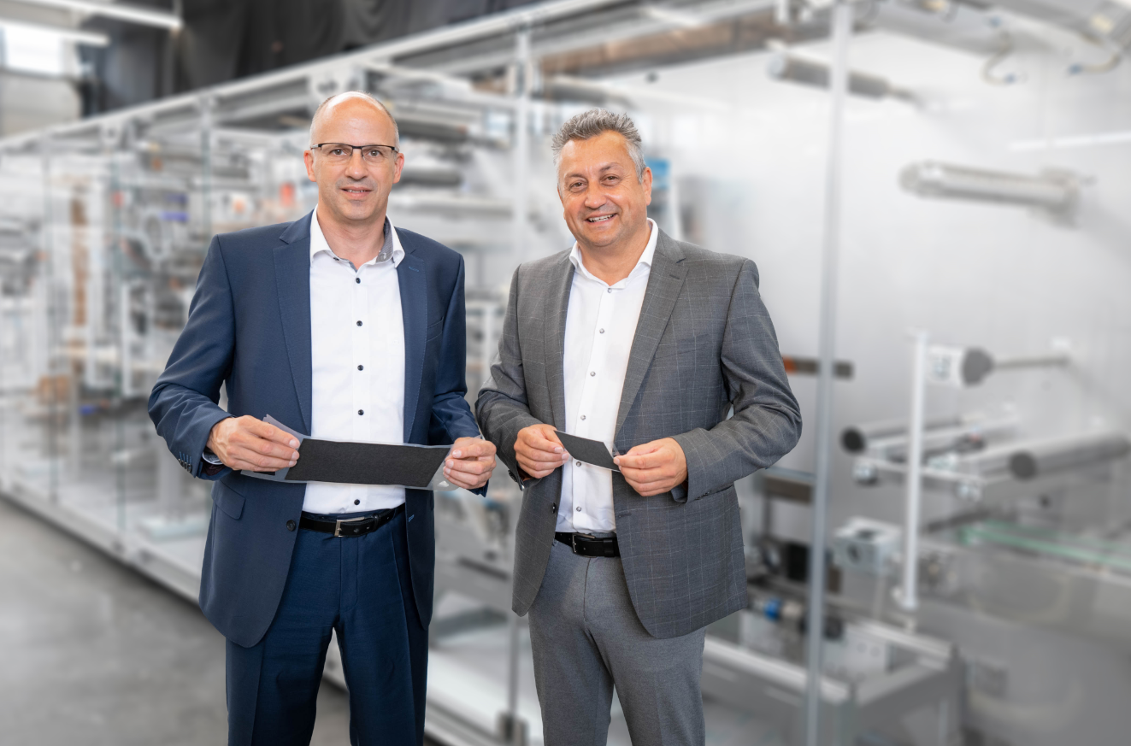 Optima Life Science receives state funding that goes into the development of a test converter. The funding supports new ideas and manufacturing processes for fuel cells that can be quickly implemented, optimized and validated. Juergen Bareiss (Head of the Optima Life Science business unit, right) and Werner Volk (Business Development Manager at Optima Life Science) present finished membrane electrode assemblies (MEAs). (Source: Optima)

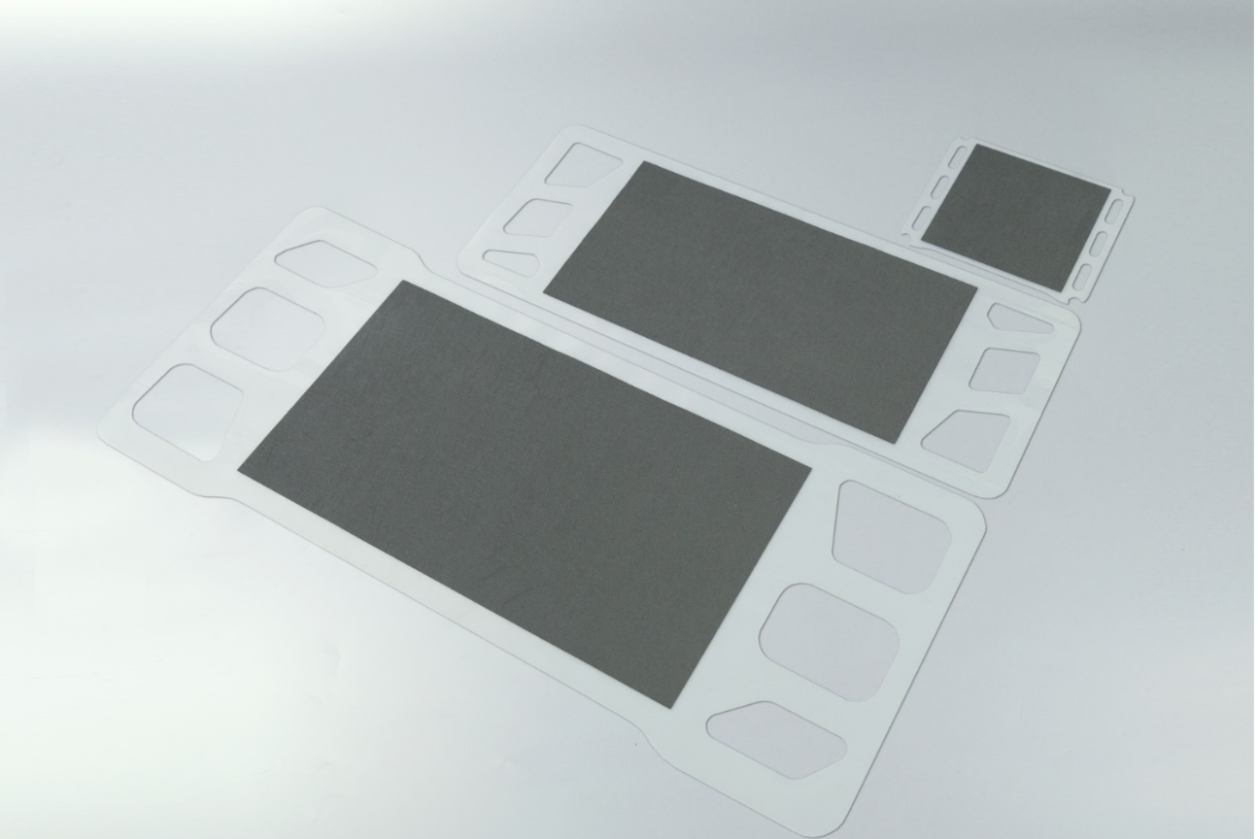 The heart of the fuel cell is the membrane electrode assembly (MEA). The individual components such as membranes, frame material and gas diffusion layers are brought together on Optima systems. (Source: Optima)

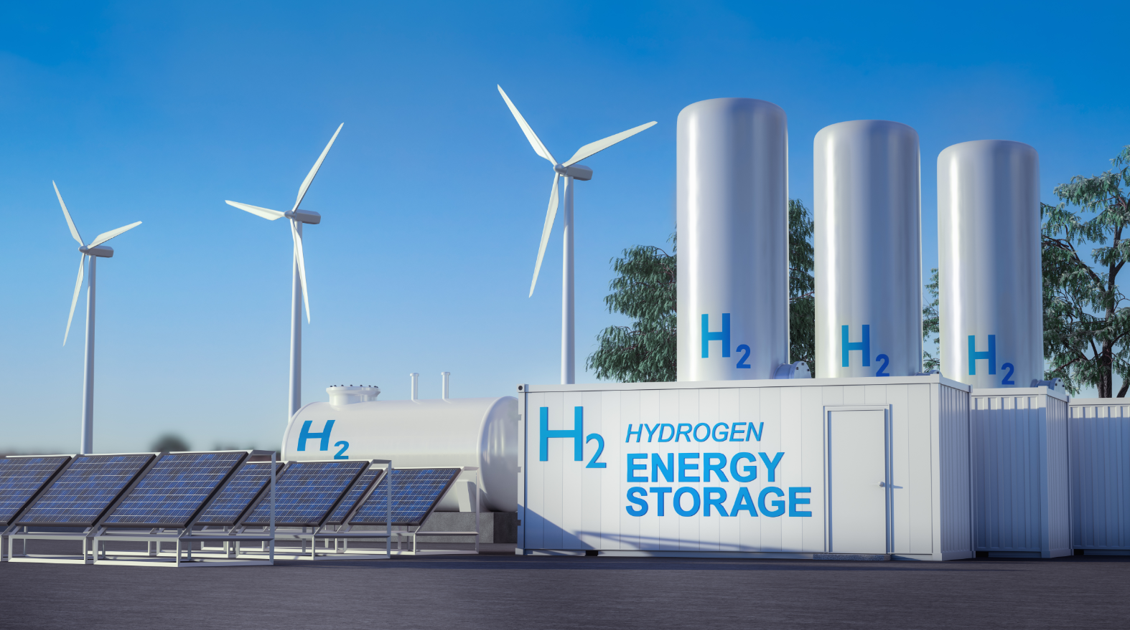
A plant for storing hydrogen. Within the framework of the "Future Program Hydrogen BW", the Ministry of the Environment, Climate Protection and the Energy Sector Baden-Wuerttemberg has been funding a total of 20 projects of hydrogen and fuel cell technologies since the beginning of 2022. (Source: shutterstock.com/Sahara Prince)

Characters (incl. spaces): 3,949

Press contact:
OPTIMA packaging group GmbH
Jan Deininger
Group Communications Manager
+49 (0)791 / 506-1472
jan.deininger@optima-packaging.com
www.optima-packaging.com

About OPTIMA
Optima supports companies worldwide with flexible and customer-specific filling and packaging machines for pharmaceuticals, consumer goods, paper hygiene and medical devices markets. As a provider of solutions and systems, Optima accompanies these companies from the product idea through to successful production and throughout the entire machine life cycle. Over 2,800 experts around the globe contribute to Optima's success. 20 locations in Germany and abroad ensure the worldwide availability of services. In 2022, Optima celebrates the company's 100th anniversary.
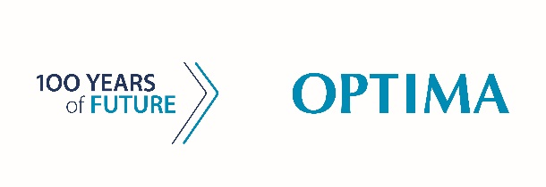
Exciting stories from 100 years of Optima: www.100-years-of-future.com

Thank you very much for your publication. We look forward to receiving a digital specimen copy.

