Safely turning heavy parts with Universal Cranes
Demag: maximum safety when turning loads

- New function in the Demag universal crane portfolio
- Safe crane operation thanks to the SafeControl system
- Versions up to performance level d, category 3 possible

Wetter, Germany, 13 October 2020. Demag has introduced a new standard function for its Universal Crane product range: With an optional package of features, crane installations can now be equipped with a load-turning function that achieves maximum safety – no longer with the need for any additional engineering. The additional costs are modest, the benefits are high. This is made possible, in part, by monitoring the entire load turning process using the Demag SafeControl safety control unit.
Every so often, many users of indoor cranes are faced with the complex task of not only lifting and horizontally moving heavy components such as press tools, machine beds or special containers, but turning them, too.

This function has been possible with Demag cranes for decades, however, this function required additional engineering that should not be underestimated. Demag has standardised the "load turning" option to such an extent that it requires significantly less individual engineering work for universal cranes with two hoists without impairing the acknowledged high level of safety. The customer thus benefits from the highest level of safety and functionality at an attractive price. With this package solution at this level of safety, Demag has a unique selling point on the crane market.
The package of features enabling the ‘turning of loads’ function includes more generous specification of the steel structure and the equipment with additional sensors. In addition, the Demag SafeControl system, which provides safety-orientated control and monitoring of all crane motions and functions, has been modified for the load turning process.

Depending on the requirements for the size of the rope hoists, an inclined angle of pull of up to 20 degrees can be achieved. With the universal cranes modified in this way, loads weighing up to 50 t can be turned.

The user can choose between two safe versions. Precise measurement of the rope angle is achieved by combining the Demag SafeControl system with a two-channel, non-contact sensor system. With the basic version, an acoustic and visual warning is given as soon as the maximum deflection angle is reached.

In the safest configuration, the Demag SafeControl system monitors all motion sequences in terms of safety and automatically stops lifting and travel motions if the maximum permissible rope angle is exceeded. A high safety category is achieved: Performance Level d (lifting) or c (travelling) to EN 13849-1, category 3.

On both variants, the load turning function is wirelessly operated by joystick transmitters as standard, allowing intuitive control while keeping an eye on the load to be turned. Alternatively, control is also possible via hand-held button transmitters or hand-held transmitters with mini-joystick operating concept.
With this option, Demag offers tool and mould manufacturers in addition to companies that produce and use special machines and installations an interesting special function in crane operation that is both safe and easy to implement.

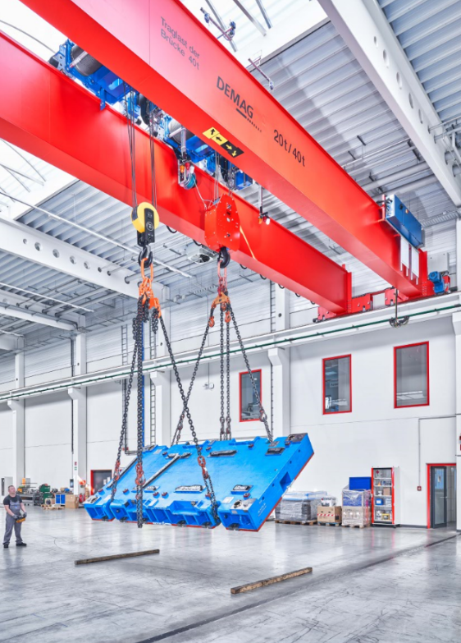
Contact for product and trade media:
Christoph Kreutzenbeck
Demag Cranes & Components GmbH
Wetter Site
Ruhrstrasse 28
58300 Wetter/Ruhr, Germany
Phone: +49 2335 92 3907
Email: christoph.kreutzenbeck@demagcranes.com

