Baroque meets Bauhaus
Discover ‘Neues Bauen’ in the Bauhaus style in Celle

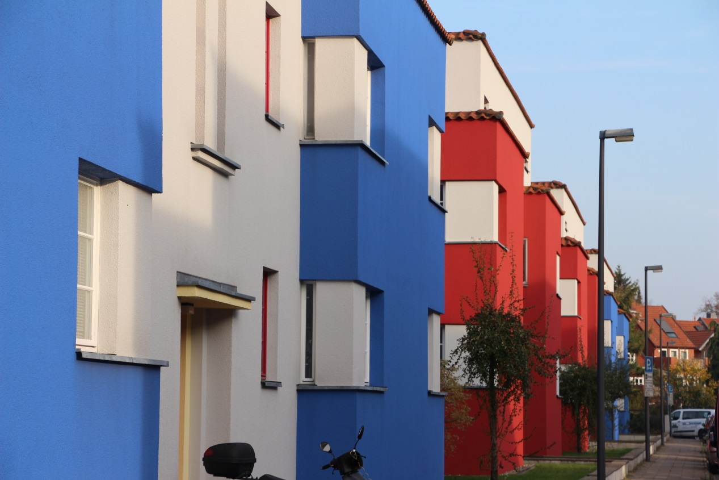
Discover ‘Neues Bauen’ in the Bauhaus style in Celle (Copyright: Celle Tourismus und Marketing GmbH)

CELLE | With over 490 colourful half-timbered houses, Celle presents the largest compact ensemble of its kind worldwide and is one of the most splendid towns in Germany. The picturesque Guelph Palace and the modern 24-hour art museum located next to the impressive Bomann Museum in the Old Town are well-known. Less well-known, however, is that Celle is effectively the birthplace of ‘Neues Bauen’ (‘New Objectivity’ – modern functional building design) and with regard to Bauhaus architecture it ranks in the same league as the towns of Weimar and Dessau.

This is the case, not only in terms of the quantity of the beautifully preserved buildings which are still partially used for their original purpose, but also in terms of quality, such as the ‘Altstädter Schule’ which in the 1920s came to international fame as the ‘Glass School’, attracting visitors from all over the world. The number of visitors was so great that the school management was forced to restrict visiting hours to Thursday afternoons and Saturday mid-mornings and to charge 50 pfennigs entry fee which was used to buy milk for the pupils.
The ‚Glass School’ which is used to this day as an elementary school is recognized as one of the most important Bauhaus buildings worldwide and is a UNESCO-worthy object. Celle has the largest density of Bauhaus architecture nationwide and owes its global architectural significance regarding Bauhaus to the architect Otto Haesler. During the Weimar Republic (1919 - 1933), through the use of innovative and technically constructive elements, combined with a consequent commitment to socially compatible functionality, and at a time of enormous financial pressure, he seized on the post-war spirit which was characterized by a housing shortage and perfected social housing.

Through his clear design language, the use of primary colours as well as the incorporation of steel-tube furniture which was produced in Celle, Haesler belongs, alongside Walter Gropius and Hannes Meyer, to the pioneers and forerunners of ‘Neues Bauen’ or Bauhaus architecture.

Many of these building projects such as the colourful, impressive red and blue houses in the ‘Italienischer Garten’ estate as well as other Haesler buildings like the ‘Director’s House’ and the Haesler Museum where attention to detail has been placed, are open to the public.

Thematic tour: Bauhaus architecture – from Italienischer Garten to the ‘Glass School’
Our tour at the edge of Celle’s Old Town leads to the buildings designed by Otto Haesler. He was one of the first German architects to replace the traditional brick construction method by a steel frame construction method. His housing estates designed for families with a modest income as well as the ‘Glass School’ and the ‘Director’s House’ served as models for modern architecture. They are significant examples of the ‘Neues Bauen’ phase during the Weimar Republic.
Various Bauhaus guided tours, on foot and on bicycle are available. There is also a digitally supported circular route to the Haesler buildings where visitors will receive further information about all individual objects via a QR code at certain points.

Due to its Bauhaus architecture, built by Otto Haesler, the city of Celle is part of the Grand Tour of Modernism - an itinerary specifically designed to celebrate the Bauhaus centenary. This makes Celle one of around 100 sites which are selected on the basis of their cultural heritage and linked up in an appealing travel route. This major centenary campaign launched by the Bauhaus Association 2019, an alliance of the three state-owned Bauhaus sites in Germany, takes the interested visitors to the history of modernism between 1900 and 2000 and can well be experienced by train, by car or by bike.
Further information about guided tours in Celle is available from:
Guided tour service
Markt 14 - 16
29221 Celle
Tel.: +49 5141 9090816
fuehrungen@celle-tourismus.de
(3.917 letters)
# # #

Please send us a voucher copy after publication.
You will find picture material and further information on our website. Should you require additional picture material, please contact us.
www.celle-tourismus.de
celle.travel

