## LAUDA world market leader for the ninth time

### Assertiveness despite economic challenges

Lauda-Königshofen, December 11, 2024 – LAUDA DR. R. WOBSER GMBH & CO. KG has been recognized as the global market leader in the field of “Constant temperature equipment and systems for precise temperature control” for the ninth time. The renowned “Global Market Leader Index”, which is determined under the direction of Prof. Dr. Christoph Müller of the University of St. Gallen, Switzerland, forms the basis for the annual award by the leading business magazine “WirtschaftsWoche”.

Dr. Gunther Wobser, President & CEO of LAUDA, emphasizes the importance of this award: “The renewed recognition as world market leader fills us with great pride, especially in this challenging year. It underlines the outstanding performance of our employees at three German sites and eleven foreign subsidiaries. Together, we will continue to pursue our vision of improving the world with precise temperatures.”

Despite ongoing global challenges such as geopolitical tensions, inflation and recession risks, LAUDA has defended its market position. The company is consistently focusing on strategic measures in the areas of digitalization, professionalization of service, customer proximity in sales and the development of an exemplary production and logistics concept.

“As a family business, we act for the long term,” Dr. Wobser emphasizes. “Our success is based on the balance between tradition and innovation. It is satisfying to contribute to solving global challenges with our technologies.”

Being named world market leader once again confirms the role of LAUDA as an innovation driver and sales leader in the industry. The company continuously invests in research and development to expand and optimize its product range. Special attention is paid to energy-efficient solutions and the support of sustainable technologies.

In the coming years, LAUDA will continue to expand its international presence and open up new markets. The world market leader is focusing on strategic partnerships and the expansion of its global sales network.

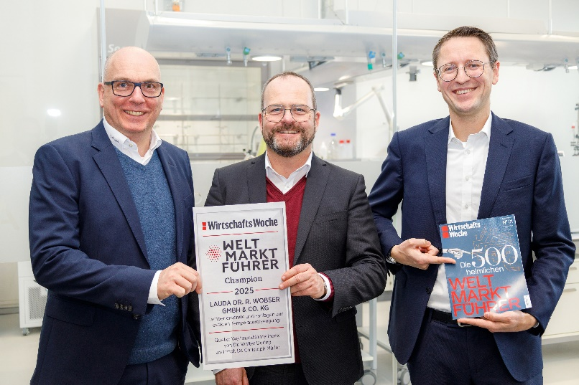

**Fig.:** LAUDA Managing Directors Dr. Marc Stricker, Dr. Gunther Wobser and Dr. Mario Englert (from left to right) are delighted to have once again been named world market leader. Despite a challenging year, they are optimistic about the future and continue to focus on innovation and global growth. © LAUDA

**We are LAUDA** –the world leader in precise temperature control. Our constant temperature equipment and systems are at the heart of important applications, contributing to a better future. As a complete one-stop supplier, we guarantee the optimum temperature in research, production and quality control. We are the reliable partner for electromobility, hydrogen, chemicals, pharmaceuticals/biotech, semiconductors and medical technology. We have been inspiring our customers for almost 70 years with our expert mentoring and innovative solutions – every day anew and all over the world.

In our company, we always go one step further. We support our employees’ development and are constantly developing ourselves: to create a better future together.

**Press contact**

We are more than happy to make prepared information about our company, the LAUDA Factory Gallery and our projects in the area of innovation promotion, digitalization and idea management available to the press. We look forward to hearing from you – just give us a call!

CHRISTOPH MUHR

Director Corporate Communications

T + 49 (0) 9343 503-349

[christoph.muhr@lauda.de](mailto:christoph.muhr@lauda.de)

LAUDA DR. R. WOBSER GMBH & CO. KG, Laudaplatz 1, 97922 Lauda-Königshofen, Deutschland/Germany. Limited partnership: Headquarters Lauda-Königshofen, Registration court Mannheim HRA 560069. General partner: LAUDA DR. R. WOBSER Verwaltungs-GmbH, Headquarters Lauda-Königshofen, Registration court Mannheim HRB 560226. Managing Directors: Dr. Gunther Wobser (President & CEO), Dr. Mario Englert (CFO), Dr. Marc Stricker (COO)