PRESS RELEASE
Schwaebisch Hall, July 9, 2020

Smarter packaging
Makeathon participants are developing solutions for more sustainable recycling economy

Taking part in the Packaging Valley Remote Makeathon on June 25 and 26, students and young professionals at Optima developed three potential solutions for more sustainable recycling economy. Because of the Corona pandemic, the development competition was decentralized and held at a variety of locations.
On June 25 and 26, the packaging clusters Packaging Valley e.V. and Packaging Excellence Region Stuttgart e.V., supported by the company ITQ, organized the 1st Packaging Valley Remote Makeathon. This neologism, created out of “to make” and “marathon”, describes a collaborative competition for developing software and hardware, held within a specific period of time. Students, young professionals and technology enthusiasts met at different locations to work together on solutions for digitalization and sustainability in packaging machine construction. All the participants were connected via digital platforms, and at the end they presented their ideas, solutions and developments.

Three solutions for environmentally friendly packaging

In Optima's new Digital Innovation Center, the participants devised three solution approaches for a more environmentally friendly recycling business. Using the slogan "Talking Foods – Smart minimization of food waste", the students presented a "dynamic tag" to replace what up till now has been the customary barcode on food packaging to inform retailers and consumers about stock levels, and so provide prompt notification of potential spoilage. Another idea was standardized reusable packaging with built-in data chips that are centrally manufactured and reprocessed. These promise logistics gains, make centralized recycling possible, and through the data storage that is integrated, create transparency about stock levels. The third team developed a prototype for a "fully automated non-packaged loading". After the desired weight has been entered, the bulk material, for instance coffee beans, is dispensed into reusable containers.

Cooperation with mechanical engineering companies and food companies is envisaged

For the next step, the participants are planning to do market research and begin close cooperation with all companies involved in the value chain – from packaging machinery manufacturers to food companies. This is how they intend to continue to grow their projects and integrate them into the recycling economy over the long term.

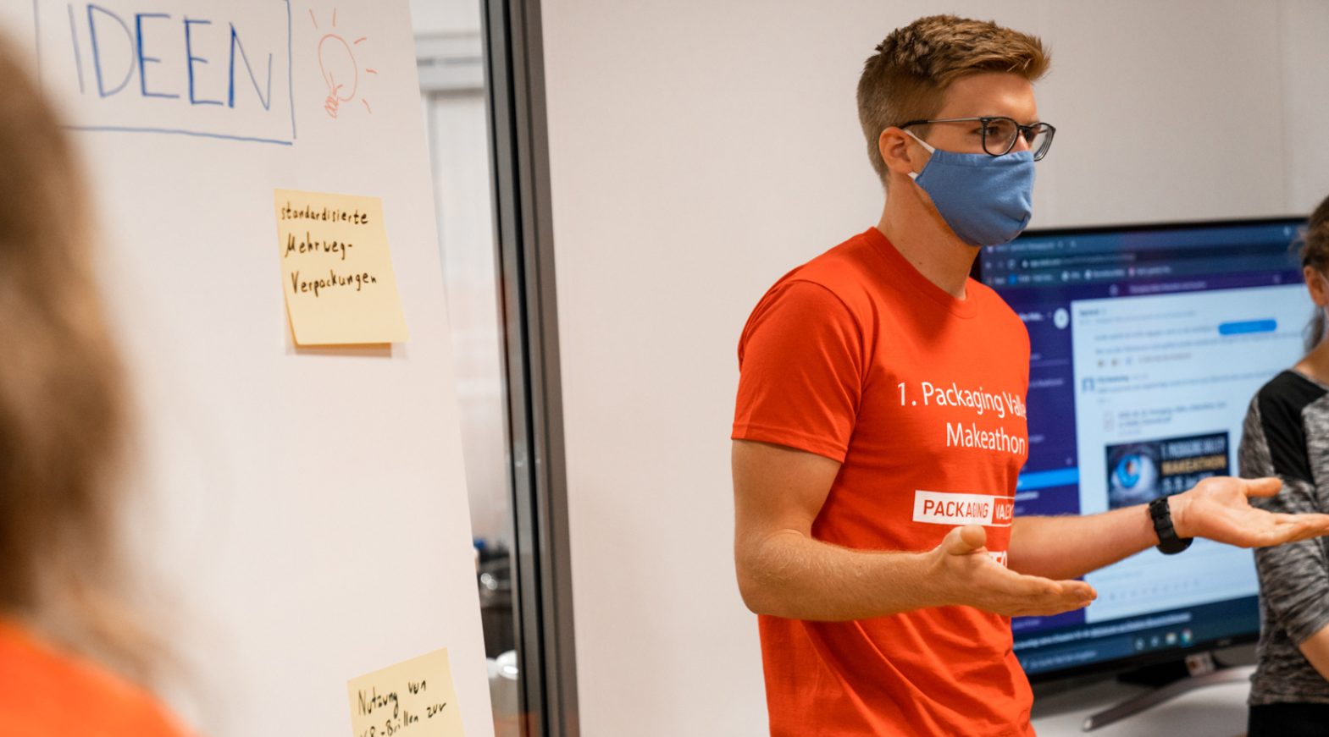
At the outset, ideas are gathered jointly before work on the project begins. (Source: Optima).

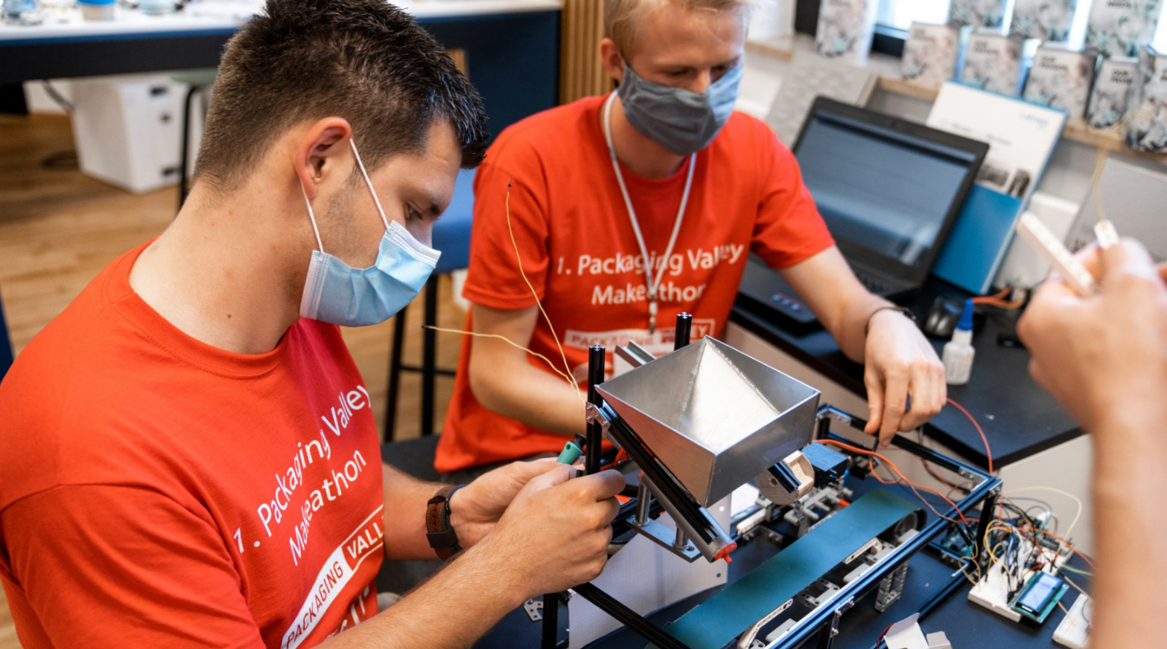
One of the project teams is working on a miniature machine for filling bulk material into returnable containers. (Source: Optima)

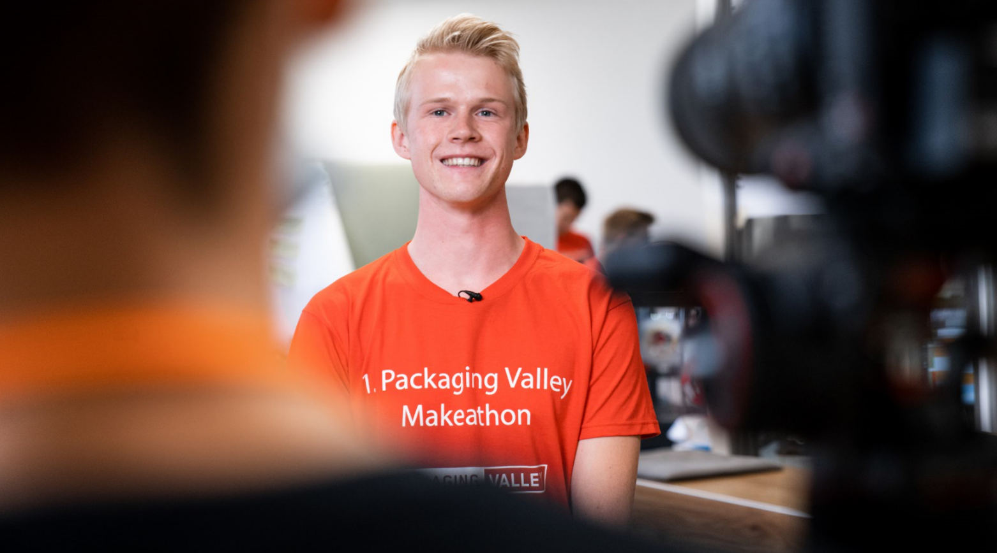
Those taking part in the Makeathon exchanged information with each other via video link. Due to the Corona pandemic, the development competition was decentralized and took place at a variety of locations. (Source: Optima).

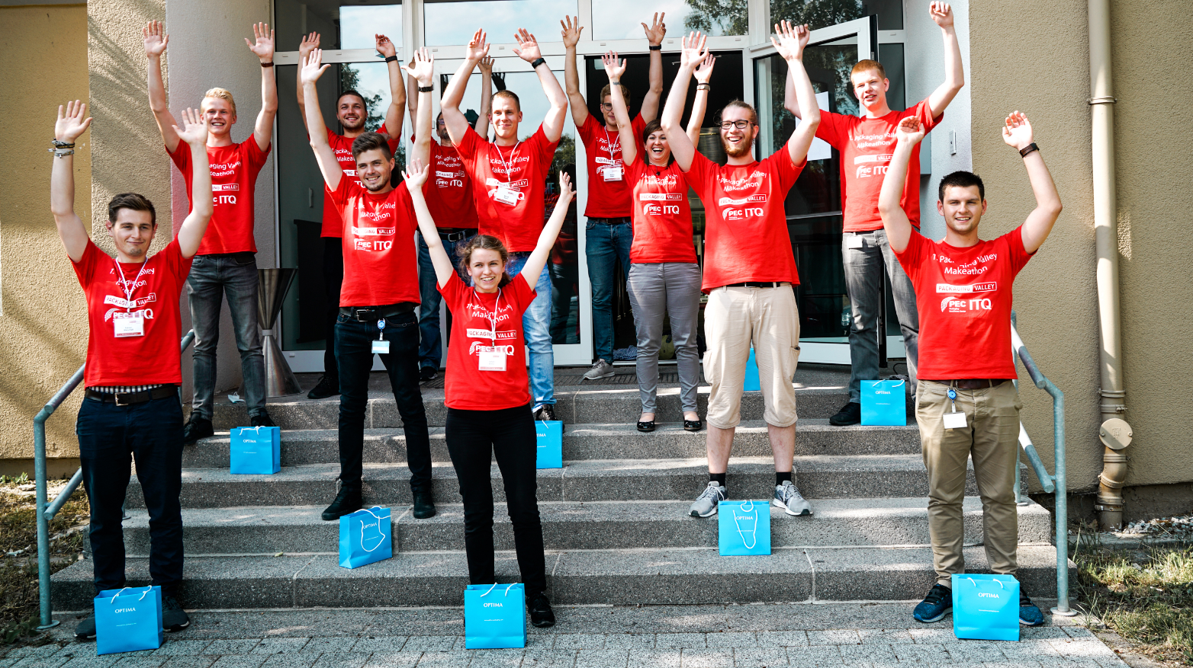
The Makeathon participants are pleased with their results after two eventful days. (Source: Optima)

Characters (incl. spaces): 2,498

Press contact:
OPTIMA packaging group GmbH
Jan Deininger
Editor
+49 (0)791 / 506-1472
jan.deininger@optima-packaging.com
www.optima-packaging.com
Thank you very much for your publication. We look forward to receiving a specimen copy.

