LAMILUX Heinrich Strunz Group Annual Report

LAMILUX holds its ground in a challenging environment

2024 was an eventful year for the LAMILUX Heinrich Strunz Group, characterised by global crises and economic uncertainties. While the German economy recorded a decline of -0.2 percent, companies were confronted with rising energy costs, increasing bureaucracy and cautious consumer behaviour. Despite these difficult conditions, LAMILUX was able to increase sales by 0.9 percent to EUR 357 million and increase the number of employees to 1,335, including 91 trainees. A key factor in this success was the company’s consistent focus on customer needs, enabling LAMILUX to reach important milestones. Particularly noteworthy are the record sales in the skylight systems segment and the successful securing of the market position in the respective business areas.

People as a key to success: development and support at LAMILUX
The commitment and expertise of its employees are central to LAMILUX’s success. In 2024, the company increased its staff from 1,276 to 1,335 – a clear indicator of sustainable growth. LAMILUX aims to create an environment that fosters both professional and personal development for its employees.
However, it is not only experienced specialists who benefit from the development opportunities - young talent also plays a key role. With a consistently high training rate of seven percent, LAMILUX underlines its responsibility for the next generation. The award-winning EDUCATION for EXCELLENCE (E4E) training programme is a particular flagship. It goes far beyond traditional specialist training and places a strong focus on personal development.
Established employees also benefit from targeted development opportunities. In 2024, a new round of TRAINING for EXCELLENCE was launched, offering tailored pathways for experts and leaders – whether in specialist roles, leadership positions, or project-based careers. The programme’s content supports both individual growth and the overall success of the company.
This commitment to a positive workplace culture was officially recognised in 2024: the employer review platform kununu named LAMILUX a Top Company 2024 – an accolade awarded to only five per cent of companies on the platform.

Strong market position through customer focus and innovation
‘Together with our committed and efficient team and a clear growth strategy, LAMILUX has not only managed to grow in terms of turnover, but also increased market share further strengthening our position, even in a difficult market environment,’ says Dr Alexander Strunz, Managing Director of LAMILUX. Over the past ten years, the family-owned company has achieved sales growth of around 88 percent. This success is the result of the consistent implementation of the customer-centric Customised Intelligence (CI) philosophy, which always focuses on customer benefit. LAMILUX not only fulfils the wishes of its customers, but also offers them individual solutions for their specific requirements.
‘By focusing on technical innovations, process optimisation and cross-business model solutions as well as the high level of expertise in both divisions, we have not only been able to assert ourselves as a performance leader, but have also established a solid market position through continuous further development,’ summarises Johanna Strunz, Managing Director of LAMILUX, looking back. LAMILUX offers customised products and solutions that create added value and make the family business a preferred partner for many companies.

Skylights
The Skylight division once again demonstrated its innovation leadership in 2024. With future-oriented products and a clear focus on the diverse needs of its customer groups - from architects and planners to construction companies and specialist dealers - the company has provided significant impetus, which was reflected not least in the record turnover.
A highlight was its successful participation at DACH+HOLZ 2024, where under the motto ‘MISSION: FLAT ROOF’, LAMILUX impressed with an engaging exhibition stand, expert lectures, and a captivating competition for master roofers.
Also noteworthy is the 2024 Plus X Award in the category ‘Germany’s Highest Customer Satisfaction’, recognising LAMILUX’s exceptional commitment to customer service. In a time when digital transformation often challenges customer advisory and after-sales services, LAMILUX goes beyond satisfaction to truly exceed expectations.
‘We are very happy about every single recognition! They confirm our endeavour to always inspire our customers beyond the desired level. For many decades, we have been following our company philosophy ‘Customised Intelligence - Serving the customer as a programme’. This philosophy is more than just a maxim - it forms the basis of everything we do,’ says Dr Alexander Strunz, Managing Director of LAMILUX.
LAMILUX recorded solid growth in all product groups - particularly in the field of glass architecture. The LAMILUX Modular Glass Skylight MS78 launched in 2023 also proved to be an important driver of this development and provided valuable impetus on the market.
The continuous further development of the products is reflected not only in their commercial success, but also in their recognition by the industry. For example, the LAMILUX Modular Glass Skylight MS78 was honoured with the renowned Red Dot Design Award for its successful combination of aesthetic design and technical excellence. This honour underlines LAMILUX's claim to create innovative and pioneering solutions for skylight systems.

Composites
The composites sector can look back on a year of challenging market conditions. While the US market recovered slightly, growth fell short of expectations. In Europe and Australia, LAMILUX also recorded a noticeable decline in sales. "As a premium provider, we are faced with the challenge that price is playing an increasingly central role for many customers. This makes it all the more important to clearly communicate our added value," explains Johanna Strunz, Managing Director of LAMILUX.
In order to maintain its market position, LAMILUX 2024 has made targeted investments in its business units and taken extensive measures in sales and technology. The New Business Development and Building and Construction business units in particular have helped to open up new markets and further expand existing segments. LAMILUX was also able to present its innovative solutions for fibre-reinforced plastics to an international audience by participating in leading industry trade fairs such as the Caravan Salon Düsseldorf and the IAA Transportation in Hanover.
One example of LAMILUX's innovative strength is the product LAMILUX Sunsation®. The gelcoat technology sets new standards in UV resistance and surface quality by ensuring long-term colour brilliance and exceptional weather resistance. The product received the 2024 International Trailer Award in the ‘Components’ category for this technological advancement. Another innovative product, LAMILUX AntiBac, was honoured with the ‘Best Food Safety Innovation of the Decade’ award at Gulfood Manufacturing 2024 in Dubai.
Despite the challenging market conditions, LAMILUX strengthened its market position in the Composites division and provided valuable impetus for the future. Through strategic and targeted measures to further develop its products and markets, the company was not only able to increase its brand resilience, but also tap into new growth opportunities. This demonstrates LAMILUX's ability to continue to assert itself as a leading supplier in a dynamic and challenging environment.

Investments focussed on long-term prospects
The family-owned company pursues a consistent long-term investment strategy and focuses on future-oriented projects that will endure beyond short-term market fluctuations. In this context, LAMILUX makes targeted investments that are geared towards sustainable stability and long-term growth.
One exemplary project is the acquisition of the production hall in Gattendorf in 2023. Following the purchase, LAMILUX is working intensively on the planning to refurbish the building for future requirements and optimise its use. This decision underlines the company's clear commitment of further growth and continuous development.
In 2024, LAMILUX invested more in digitalisation and sustainable projects. Of particular note is the installation of a modern wood chip heating system in Plant 2. This innovative heating solution not only contributes to energy efficiency, but also to environmental protection. The use of biomass as an alternative energy source not only optimises the company's energy supply, but also increases security of supply. With this step, LAMILUX is sending a clear signal in favour of a sustainable future and demonstrating how environmentally friendly technologies can be successfully integrated into industrial applications.

Commitment to young talent and regional cohesion
LAMILUX is actively committed to promoting young talent and securing the next generation of skilled workers. This commitment is important to LAMILUX in order to inspire future generations for the challenges of the world of work and to strengthen regional cohesion. With targeted initiatives, the family-owned company provides important impulses that not only develop the skilled workers of tomorrow, but also emphasise the attractiveness of the region as a business location.
In 2024, LAMILUX participated in numerous initiatives and events aimed at career guidance and youth development. Activities such as "Eine Stadt spielt MINT" and "Coding Kids" sparked interest in STEM professions (science, technology, engineering, and mathematics), inspiring young people to pursue technical and scientific careers.
At CONTACTA HochFranken – the region’s largest careers and study information fair – around 1,100 pupils gained valuable insights into different career paths. LAMILUX played a key role in shaping and co-organising the event, which fostered dialogue between students, businesses, and universities. Additionally, with the “students4students” programme at the X-mas Reunion 2024, the company helped connect alumni and current students, encouraging the exchange of real-life job experiences.
With these initiatives, LAMILUX not only demonstrates its commitment to the region, but also its responsibility to specifically promote the skilled workers of tomorrow and retain them at the location in the long term.

Captions

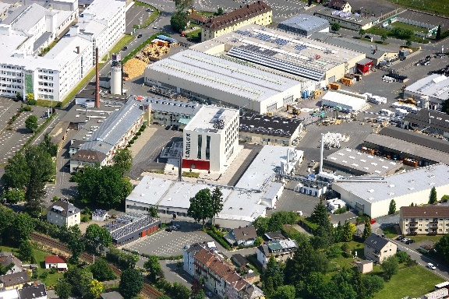
Aerial view of LAMILUX's main site in Rehau, Upper Franconia, Bavaria

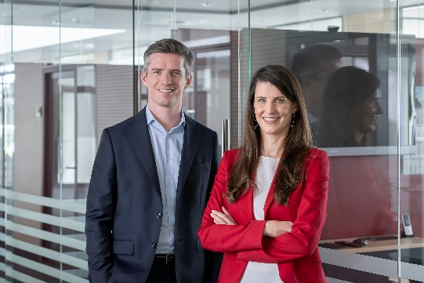
The managing partners: Dr Alexander Strunz and Johanna Strunz

