## LAUDA benefits from the Indian growth market

### Dr. Gunther Wobser Participant of the Baden-Württemberg Business Delegation

Lauda-Königshofen, 6 March 2025 – Dr. Gunther Wobser, President & CEO of LAUDA DR. R. WOBSER GMBH & CO. KG, accompanied a high-ranking business delegation led by Baden-Württemberg's Minister of Economic Affairs Dr. Nicole Hoffmeister-Kraut to India at the beginning of February. The world market leader for precise temperature control used the trip to intensify its already very successful business relationships in what is now the world's most populous country with over 1.4 billion people.  
  
Before the actual travel program, the trip began with an important strategy meeting in Mumbai with Sandeep Sawant, Managing Director of Sawant Process Solutions and LAUDA representative. The company is the most important partner of LAUDA in the Indian market. The focus was on current market developments and new prospects for intensified cooperation.  
  
Dr. Wobser then took part in the five-day trip with stops in Delhi, Pune and Mumbai as part of the 44-strong business delegation. The agenda included company visits to JBM Group, Bucher Hydraulics and Siemens as well as high-level business talks on the opportunities for Indo-German cooperation.  
  
“The dynamism of the Indian market is very impressive. The interlocutors are very self-confident and have a clear, ambitious vision of the future,” summarizes Dr. Wobser his impressions. “Up until now, I was more of an Asia and China fan, but now I can see great opportunities for LAUDA to expand in the Indian market.”  
  
In Pune, the ‘Oxford of the East’ with 265,000 students, the delegation visited leading industrial companies such as Bharat Forge and Marquardt. These contacts showed great potential for technological partnerships. The trip concluded with the 21st edition of the popular wine festival ‘Stuttgart meets Mumbai’, where Dr. Wobser was able to deepen relations with Indian partners.  
  
“This trip marks an important step for our commitment in India,” emphasizes Dr. Wobser. “The excellent academic education, the dynamic development of Indian companies and the cooperation with our partner Sawant Process Solutions offer promising prospects.” LAUDA is planning to establish its own presence in Pune this year.  
  
Minister of Economic Affairs Dr. Nicole Hoffmeister-Kraut reaffirms the strategic importance of economic cooperation with India. With a trade volume of over four billion euros in 2023, India is an important trading partner for Baden-Württemberg. Around 350 companies from the state are already active in the country. Baden-Württemberg's partnership with the state of Maharashtra, where Mumbai and Pune are located, has been in place for exactly ten years.

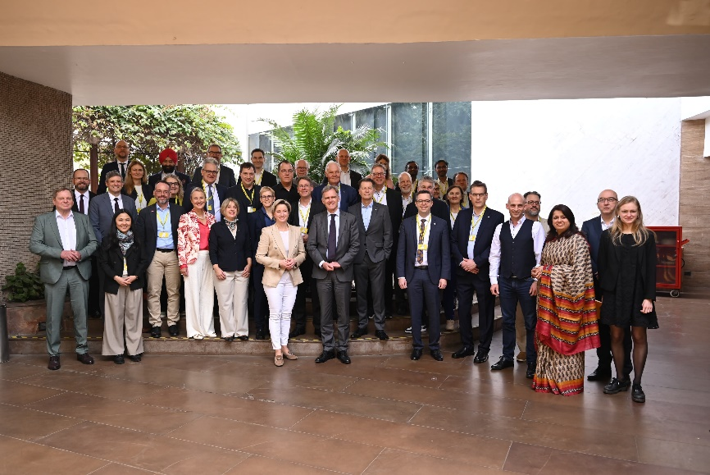

**Picture 1:** The Baden-Württemberg business delegation with Dr. Gunther Wobser, President & CEO of LAUDA (2nd from left) in Delhi. The trip included numerous company visits and high-level talks aimed at strengthening Indo-German economic relations. © Sunil Kumar

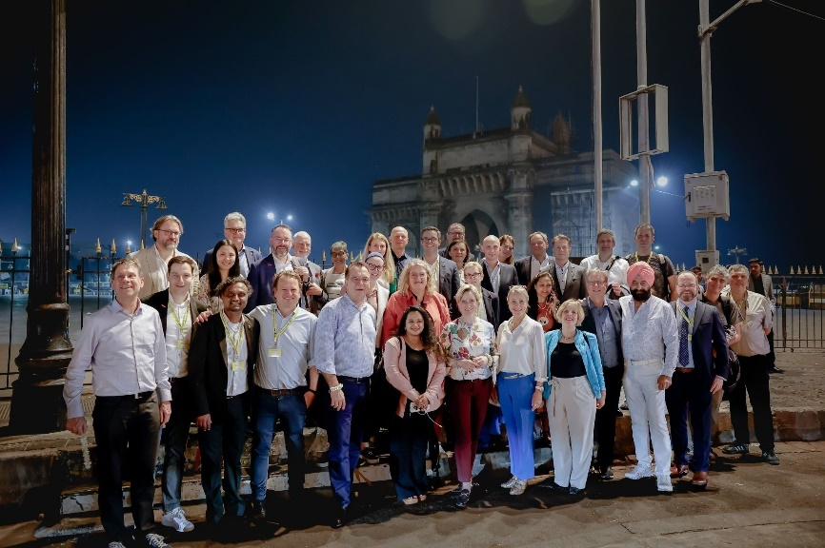

**Picture 2:** A highlight of the delegation trip: Dr. Gunther Wobser, President & CEO of LAUDA (3rd from right), with participants of the business delegation in front of the historic Gateway of India in Mumbai. The imposing landmark of the metropolis from the British colonial era has shaped the skyline on the Arabian Sea since 1924. © Jayesh Pawar

**We are LAUDA** –the world leader in precise temperature control. Our constant temperature equipment and systems are at the heart of important applications, contributing to a better future. As a complete one-stop supplier, we guarantee the optimum temperature in research, production and quality control. We are the reliable partner for electromobility, hydrogen, chemicals, pharmaceuticals/biotech, semiconductors and medical technology. We have been inspiring our customers for almost 70 years with our expert mentoring and innovative solutions – every day anew and all over the world.

In our company, we always go one step further. We support our employees’ development and are constantly developing ourselves: to create a better future together.

**Press contact**

We are more than happy to make prepared information about our company, the LAUDA Factory Gallery and our projects in the area of innovation promotion, digitalization and idea management available to the press. We look forward to hearing from you – just give us a call!

CHRISTOPH MUHR

Director Corporate Communications

T + 49 (0) 9343 503-349

[christoph.muhr@lauda.de](mailto:christoph.muhr@lauda.de)

LAUDA DR. R. WOBSER GMBH & CO. KG, Laudaplatz 1, 97922 Lauda-Königshofen, Deutschland/Germany. Limited partnership: Headquarters Lauda-Königshofen, Registration court Mannheim HRA 560069. General partner: LAUDA DR. R. WOBSER Verwaltungs-GmbH, Headquarters Lauda-Königshofen, Registration court Mannheim HRB 560226. Managing Directors: Dr. Gunther Wobser (President & CEO), Dr. Mario Englert (CFO), Dr. Marc Stricker (COO)