Embargo until March 13th 2018 – 10:30am CET

Press release
Magazino awarded prize for ‘Best Product’ at LogiMAT 2018

Stuttgart, 13th March 2018: Robotics startup, Magazino has been awarded the prize for ‘Best Product’ at LogiMAT 2018, for its newly developed robot SOTO. SOTO was recognized within the prize category ‘Order Picking, Conveying, Lifting and Storage Technology’. The fully autonomous robot uses 3D camera technology to grasp objects, such as cardboard boxes from a conveyor belt, then store them on the vehicle, navigate to the destination and place the boxes precisely in shelving racks. This makes SOTO the world's first perception-driven robot that combines this spectrum of capabilities in a single solution. The use of these intelligent robots is primarily in distribution centers of fashion logistics. Another field of application is the supply of small load carriers in production logistics. SOTO is on display at Magazino’s booth D55, in Hall 5 at the Fair.
The most important customer benefits of the award-winning robot are: manual work processes that were previously too complex can now be automated for the first time in a flexible and scalable way. This results in extended operating times, a smoothing of order peaks and a reduction of operating and process costs. Above all, SOTO makes it possible for employees to be relieved of ergonomically unfavorable tasks, especially when it comes to the lowest or highest shelf level, where the picking and placing of 15 kg boxes full of textiles is an exhausting task.
“This award means a lot to us” says Lukas Zanger, Co-Founder and COO of Magazino. “One of the reasons we developed SOTO was because of conversations held at LogiMAT Fairs, where it became clear there was a high demand for this kind of robot.”
Objects up to a size of 600 x 400 x 400 millimeters can be handled by SOTO with its adaptive gripper. Depending on the size, up to eight boxes can be stored temporarily in an integrated shelf. The lifting mechanism allows it to pick up and put down objects in both directions and reach heights from 5 cm to 250 cm above ground. Certified safety laser scanners not only enable a completely autonomous navigation, but also ensure safe operations parallel to employees. Connected by a cloud system, SOTO shares information with other robots about current changes in the warehouse environment, unknown objects or experiences with challenging situations. This allows them to learn from each other and thus improve their performance continuously.
About the prize ‘Best Product’
At LogiMAT 2018, excellence awards are presented for innovative products of exhibitors that contribute significantly towards rationalization, cost-savings and increasing productivity in in-company logistics. The ‘Best Product’ award is now in its fifteenth year.
The prize categories of the ‘Best Product’ award are:
- Software, Communication, IT
- Order picking, Conveying, Lifting, Storage technology
- Identification, Packaging and Loading technology, Load securing
The winners are chosen by an independent jury that reviews the products on display ahead of LogiMAT 2018 in line with the competition requirements. The jury is made up of representatives from industry, research and the media. The award has established itself as one of the most coveted in the intralogistics sector.

About Magazino
Magazino GmbH, headquartered in Munich, Germany, was founded in 2014 by Frederik Brantner, Lukas Zanger and Nikolas Engelhard. The startup develops and builds perception driven, mobile robots for intralogistics. With over 80 employees Magazino has one of the biggest teams in Europe working on perception driven robotics. Magazino has already developed the mobile picking robot TORU, which runs at several customer sites in live operation. The new robot SOTO works similar to TORU, but is designed for much larger and heavier objects. For further information and pictures visit: www.magazino.eu

Location at the LogiMAT 2018: Hall 5, Booth D55
Magazino Website: https://www.magazino.eu/?lang=en
Video – SOTO in fashion logistics: https://youtu.be/xosH4TFB9_E
Video – SOTO in production logistics: https://youtu.be/cly9XPi9cJU
Images: https://www.magazino.eu/news/#/latest_media (click on “Herunterladen”)

Press contact
Magazino GmbH
Florin Wahl (Public Relations)
Magazino GmbH
Landsberger Straße 234
80687 München
GERMANY
wahl@magazino.eu
www.magazino.eu
Tel: +49 (0) 21552415-3

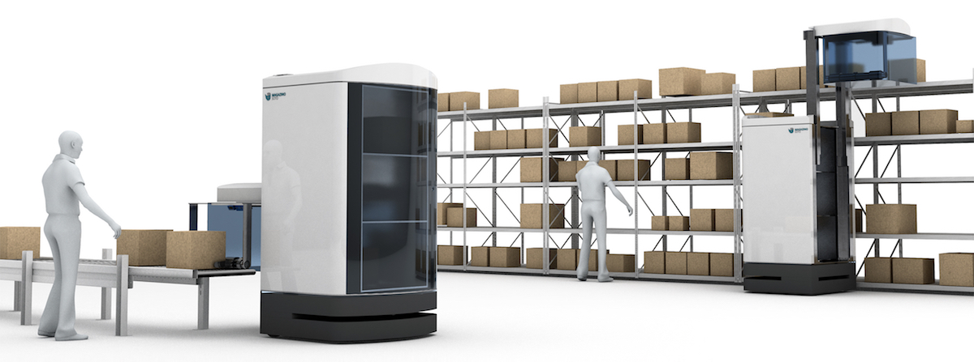
Download picture:
https://www.magazino.eu/web2016/wp-content/uploads/2018/01/SOTO_Gesamt_Karton_Flach.jpg

