Neue Nass-/Trockensauger von Kärcher mit starker Saugleistung und verbesserter Ausstattung

Jedem Schmutz gewachsen

Pressekontakt
Alexander Becker
Pressereferent
Alfred Kärcher SE & Co. KG
Alfred-Kärcher-Str. 28-40
71364 Winnenden
T +49 71 95 14-4256
alexander.becker@de.kaercher.com
Winnenden, im September 2018 – Ob im Handwerk, in der Industrie oder bei Gebäudedienstleistern mit ihren vielseitigen Aufgaben – die neuen Nass-/Trockensauger von Kärcher mit halbautomatischem Filterabreinigungssystem erweisen sich als praktische Allrounder. Die drei Modelle NT 30/1 Ap L, NT 30/1 Ap Te L und NT40/1 Ap L überzeugen mit verbessertem, robusten Zubehör und einfacher Bedienung. Mit kompakten Bauformen und geringem Gewicht empfehlen sich die Geräte auch für mobile Einsätze.
Die weiterentwickelte, halbautomatische Ap-Filterabreinigung wird manuell mit einem Tastendruck ausgelöst. Der Luftstrom wird in kurzen Stößen umgekehrt und der Filter ausgeblasen. Ein sauberer Filter besitzt einen höheren Luftdurchsatz und ermöglicht ein besseres Reinigungsergebnis. Das umständliche Abklopfen des Filters von Hand und damit verbundene, längere Arbeitsunterbrechungen entfallen. Das System ist leichter als bisher zu handhaben, denn die Bedientaste wurde auf die Vorderseite verlegt und ist so besser zu erreichen.
Alle drei neuen Geräte sind Sauger der L-Klasse zur Aufnahme von Schmutz und Stäuben ohne gesundheitsgefährdende Eigenschaften. Der Abscheidegrad beträgt 99 Prozent. Das Modell NT 30/1 Ap Te L besitzt zusätzlich eine Steckdose, an der Elektrowerkzeuge direkt mit dem Sauger betrieben werden können.
Saugschläuche mit einem größeren Innendurchmesser – serienmäßig NW 35 mm – ermöglichen einen höheren Luftstrom und wirken der Gefahr von Verstopfungen entgegen. Der Anschluss des Zubehörs erfolgt mit leicht bedienbaren Bajonett- und Clipverbindungen. Diese verbessern auch die Dichtheit des Gesamtsystems, was der Saugkraft zu Gute kommt. Der Anschluss des Saugschlauches ist im Behälterkopf untergebracht. Das Ergebnis ist ein größeres Nettovolumen des Schmutzbehälters. Bei Bedarf kann so länger als bisher gearbeitet werden, bevor er geleert werden muss. Der Krümmer mit gummiertem Handgriff wurde ergonomisch verbessert und bietet mehr Komfort auch bei längeren Einsätzen.
Der flache Gerätekopf besitzt Halterungen für Zubehör und Elektrowerkzeug-Adapter und lässt sich als praktische Abstellfläche nutzen, beispielsweise für Werkzeugboxen. Als praktisch erweisen sich die großen und robusten Verschlusslaschen, mit denen der Saugerkopf und der Schmutzbehälter verbunden sind. Sie lassen sich mühelos öffnen und schließen.
 | NT 30/1 Ap L /  NT 30/1 Ap Te L | NT 40/1 Ap L
Luftmenge | 74 l/s
Vakuum | 254 mbar
Gewicht | 11,8 kg | 12,4 kg
Behälterinhalt | 30 l | 40 l
Max. Aufnahmeleistung | 1380 W
Schalldruckpegel | 70 dB(A)

Eine Word-Datei und druckfähige Bilder zu dieser Presseinformation liegen für Sie in unserem Newsroom https://www.kaercher.com/presse zum Download bereit.

Kaercher_NT_Ap_2nd_Generation_DE.docx

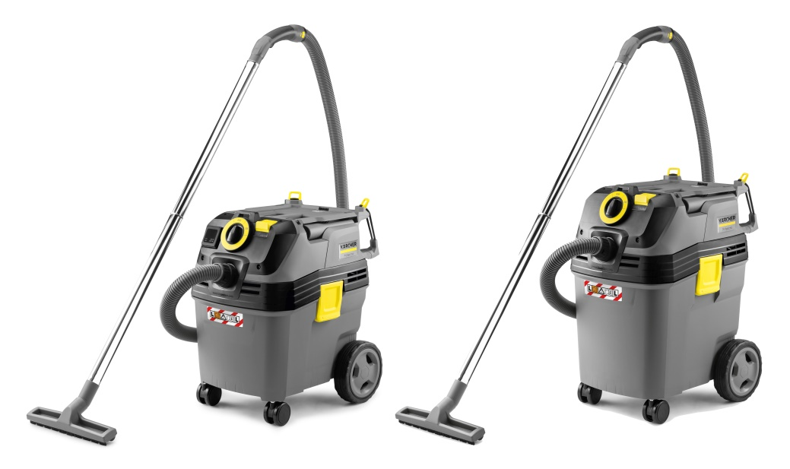
Die neuen Nass-/Trockensauger mit halbautomatischem Filterabreinigungssystem sind mit Behältergröße von 30 und 40 Litern verfügbar.

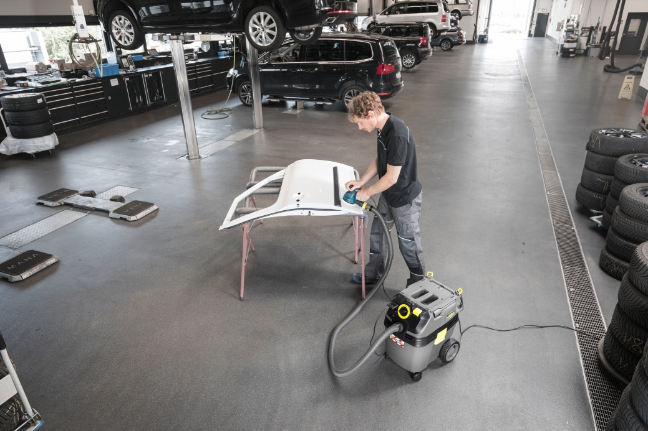
Das Modell NT 30/1 Ap Te L verfügt über eine Steckdose, an der Elektrowerkzeuge angeschlossen werden können.

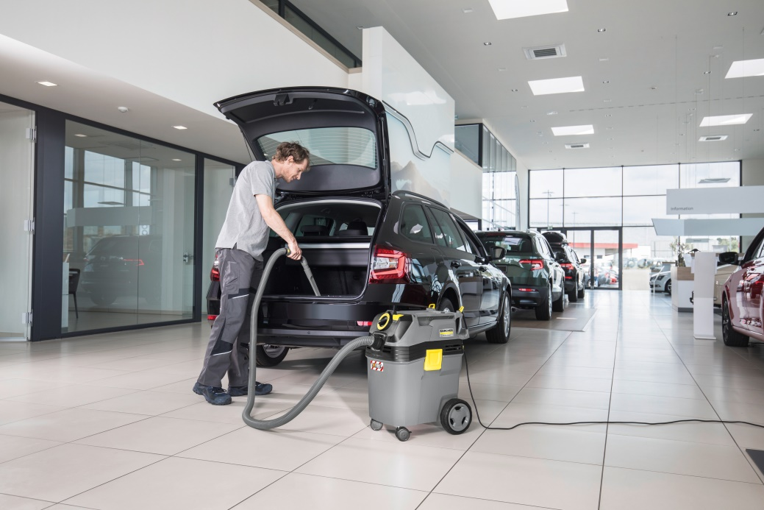
Die neuen Nass-/Trockensauger von Kärcher eignen sich für den Einsatz in unterschiedlichen Zielgruppen, etwa im Automotive-Bereich.

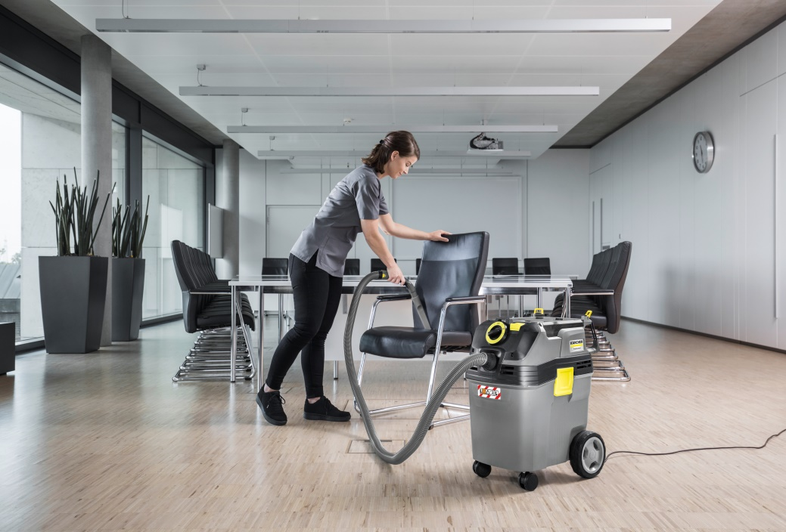
Der Schalter zum Auslösen des halbautomatischen Filterabreinigungssystems ist nun am Bedienfeld auf der Vorderseite des Geräts angebracht.

