First industrial heat pump for Türk Tuborg

Duesseldorf (Germany), June 16, 2026 – The delivery and installation of GEA's industrial heat pump to Türk Tuborg represents a major step forward for its sustainability projects and decarbonization efforts in the region. The system was installed at the Tuborg site in Izmir and is designed to recover waste heat from the existing cooling infrastructure and upgrade it into usable process heat for brewery operations. By enabling the reuse of thermal energy within production, the solution significantly improves overall energy efficiency and reduces reliance on conventional heat sources. The technology directly supports Türkiye’s net-zero target for 2053 and complies with the new climate law, which mandates emissions reporting and reduction measures.

Responses and solutions to challenges in achieving climate targets

With the installation and operation of the GEA heat pump solution, GEA supported its customer Türk Tuborg on its way to achieving its sustainability goals. The project requirements included overcoming dependence on fossil fuels for heating, recovering and reusing low-grade process heat, and improving overall energy efficiency.

CO₂ emissions reduced by 7.4 percent

The early results are promising. In the early stages of the operation, a 7.4 percent reduction in CO₂ emissions was achieved, with overall energy efficiency remaining stable.

Full integration into the customer's cooling system

The system at Türk Tuborg is built on a high-efficiency industrial heat pump solution designed to recover and reuse waste heat within the facility. It operates in full integration with the existing cooling infrastructure, ensuring optimized energy use and process continuity. Advanced control and monitoring capabilities enable stable, reliable, and data-driven operation. This integrated approach supports improved resource efficiency while contributing to the company’s broader sustainability and decarbonization objectives.

Photo:

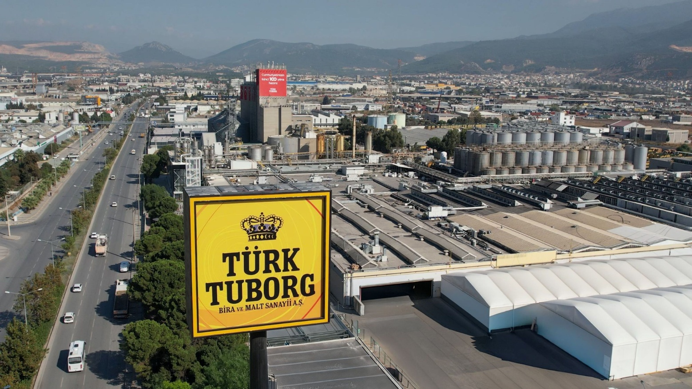

Photo, caption: Türk Tuborg partnered with GEA to implement an industrial heat pump at their brewery in İzmir, Türkiye.Thr solution captures waste heat from existing cooling systems and converts it into process heat for the wort production line. (Photo: Türk Tuborg)

About GEA
GEA is one of the world’s largest suppliers of systems and components to the food, beverage and pharmaceutical industries. The international technology group, founded in 1881, focuses on machinery and plants, as well as advanced process technology, components and comprehensive services. For instance, every second pharma separator for essential healthcare products such as vaccines or novel biopharmaceuticals is produced by GEA. In food, every fourth package of pasta or every third chicken nugget are processed with GEA technology. With more than 18,000 employees, the group generated revenues of about EUR 5.5 billion in more than 150 countries in the 2024 fiscal year. GEA plants, processes, components and services enhance the efficiency and sustainability of customers’ production. They contribute significantly to the reduction of CO2 emissions, plastic usage and food waste. In doing so, GEA makes a key contribution toward a sustainable future, in line with the company’s purpose: ”Engineering for a better world.”

GEA is listed on the DAX, the STOXX® Europe 600 Index and is also a constituent of the leading sustainability indices DAX 50 ESG, MSCI Global Sustainability and Dow Jones Best-in-Class World.

More information can be found online at gea.com.
If you do not want to receive any further information from GEA, please send an e-mail to pr@gea.com.

NOTE TO EDITORS

- Further information about GEA
- To the GEA Press page
- To the GEA Media Center
- Background information on current topics can be found at Features
- Follow GEA on  

GEA
Media Relations GEA
Dr. Michael Golek
Ulmenstraße 99, 40478 Düsseldorf
Phone +49 211 91361505
Tel. +491736205746
michael.golek@gea.com

