New Report reveals:
German Celle has the world's most dense
network of half-timbered houses

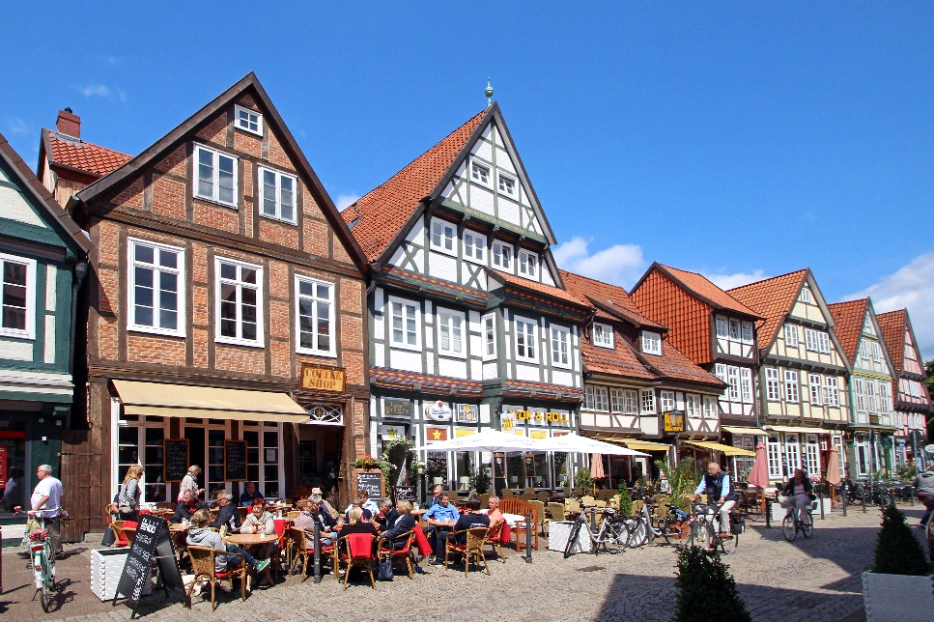

Celle's framework is unique in the world - this is confirmed by a current expertise by the
renowned expert for timber framing, Prof. Manfred Gerner. (Image copyright: Celle Tourismus)

CELLE - Germany | September 2021 - A new report has revealed that the city of Celle in North Germany has the most dense proportions of original half-timbered historic houses per hectare compared to any similar sized city worldwide. The study undertaken by Professor Manfred Gerner, one of Germany's most respected experts on architecture and the preservation of historical monuments, has also revealed a wealth of important architectural features unique to Celle, including the oldest original medieval ground plan of a half-timbered city.

Celle, famous for its white shining royal castle, has long been seen as an ideal destination for cultural travelers, not least because this beautiful and compact city is so easy to explore on foot, but also because of the history revealed its fascinating architecture. Professor Gerner's report has confirmed that the sheer density of preserved half-timbered houses per hectare in Celle is unique; the fact that Celle has survived the two world wars almost undamaged, ensured that all of the more than 480 half-timbered houses, many more than 600 years old, are now protected listed buildings.

More than 60 of these half-timbered buildings are considered outstanding and through a wealth of architectural details, such as oriels, beams, hatches, castors, doors and windows, through courtyard entrances and cobbled streets, tell the story of Germany's urban house landscape over the centuries. Professor Gerner's report also highlights a renaissance staircase frieze, little known outside of Celle, yet considered to be of great importance and worthy of a visit in its own right.

Celle also has the oldest and still existing original medieval city plan in the world dating from 1292, showing a castle, tournament square, church, market square and town hall. Explore further and Celle's history unfolds through Gothic, Renaissance, Baroque and Classicism, Eclectic Modern to Postmodern architecture, including Bauhaus - an extraordinary accumulation of techniques and design, that blend seamlessly into their medieval surroundings.

With so much culture packed into the center of Celle, a guided city tour is an ideal starting point. Or simply wander through the medieval streets, exploring the many independent, family owned and often specialist shops; enjoy the city atmosphere while having a cup of coffee and the local specialty buckwheat cake in one of the famous cafés in the old city. Celle is agreeably light on the feet, but high on style and culture, and offers visitors of all ages a relaxed city break to remember.

(2.563 signs)
# # #

CELLE. surprising. diverse.
About 40 kilometers north of Hannover, Celle, with around 70,000 inhabitants, is the picturesque southern gateway to the Lüneburg Heath. This 700-year-old Ducal Town is not only home to one of the most beautiful Guelph castles of northern Germany with its own baroque theatre, Celle also impresses with its historic old town which has the largest half-timbered ensembles in the world. There is also Bauhaus Architecture, classic and modern museums and a diverse mix of culture and gastronomy. Celle is a holiday destination for young and old and with its many owner-managed shops in the old town, also inspires as a shopping town with flair. www.celle-tourismus.de

More pictures of Celle can be found in the Image Database on the homepage of Celle Tourismus und Marketing GmbH. Please contact us for additional pictures.

Follow us on:

