analytica 2026: LAUDA Celebrates a Successful Trade Show Appearance in Its Anniversary Year

World market leader increases customer contacts again

Lauda-Königshofen, March 27, 2026 – analytica 2026, the world’s leading trade fair for laboratory technology, analytics, and biotechnology, has come to a close in Munich after four successful days. With 1,135 exhibitors from 40 countries, the international trade fair once again confirmed its role as the industry’s most important gathering. For LAUDA DR. R. WOBSER GMBH & CO. KG, the global market leader in precise temperature control, analytica 2026 was a special event: The family-owned company is celebrating its 70th anniversary throughout the year and entered the show with the clear goal of inspiring the public. The strategy paid off: Customer contacts saw single-digit percentage growth – even in light of geopolitically driven travel restrictions. A festive evening with international guests rounded out the trade show appearance and underscored the close ties of LAUDA with its partners.

Focus on the New LAUDA Universa Product Line and Digital Solutions
Under the trade show motto “LAUDA – The Home of Innovation. Since 1956,” the temperature control specialist presented its booth concept in Hall B1, Booth 504, centered around three key themes: the new modular LAUDA Universa product line, comprehensive digital solutions, and expanded service offerings. The trade audience showed great interest in the completely new designed Universa product line, which was showcased for the first time at analytica in all three performance classes – ECO, PRO, and MAX. With a temperature range of -90 to 300 °C, temperature stability of up to ±0.01 K, a modular design, and natural refrigerants, the product line sets new standards for flexibility, performance, and sustainability in the laboratory.

LAUDA Mobifreeze also attracted a great deal of attention. It is the world’s first mobile, battery-powered ultra-low-temperature chest freezer, capable of operating independently of the power grid at temperatures as low as -86 °C, and is fundamentally transforming cold-chain logistics for temperature-sensitive substances.

At the digitalization podium on the LAUDA booth, visitors experienced firsthand how the LAUDA Command app, the LAUDA.LIVE Services cloud solution, and an AI-powered chat and voice assistant ensure device operation, remote maintenance, and round-the-clock service availability. In addition, LAUDA participated in the special “Digital Transformation” show with a combination of Universa bath thermostats, intelligent sensor technology, and a cobot robot arm as a fully integrated, automated laboratory workflow.

“In our 70th anniversary year, one thing was paramount for us at analytica: staying close to our customers, inspiring them with our solutions, and creating real added value. The strong response to our Universa product line, our digital solutions, and our service innovations confirms our belief that we will gain even more momentum in this area in the future,” summarizes Dr. Gunther Wobser, President & CEO of LAUDA and also Chairman of the trade show’s Exhibitor Advisory Board. “As the world’s leading trade fair, analytica provides the ideal setting for this – and motivates us to boldly drive the development of precise temperature control technology forward.”

Press Event at the LAUDA Booth
A press event was once again held at the LAUDA booth for representatives of the trade media. Members of management and the product marketing team gave the press representatives a tour of the booth, presented the latest innovations, and were available to answer questions.

Following analytica, LAUDA is seamlessly continuing its busy trade show schedule: Starting in April, the company will be exhibiting at a total of 13 additional trade shows – including the Hannover Messe, the Battery Show in Stuttgart, the Automotive Testing Expo also in Stuttgart, and Lab Supply events at various locations throughout Germany. These trade show appearances offer LAUDA the opportunity to present its innovations to a broad professional audience from other industries and application fields and to continuously deepen its dialogue with customers and partners.

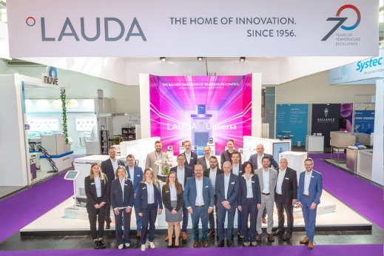 | 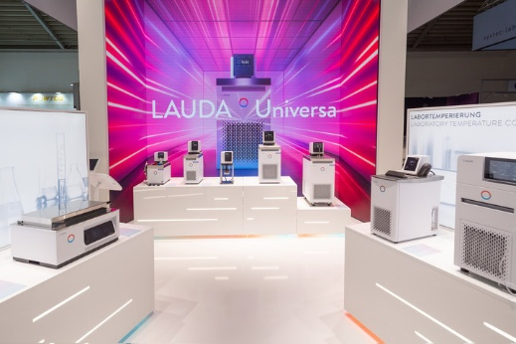
The LAUDA trade fair stand with the team at analytica 2026 © Foto Besserer | Picture 2: LAUDA Universa bath thermostats at analytica 2026 © Foto Besserer
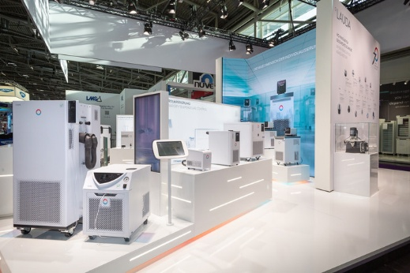 | 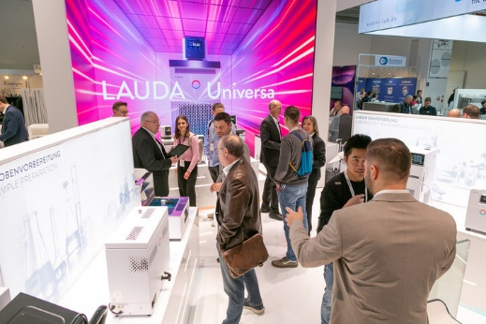
Picture 3: The LAUDA trade fair stand at analytica 2026 © Foto Besserer | Picture 4: The LAUDA trade fair stand with visitors at analytica 2026 © Foto Besserer

We are LAUDA – the world leader in precise temperature control. Our constant temperature equipment and systems are at the heart of important applications, contributing to a better future. As a complete one-stop supplier, we guarantee the optimum temperature in research, production and quality control. We are the reliable partner for Aerospace, Electromobility, Hydrogen, Chemistry, Pharmaceuticals/Biotech, Semiconductors and Medtech. We have been inspiring our customers for over 70 years with our expert mentoring and innovative solutions – every day anew and all over the world.

In our company, we always go one step further. We support our employees’ development and are constantly developing ourselves: to create a better future together.

Press contact
We are more than happy to make prepared information about our company, the LAUDA Factory Gallery and our projects in the area of innovation promotion, digitalization and idea management available to the press. We look forward to hearing from you – just give us a call!

CHRISTOPH MUHR
Director Corporate Communications
T + 49 (0) 9343 503-349
christoph.muhr@lauda.de

LAUDA DR. R. WOBSER GMBH & CO. KG, Laudaplatz 1, 97922 Lauda-Königshofen, Deutschland/Germany. Limited partnership: Headquarters Lauda-Königshofen, Registration court Mannheim HRA 560069. General partner: LAUDA DR. R. WOBSER Verwaltungs-GmbH, Headquarters Lauda-Königshofen, Registration court Mannheim HRB 560226. Managing Directors: Dr. Gunther Wobser (President & CEO), Dr. Mario Englert (CFO), Dr. Marc Stricker (COO)

