Combating child poverty
GEA Foundation donations support children in need

- EUR 500,000 to the charity BILD hilft e.V. “Ein Herz für Kinder”
- Roughly EUR 240,000 to “Die Arche – Kinderstiftung, Christliches Kinder- und Jugendwerk“
- Both donations made through the GEA Foundation, which is tasked with distributing one percent of GEA Group’s net profit each year to charitable causes

Düsseldorf (Germany), December 11, 2025 – The GEA Foundation recently donated roughly EUR 1.2 million to two children's aid organizations in Germany. The recipients include BILD hilft e.V. “Ein Herz für Kinder” (A Heart for Children) and “Die Arche – Kinderstiftung, Christliches Kinder- und Jugendwerk” (The Ark – Children’s foundation, Christian Children's and Youth Welfare Organization). Both associations work to combat child poverty – one of the GEA Foundation's key objectives.

“We are delighted to be able to support two important aid organizations with a large donation at the end of year. With the creation of the GEA Foundation, we have placed our commitment to charitable giving and our social responsibility on a new footing and developed it further,” explains Stefan Klebert, CEO of GEA Group. “With EUR 500,000 for ‘Ein Herz für Kinder’ and EUR 712,000 for ‘Die Arche,’ we want to make a sustainable contribution to helping children in need and combating child poverty. This support provides financial stability for the projects carried out by these organizations which help shape a better future for children long term.”

"Ein Herz für Kinder": GEA donates EUR 500,000
The BILD hilft e.V. “Ein Herz für Kinder” helps children in need in Germany and around the world. The association provides support in the areas of medicine and research, education and equal opportunities, disaster relief and assistance for children with special needs. For the fourth year in a row, GEA is supporting the association with a substantial donation. This year, the foundation gave a donation of EUR 500,000, which represents another increase.

“Die Arche”: GEA provides ca. EUR 240,000 in support this year
Die Arche is a charitable organization committed to combating child poverty in Germany. The organization provides leisure centers and after-school programs for disadvantaged children in several German cities. It empowers children by organizing activities that promote meaningful leisure time, provides homework supervision and learning support and offers material assistance in the form of free meals and clothing banks. GEA is supporting the “Mutmacher” (Encouragers) project in Osnabrück, Berlin-Reinickendorf, and Düsseldorf, as well as the “Entdecker-Projekt” (Discoverers Project) in the Ark at the Mozart School in Berlin, with a total of EUR 712,000 over three years. Socially disadvantaged young people aged 13 and above receive individualized support and targeted preparation for their final-year exams. Trained social workers, social educators and volunteers accompany these young people for several years, acting as confidants and coaches. Support includes training in money management, personality development, job application assistance and learning camps during school holidays.

Social commitment part of sustainable action
For GEA, sustainability encompasses more than just environmental and climate protection; it also involves improving the social and economic lives of people worldwide. To this end, the Group established the GEA Foundation in February 2025. Through the foundation, one percent of the Group's annual net profit is donated to charitable causes, with special focus on STEM education, combating child poverty, improving access to basic infrastructure and providing emergency disaster relief.

gea.com/foundation

Picture overview (Downloadlink for 3 pictures)

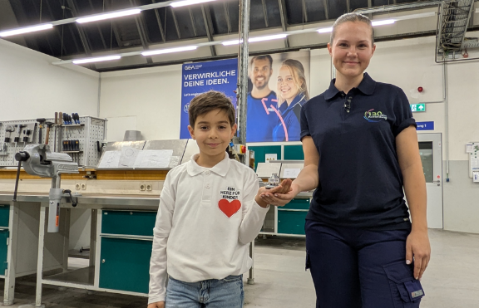
Image 1: GEA donates EUR 500,000 to “Ein Herz für Kinder” (A Heart for Children), supporting the fight against child poverty and funding education and research projects for the youngest generation. Source: GEA Foundation

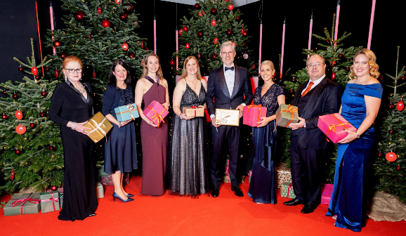

Image 2: Alexander Kocherscheidt, CFO at GEA Group AG (center), together with a small delegation from the company, symbolically handed over the large donation of EUR 500,000 to “Ein Herz für Kinder” in Berlin during the ZDF charity gala. Source: © Ein Herz für Kinder / Peter Müller

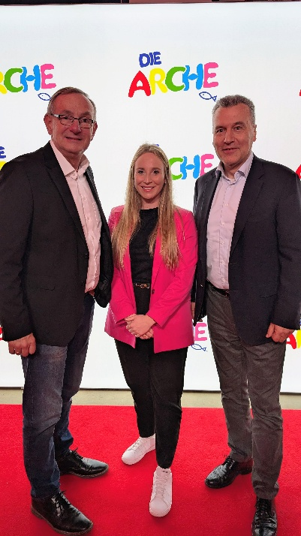
Image 3: Annika Westphal, Head of Sustainability LPT at GEA and member of the GEA Foundation, and Thomas Strotkötter (right), Senior Vice President Compression Technologies at GEA's Berlin site, jointly delivered the good news to Bernd Siggelkow (left), Founder and Director of Die Arche, about the large donation from the GEA Foundation.
Source: GEA

NOTE TO EDITORS
- More about the GEA Foundation
- More about GEA
- GEA Media page
- Follow GEA at  

Media Relations
Nicole Hoffmann
Ulmenstraße 99, 40476 Düsseldorf, Germany
Telephone +49 211 9136-1503
nicole.hoffmann@gea.com

About GEA Foundation
The GEA Foundation, established in 2025 by GEA Group, supports global and local projects in STEM education, child poverty reduction, infrastructure access and disaster relief. Through its Mission 30 strategy, GEA commits to donating one percent of annual net profit to build resilient communities.

More information can be found online at gea.com/foundation.

About GEA
GEA is one of the world’s largest suppliers of systems and components to the food, beverage and pharmaceutical industries. The international technology group, founded in 1881, focuses on machinery and plants, as well as advanced process technology, components and comprehensive services. For instance, every second pharma separator for essential healthcare products such as vaccines or novel biopharmaceuticals is produced by GEA. In food, every fourth package of pasta and every third chicken nugget is processed with GEA technology.

With more than 18,000 employees, the group generated revenues of about EUR 5.5 billion in more than 150 countries in the 2024 fiscal year. GEA plants, processes, components and services enhance the efficiency and sustainability of customers’ production. They contribute significantly to the reduction of CO2 emissions, plastic usage and food waste. In doing so, GEA makes a key contribution toward a sustainable future, in line with the company’s purpose: ”Engineering for a better world.”

GEA is listed on the DAX, the STOXX® Europe 600 Index and is also a constituent of the leading sustainability indices DAX 50 ESG, MSCI Global Sustainability and Dow Jones Best-in-Class World.

More information can be found online at gea.com.
If you do not want to receive any further information from GEA, please send an e-mail to pr@gea.com.

