Reorganization in Sales and Service

LAUDA expands management responsibilities of Felix Heinrich-Bignasse and Enrico Bossart

Lauda-Königshofen, July 31, 2025 – LAUDA DR. R. WOBSER GMBH & CO. KG announces the expansion of the areas of responsibility of two executives. Effective July 1, 2025, Felix Heinrich-Bignasse will take over as the new Director Global Sales, assuming overall responsibility for the worldwide sales activities of the leading supplier of temperature control devices and systems. At the same time, Enrico Bossart will expand his responsibilities and, as Director Product Management & Service, will also be responsible for the central service division of the global market leader for precise temperature control.

The bundling of responsibilities will strengthen global customer-focused activities, further consolidate the market position and open new growth opportunities. In his new role, Felix Heinrich-Bignasse will be responsible for global sales activities for the entire range of services and will take over regional sales in addition to key account management. Enrico Bossart will be responsible for service in addition to his previous tasks in product management, including product marketing. This will achieve even closer integration between innovative services and service products and customer support. Digital service and sales via e-commerce solutions play a particularly important role here.

Dr. Gunther Wobser, the President & CEO who is responsible for customer activities, temporarily headed both departments himself. He praised the achievements of both executives: “In Felix Heinrich-Bignasse and Enrico Bossart, we have two proven leaders who have both demonstrated their skills over the past six years. The expansion of their areas of responsibility is recognition of their achievements to date and will further strengthen our market position.”

Felix Heinrich-Bignasse holds a degree in industrial engineering and studied at the University of Würzburg-Schweinfurt. He also holds a master's degree in International Business and Export Management from the University of Krems in Austria. Heinrich-Bignasse joined LAUDA in April 2019, initially working as Sales Specialist OEM. In February 2021, he became Acting Sales Manager OEM, and in March 2022, he was appointed as Director Key Account Management. His appointment to this management position marked his promotion to the executive board. His achievements to date include the successful establishment of key account management and sales responsibility for plant engineering. In his new role as Director Global Sales, Heinrich-Bignasse will drive forward international expansion and intensify cooperation with the regional sales teams.

Enrico Bossart studied International Technical Management at the Mosbach Cooperative State University. He then worked in product management at a leading German manufacturer of industrial measurement technology. The graduate engineer has been successfully strengthening the LAUDA team as Director Product Management since April 2019. On March 1, 2022, he was appointed Division Manager and joined the management team. His achievements to date include the implementation of the 5-year best-warranty and the successful launch of the new LAUDA Universa product line. With the assumption of responsibility for service, Bossart will use his extensive product knowledge to develop innovative service solutions and further increase customer satisfaction.

With this restructuring, LAUDA is bundling responsibilities in sales and service and expects to increase sales in the service area through new initiatives. With these personnel decisions, LAUDA is optimally positioned for future challenges in the market and underscores its confidence in its own management.

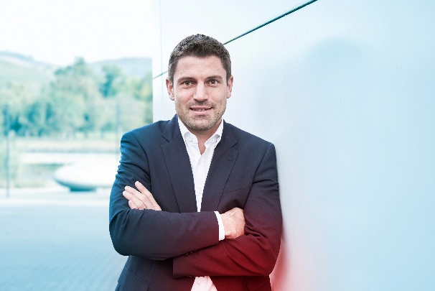 | 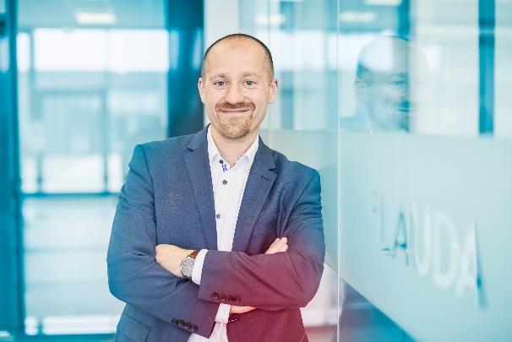
Image 1: Felix Heinrich-Bignasse is the new Director Global Sales at LAUDA. He is responsible for worldwide sales activities, while continuing to oversee key account management and sales for plant engineering. © LAUDA | Image 2: Enrico Bossart is the new Director Product Management & Service at LAUDA. In addition to product management, he is now responsible for service. © LAUDA
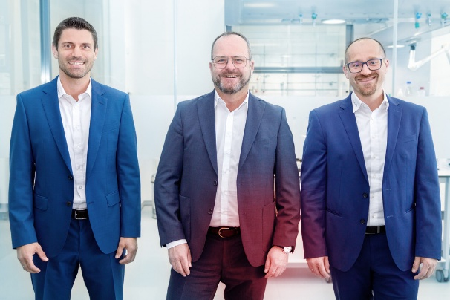
Image 3: LAUDA President & CEO Dr. Gunther Wobser (center) is counting on his proven collaboration with Heinrich-Bignasse (left, Director Global Sales) and Bossart (right, Director Product Management & Service) to strengthen the company's market position. © LAUDA

We are LAUDA – the world leader in precise temperature control. Our constant temperature equipment and systems are at the heart of important applications, contributing to a better future. As a complete one-stop supplier, we guarantee the optimum temperature in research, production and quality control. We are the reliable partner for electromobility, hydrogen, chemicals, pharmaceuticals/biotech, semiconductors and medical technology. We have been inspiring our customers for almost 70 years with our expert mentoring and innovative solutions – every day anew and all over the world.

In our company, we always go one step further. We support our employees’ development and are constantly developing ourselves: to create a better future together.

Press contact
We are more than happy to make prepared information about our company, the LAUDA Factory Gallery and our projects in the area of innovation promotion, digitalization and idea management available to the press. We look forward to hearing from you – just give us a call!

CHRISTOPH MUHR
Director Corporate Communications
T + 49 (0) 9343 503-349
christoph.muhr@lauda.de

LAUDA DR. R. WOBSER GMBH & CO. KG, Laudaplatz 1, 97922 Lauda-Königshofen, Deutschland/Germany. Limited partnership: Headquarters Lauda-Königshofen, Registration court Mannheim HRA 560069. General partner: LAUDA DR. R. WOBSER Verwaltungs-GmbH, Headquarters Lauda-Königshofen, Registration court Mannheim HRB 560226. Managing Directors: Dr. Gunther Wobser (President & CEO), Dr. Mario Englert (CFO), Dr. Marc Stricker (COO)

