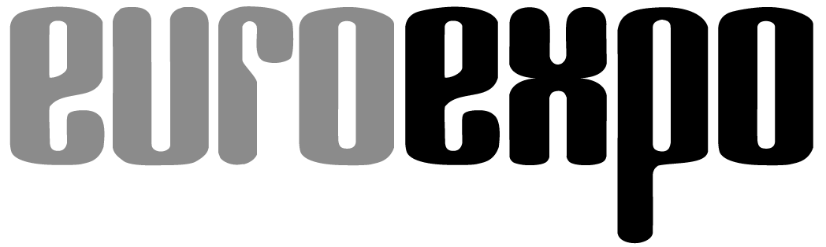
Messe- und Kongress-GmbH
Joseph-Dollinger-Bogen 7
D-80807 Munich, Germany
Phone: +49 89 32391 259
Fax: +49 89 32391 246
www.euroexpo.de/en
www.logimat-messe.de/en
www.tradeworld.de/en

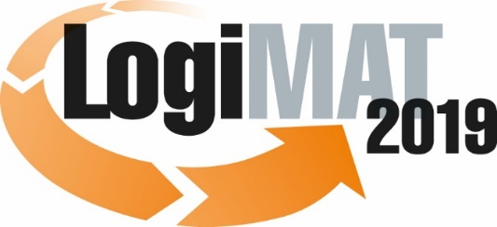

The 17th International Trade Show for
Intralogistics Solutions & Process Management
February 19–21, 2019 | Messe Stuttgart

Also featured at LogiMAT:

Munich, December 11, 2018

Press Release

LogiMAT 2019 in Stuttgart
Intralogistics information from the source

LogiMAT 2019’s accompanying program, with more than 30 forums and live events hosted by a distinguished slate of presenters, offers industry professionals real-world insights and information across the spectrum of trending themes in forward-looking intralogistics.

A sophisticated program of accompanying events with the added value of an industry conference: This is what has defined the LogiMAT brand and made it so successful. The 17th International Trade Show for Intralogistics Solutions and Process Management is casting its gaze far into the future. In some 30 expert forums of 75 minutes each held right in the exhibit halls, more than 100 proven experts from the business and academic communities and industry press will explore today’s top issues driving forward-looking investments in intralogistics. Front and center in all of this is sustainability, innovation, autonomous transports, artificial intelligence (AI), and robotics. Three series of live events and over 40 presentations by exhibitors each day will also focus on current topics and best-practice projects, giving industry professionals proven solutions for the challenges they face today. “The high caliber of speakers in the accompanying program offer visitors valuable information on how to optimize and future-proof their intralogistics and supply chain, make their logistics more efficient, and lower their logistics costs,” notes Michael Ruchty, LogiMAT’s new Exhibition Director. “This underscores LogiMAT’s mission to give its visitors a complete portfolio of solutions, from innovative products to integrated concepts.”

Three expert forums on the subject of artificial intelligence look at the latest technological approaches. Powerful IT systems and technologies already make it possible to use algorithms for smart management of intralogistical processes. The first such forum taking place on February 19 at 11:00 a.m. in Forum A, Hall1 – offers a preview of what this future will look like and how it can be shaped. The other two AI-themed expert forums explore the status and development potential that AI and robotics already enjoy in the logistics industry (February 21, Forum T in Hall 2) and how production data can be used effectively for AI applications (February 21, Forum D in Hall 8). Other programs highlight the added value of the digital innovations of AI, robotics, and autonomation through a critical examination of the opportunities and limits of automation in digital transformation (February 19, Forum B in Hall 3) and a look at what it takes to make the digital warehouse a success (February 21, Forum B in Hall 3).

Well worth a visit for industry professionals

Another factor driving the optimization of intralogistical processes is sustainability—from energy efficiency to a comprehensive understanding of carbon footprint. Experts will explore industrial and research-driven solutions for the smart use of energy in logistics centers (February 20, Forum E in Hall 9) as part of IFT Day program. Other forums focus on the tweaks and solutions already available in the area of packaging (February 19, Forum C in Hall 4) and the innovative solutions emerging in the next generation of packaging logistics (February 20, Forum C in Hall 4).

The forums cover many other themes of digital innovation with the role of auto-ID as an enabler of digital transformation, in the control and optimization of business processes on the path toward the “smart factory” (February 19, Forum C in Hall 4), as an underlying technology for industrial innovations (February 20, Forum C in Hall 4), and even in the rapid development of new products (February 21, Forum C in Hall 4). Another highlight amid the current turmoil in global trade will be a session focusing on the opportunities and challenges of German-Chinese partnerships in logistics (February 21, Forum C in Hall 4). Through the “Made in China 2025” initiative, the world’s third-largest economy is gaining further momentum in modernizing its industry and infrastructure. The forum – organized jointly by the Fraunhofer Institute for Material Flow and Logistics in Dortmund and the Institute for Materials Handling, Material Flow, Logistics at the Technical University of Munich – highlights the opportunities and challenges for collaboration between the two countries. “With this broad spectrum of field-tested, forward-looking solutions, the accompanying program for the 17th International Trade Show for Intralogistics Solutions and Process Management underscores the importance of LogiMAT as a platform for in-depth learning about all the major topics trending in intralogistics today,” concludes Ruchty. “This high level of added value for industry professionals has been and remains a defining characteristic of LogiMAT.”

Event organizer: EUROEXPO Messe- und Kongress-GmbH
Joseph-Dollinger-Bogen 7 | 80807 Munich, Germany
Phone: +49 89 323 91 259 | Fax: +49 89 323 91 246
www.logimat-messe.de | www.tradeworld.de

4,839 characters (with spaces)
Munich, December 11, 2018 – This text may be reprinted free of charge, but please send a copy to EUROEXPO Messe- und Kongress-GmbH, Press and Public Relations Department, 80912 Munich.

About LogiMAT

LogiMAT 2019, the 17th International Trade Show for Intralogistics Solutions and Process Management, will take place February 19 - 21 on the grounds of Messe Stuttgart, directly adjacent to Stuttgart International Airport. LogiMAT, the world’s largest intralogistics trade show, offers a comprehensive overview of everything driving the intralogistics industry, from procurement to production to shipping. International exhibitors gather early in the year to showcase innovative technologies, products, systems, and solutions for streamlining operations, optimizing processes, and cutting costs in a company’s internal logistics.
TradeWorld, the Professional Platform for Trade Processes embedded within LogiMAT, features products and solutions for e-commerce and omnichannel. Beyond the exhibitor booths, visitors to this combined event can also experience a different program of presentations each day covering a wide range of topics.

