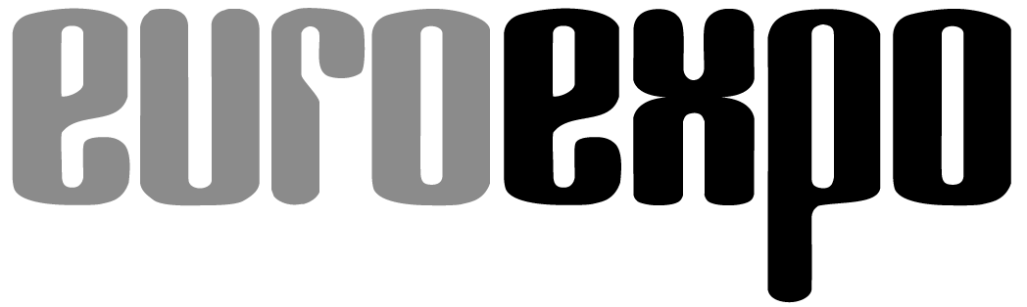
Messe- und Kongress-GmbH
Joseph-Dollinger-Bogen 7
D-80807 Munich, Germany
Phone: +49 89 32 391 259
Fax: +49 89 32 391 246
www.euroexpo.de/en
www.logimat-messe.de/en
www.tradeworld.de/en

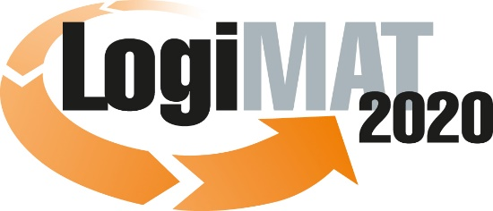

18th International Trade Show for
Intralogistics Solutions & Process Management
March 10–12, 2020 | Messe Stuttgart

Also featured at LogiMAT:
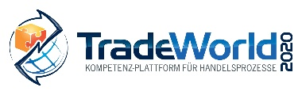

Munich, February 10, 2020

LogiMAT 2020 in Stuttgart

Future of logistics dominated by AI

Many areas of logistics are experiencing a paradigm shift in technology. Intralogistics will be the first area reshaped by digital technology and artificial intelligence (AI). Over 210 software companies will be on hand at LogiMAT 2020 to present industry professionals from around the world with innovative solutions and services already available for state-of-the-art, sustainable IT infrastructure.

The tech industry is booming. Software developers and providers saw sales in Germany rise 6.3% to over €26 billion in the past year—not counting IT services, projects, and IT consulting—according to IT industry group Bitkom. “The growing presence of digital technology in business, government, and society as a whole is driving growth in tech,” notes Bitkom President Achim Berg, explaining this trend. “Every company needs IT consulting and software solutions to roll out new products and services and optimize business processes.” In a Bitkom survey, over two-thirds of logistics companies point to time savings as a benefit of digital applications, while 43% cite lower susceptibility to errors and outages, 35% a physical benefit to employees, 33% better service to end customers, and 31% less need for storage space. “Purely analog logistics is not sustainable,” Berg concludes.

No question: Digital technology is transforming intralogistics. The use of AI for efficient route planning or the predictive maintenance of equipment and machinery; the transport of goods using automated guided vehicles, trucks, and drones; or the use of blockchain for a transparent supply chain: A paradigm shift in technology is already underway in many areas of logistics. The latest IT developments in both hardware and software form the foundation of this shift. As storage capacities grow and high-performance processors deliver ever-greater processing speeds, it becomes possible to process more and more data faster and faster using sensor and imaging technologies, for example. Robotic process automation and AI methodologies and processes use automated computing processes to deliver optimized, self-organized reactions in real time. Intralogistics software companies from around the world will be on hand to demonstrate how far such ideas have already advanced and how they have found their way into the spectrum of features that their solutions offer—at the 18th International LogiMAT Trade Show for Intralogistics Solutions and Process Management, March 10–12 in Stuttgart.

The IT sector, traditionally the second-largest exhibitor contingent, is located in Halls 6 and 8 of the Messe Stuttgart convention center with a broad overview of the latest software for transport and warehouse management systems and for customs, shipping, and export controls. “The demands placed on IT infrastructure are growing more complex all the time,” emphasizes Michael Ruchty from Munich-based organizer EUROEXPO Messe- und Kongress-GmbH. “On the one hand, digital transformation requires integrated data management, end-to-end interconnectivity, integration, and smart data flows. “On the other hand, people want systems with simpler, more intuitive interfaces. That’s why many key software processes run automatically in the background using AI algorithms and robotic process automation.”

AI for more transparency, efficiency, flexibility

AI applications like machine learning and neural networks make it possible to apply specific algorithms to huge volumes of data, identifying patterns and calculating probabilities that would otherwise be all but unknowable. The software does this by simulating a variety of different processes and variables in real time and comparing the analytic results to initiate the ideal solution. Industry professionals attending LogiMAT 2020 can see first hand what kind of innovations are already on the market and the visions still in development.

Across nearly all levels of intralogistics software systems, exhibitors are showing features, tools, and systems that enhance the transparency, efficiency, and flexibility of internal processes with the help of AI methodologies and processes. Inform GmbH (Hall 8, Booth D61) is one example, coming to Stuttgart with a new cross-enterprise, cross-sector system platform for industrial transport logistics. The cloud-based platform SyncroSupply Central brings tremendous added value to shippers, OEMs, suppliers, transport companies, and retailers in achieving transparent processes, allocating time slots and loading docks, and plugging in individual services without the need for a time-consuming process of integration.

Logivations GmbH (Hall 8, Booth F05), an international consulting and technology company from Munich, is coming to LogiMAT to show how AI can be used in the packing process with new features for its software solution W2MO. Interfaces to freight cost databases and Google traffic data also help optimize networks. MotionMiners GmbH (Hall 8, Booth C18) presents the world debut of Manual Process Intelligence, which it calls the “first motion-mining® product solution” for the automatic recording and analysis of manual work processes using sensors and AI. Beacons record the activities and process steps of warehouse workers for two weeks, then use AI analysis to optimize walking, waiting, and picking times and to run efficiency and ergonomics analyses.

PSI Logistics GmbH (Hall 8, Booth D70) is coming to Stuttgart to present the PSIglobal supply chain network design system in its brand-new 2020 version, with efficient AI algorithms and helpful new features to analyze and prepare available data. PSIglobal’s innovations include new features for analyzing shipping data, creating multi-criteria transport rates, and identifying additional value-adding potential in the supply chain. One concrete application of this is to reduce logistics costs through the smart analysis of customer behavior in order placement. “Developing these new features would've been almost inconceivable without the integration of AI methodologies and processes,” concludes Dr. Giovanni Prestifilippo, Managing Director of PSI Logistics.

Optimization algorithms for multi-order picking

But the 18th LogiMAT is also the place to find less resource-hungry software applications that do their job just fine without AI. Dr. Malek Software GmbH (Hall 8, Booth A06) from Dresden presents its M3 MapDispo software and the M3 app with a new graphical interface for dispatching, route optimization, and location, including the option to have drivers enter unit load device swaps. IT service provider Weber Data Service GmbH (Hall 8, Booth F06) is showcasing new features in its DISPONENTplus transport and warehouse management system, with a focus on the warehouse logistics module. The innovations include an extended capacity for managing hazardous goods, graphical support for warehouse scanning, and new options for drag-and-drop order prioritizing.

The software and consulting provider Soloplan GmbH (Hall 8, Booth C01) presents CarLo inHub, an add-on that maps all warehouse cross-docking processes in the transport management system CarLo. The Sievers Group (Hall 8, Booth B62) is coming to Stuttgart with an integrated solution for optimized batch consolidation that works with the SNC/Logistics warehouse management system. “The software calculates the most effective sequence for the picking process and intelligently groups multiple orders,” explains Hendrik Ohlms, Head of Business Solutions ERP at the Sievers Group. “Optimization algorithms control this multi-order picking, calculate the shortest walking paths, and deploy the personnel efficiently to achieve significantly higher picking performance.”

“The software industry, as is clearly evident from the presentations at the 18th LogiMAT, is at a real crossroads now,” concludes LogiMAT Exhibition Director Ruchty. “On the one hand, it must adapt new technological developments and integrate them into evolving product portfolios. But on the other hand, those in the market who use these business applications are hesitant and underinformed when it comes to embracing new technologies and the demand for such systems. A lot of IT potential actually goes unrealized as a result.”

The McKinsey Global Institute estimates that the European Union could expand its economic output by 19 percentage points by 2030, representing some €2.7 trillion euros, if businesses would eliminate their digital deficits and truly embrace AI. McKinsey finds that Europe currently lags behind the United States in its capacity to use AI, with Germany occupying the middle of the field worldwide. “So naturally, those who run conventional software want their systems to continue to be maintained,” Ruchty adds. “The software companies face the challenge of accommodating both sets of demands and developing marketable solutions that push the digital transformation and further mainstream AI applications. The wealth of information and exhibits available at LogiMAT offers industry professionals a solid roadmap for developing their own sustainable IT infrastructure strategies.”

Organizer:
EUROEXPO Messe- und Kongress-GmbH | Joseph-Dollinger-Bogen 7, 80807 Munich
Phone: +49 89 32 391 259 | Fax: +49 89 32 391 246
www.logimat-messe.de | www.tradeworld.de

9,105 characters (with spaces)
Munich, February 10, 2020—This text may be reprinted free of charge, but please send a copy to EUROEXPO Messe- und Kongress-GmbH, Press and Public Relations Department, 80912 Munich.

About LogiMAT
LogiMAT, the 18th International Trade Show for Intralogistics Solutions and Process Management, is coming to the Messe Stuttgart convention center, directly adjacent to Stuttgart International Airport, March 10–12, 2020. Presented by EUROEXPO Messe- und Kongress-GmbH, LogiMAT ranks as the world’s largest trade show for intralogistics solutions with a complete market overview of everything driving the intralogistics industry, from procurement to production to shipping. International exhibitors gather early in the year to showcase innovative technologies, products, systems, and solutions for streamlining operations, optimizing processes, and cutting costs in a company’s internal logistics. Beyond the exhibitor booths, visitors can also experience a different program of presentations each day covering a wide range of topics.
EUROEXPO has also partnered with Landesmesse Stuttgart since 2014 to present the annual LogiMAT China, which returns to Shanghai alongside transport logistic China, June 16–18, 2020.
Bangkok, Thailand, is a new venue in the portfolio. “LogiMAT | Intelligent Warehouse” makes its debut May 13–15, 2020. It focuses on the Southeast Asian market and follows in the footsteps of “Intelligent Warehouse,” which was presented by local organizer Expolink Global Networks Ltd. from 2015 to 2019.

