PRESS RELEASE
Schwaebisch Hall, March 19, 2020

Launch pad for 3D printing
OPTIMA lays out the roadmap for additive manufacturing

At Optima in Schwaebisch Hall, 3D printing is now part of the company's range of machines. For this future-oriented technology, the company has specifically founded a 3D printing center – the Additive Innovation Center – and has presented a route map. 3D printing will massively change special purpose machine manufacturing.
“Machine parts that previously took a week to manufacture can now be printed in a significantly shorter time”, says Optima Vice President Manufacturing Volker Freisinger. At its Schwaebisch Hall site, Optima has invested around half a million euros in the new 3D printing center, known as the Additive Innovation Center. The Additive Innovation Center has been in operation since July 2019 and, after a test phase and staff training, went into production at the end of 2019. It features a 3D printing lab and a training and design area, known as the Innovation Space. Since December 2019, employees with key roles are being trained there in 3D-compatible design.
The 3D printing process enhances customer flexibility
The consumer demand for specific products is changing at an ever increasing pace. Social media and e-commerce are accelerating this growth. This affects all the market segments for that Optima develops machines for, which include pharmaceuticals, paper hygiene, consumer goods and healthcare products. New agile and flexible processes and technology are needed to counter this trend. “That's why we are providing our customers with support in terms of flexibility with additive manufacturing technology”, says Michael Weber, Director Service at OPTIMA consumer GmbH. Machine, format and replacement parts can be produced in a significantly shorter amount of time. In addition, a better price/performance ratio can also be achieved over the entire manufacturing process, especially for complex components. Therefore, design solutions that could not be implemented before are now possible. Inspired by nature, existing parts can be made lighter, stronger and with less material than before, for example, by using honeycomb structures. This is also a positive development in terms of sustainability – after all, no shavings or waste are generated during production.
All current printing methods are possible
In the Additive Innovation Center, all the standard 3D printing methods are used. To produce prototypes quickly, Optima uses the fused deposition modeling (FDM) process, which has been successfully used in the automotive industry for many years, and the selective laser sintering (SLS) process. The SLS process opens up a broad range of materials, colors and subsequent treatments. A partner company contributes to the team advanced SLS processes with a wide variety of post-processing options. These include, for example, tinting and smoothing the components. Optima has also invested in the advanced multi-jet fusion technology which enables parts to be produced faster than with the SLS process. The breakthrough of SLS and multi-jet fusion printing technology has paved the way for companies to take 3D printing to an industrial level, far beyond simply creating prototypes.
Optima will be presenting a platform where machine users can order their parts online.

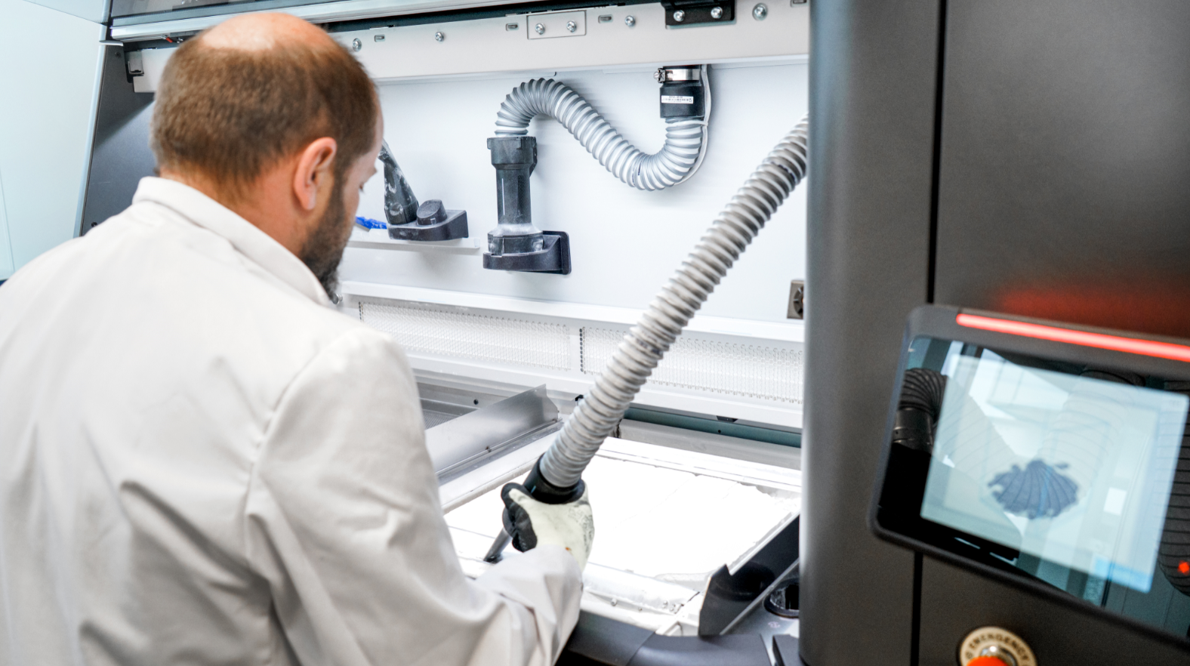
Optima has invested in the advanced multi-jet fusion technology which enables parts to be produced faster than with the SLS process. (Source: Optima)

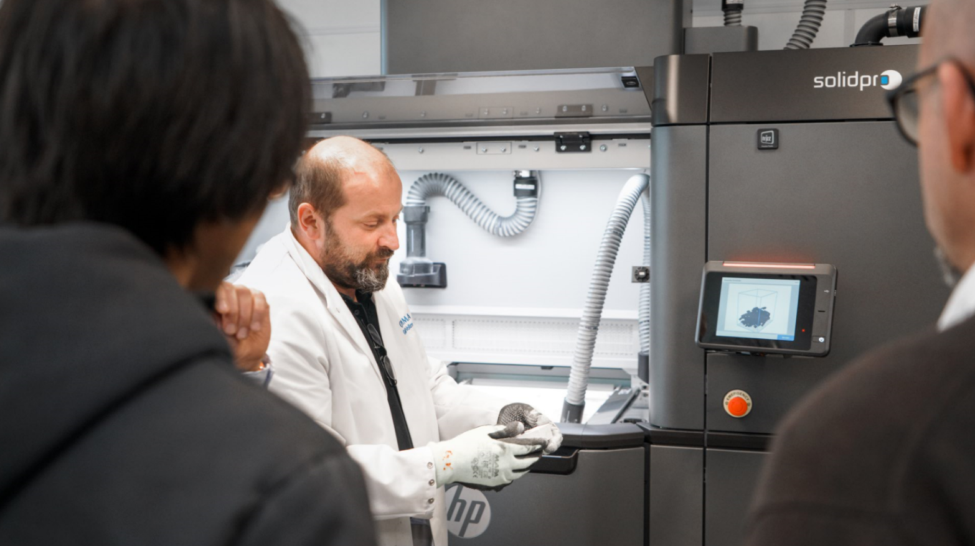
The breakthrough of SLS and multi-jet fusion printing technology has paved the way for companies to take 3D printing to an industrial level, far beyond simply creating prototypes. (Source: Optima)

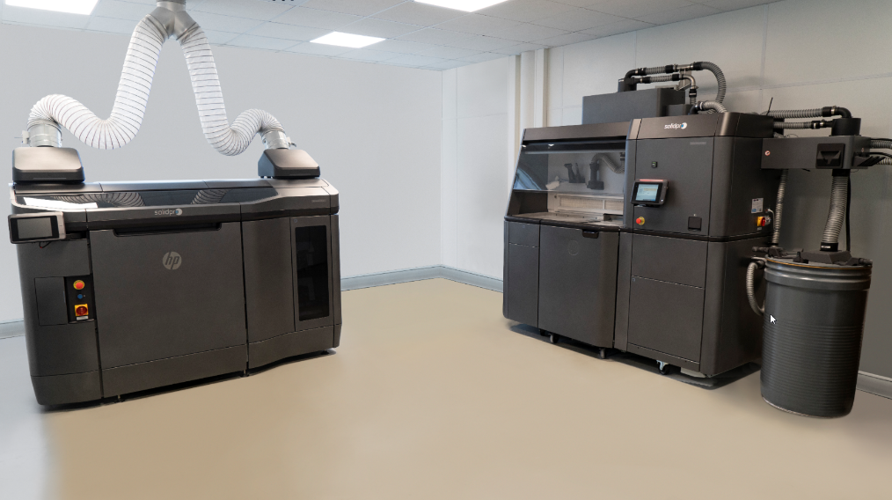
Additive manufacturing – the 3D printing process – enables Optima customers to respond with even greater flexibility to new market requirements. Among other processes, Optima uses the multi-jet fusion printing process (image). (Source: Optima)

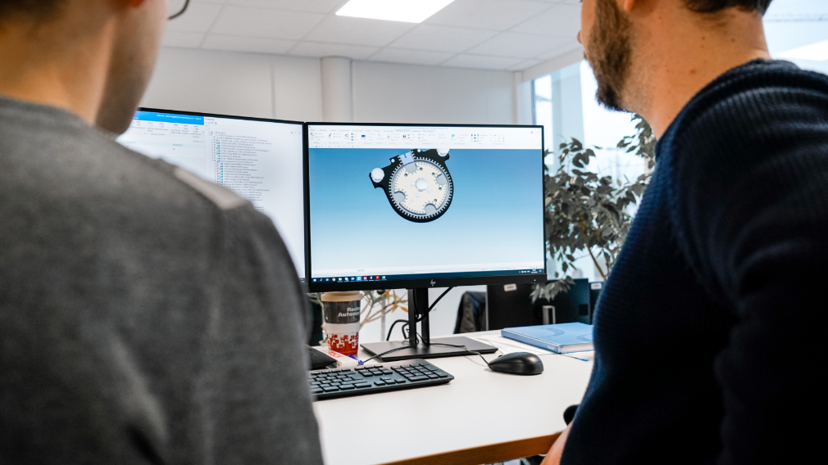
In the Additive Innovation Center's Innovation Space, Optima's engineering department is learning how to use the new technologies. New parts are being created using completely new methods, and existing parts can be designed to be lighter and more stable than before and with less material. (Source: Optima)

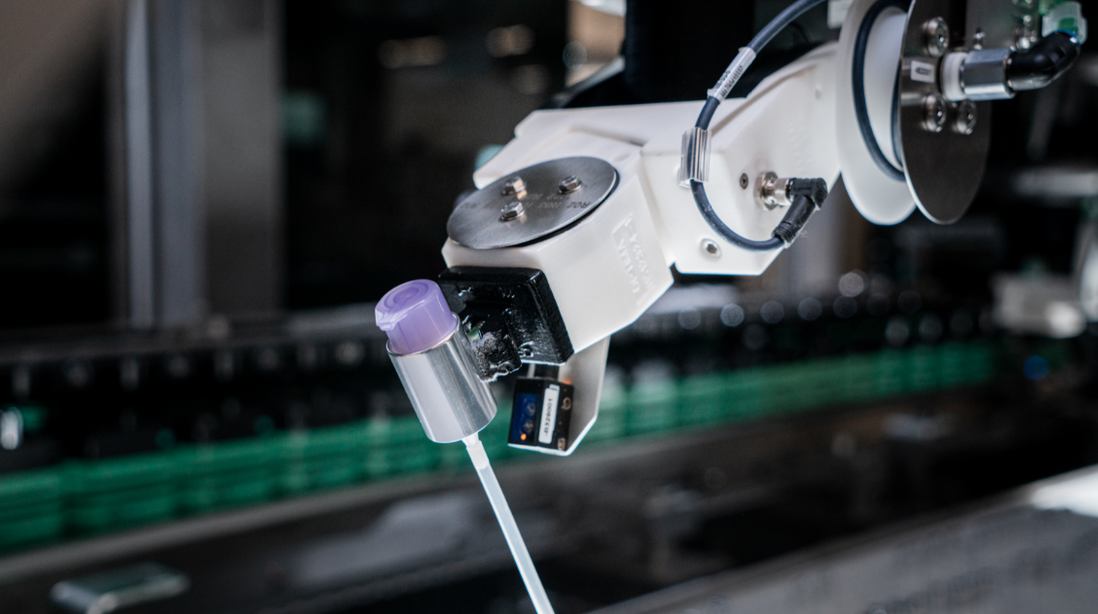
3D components make for greater flexibility: At Optima, for example, they are used in this robot gripping tool of a filling system for cosmetics. If new closure types have to be processed, a suitable gripping element can be printed on the 3D printer. (Source: Optima)

Characters (incl. spaces): 3,311

Press contact:
OPTIMA packaging group GmbH
Jan Deininger
Editor
+49 (0)791 / 506-1472
jan.deininger@optima-packaging.com
www.optima-packaging.com
Thank you very much for your publication. We look forward to receiving a specimen copy.

