GEA opens reciprocating compressor package assembly line in Izmir, Turkey.

Duesseldorf (Germany), November 13, 2025 – GEA has inaugurated a new reciprocating compressor package assembly line in Izmir, Turkey. The facility strengthens GEA’s regional footprint and enables faster delivery to customers in Turkey and neighboring CIS markets, including Azerbaijan, Kazakhstan, and Uzbekistan. The Izmir site complements GEA’s European operations by assembling packages to global standards while increasingly leveraging regional suppliers to reduce import dependency and strengthen supply resilience.

Optimizing Existing Infrastructure

The Compression Technologies assembly area was established in a newly dedicated part of the GEA facility, expanding the existing service and repair workshop. The assembly line and service workshop now encompasses more than 800 square meters. Upgrades include a new 15-ton crane, tools and fixtures for welding and assembly, and a dedicated room for end-of-line pressure testing.

A new training room, centrally located within the assembly facility, is fully equipped to provide hands-on technical training for employees, contractors, and partners on reciprocating compressor assembly and maintenance.

To ensure the highest standards of quality and safety, the Izmir facility is certified according to ISO 9001. Welding processes follow WPS (Welding Procedure Specification) certification, with compliance verified by an accredited inspection organization. These certifications underscore GEA’s commitment to delivering reliable, high-performance solutions that meet international benchmarks.

With these new capabilities in Izmir, GEA strengthens its ability to serve regional customers with locally assembled, high-quality solutions—delivered faster and built to global standards.

Reciprocating compressor package: ready-to-use solution for industrial applications

The localized portfolio of GEA’s reciprocating compressor packages are specifically designed for cooling applications. Widely recognized for their straightforward installation and robust performance, these packages are used across a broad range of industries—including food, dairy, beverage, cold storage, and data centers. With the new assembly line in Izmir, GEA reinforces its commitment to delivering locally assembled, high-quality solutions to regional customers—minimizing lead times and ensuring reliable supply, all while maintaining the same global standards of excellence.

Photos:

Photo 1:

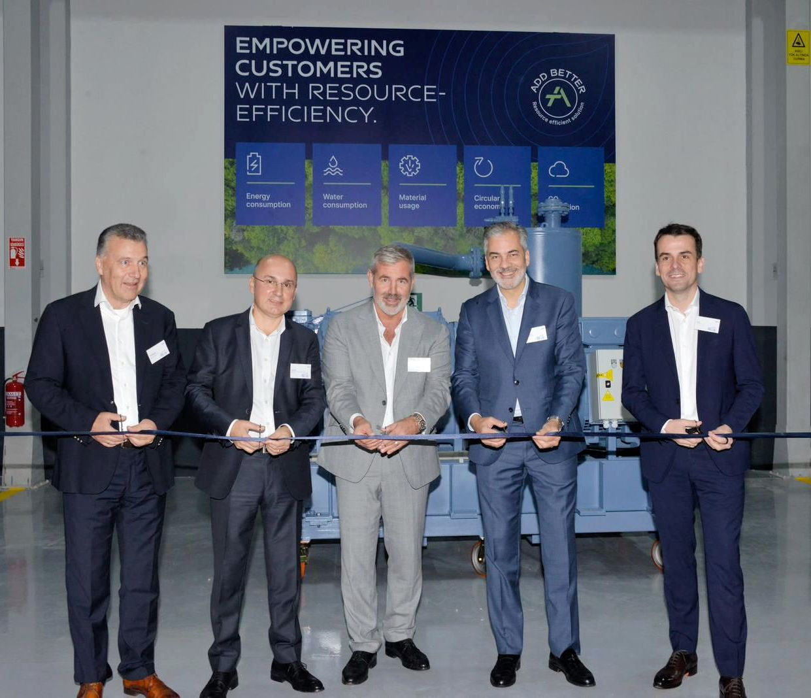

Photo 1, caption: Opening the new assembly line for a reciprocating compressor packages at the GEA site in Izmir (from left to right): Thomas Strotkoetter (GEA, Senior Vice President Business Unit Compression Technologies, Heating & Refrigeration Technologies), Ilker Damar (GEA Turkey, Senior Director Division Heating & Refrigeration Technologies, Western Europe Middle East), Stefan Klebert (CEO GEA Group), Alvaro Martinez (CEO, GEA Western Europe Middle East, Latin America) and Kai Becker (CEO, GEA Heating & Refrigeration Technologies). (Photo: GEA)
Photo 2:

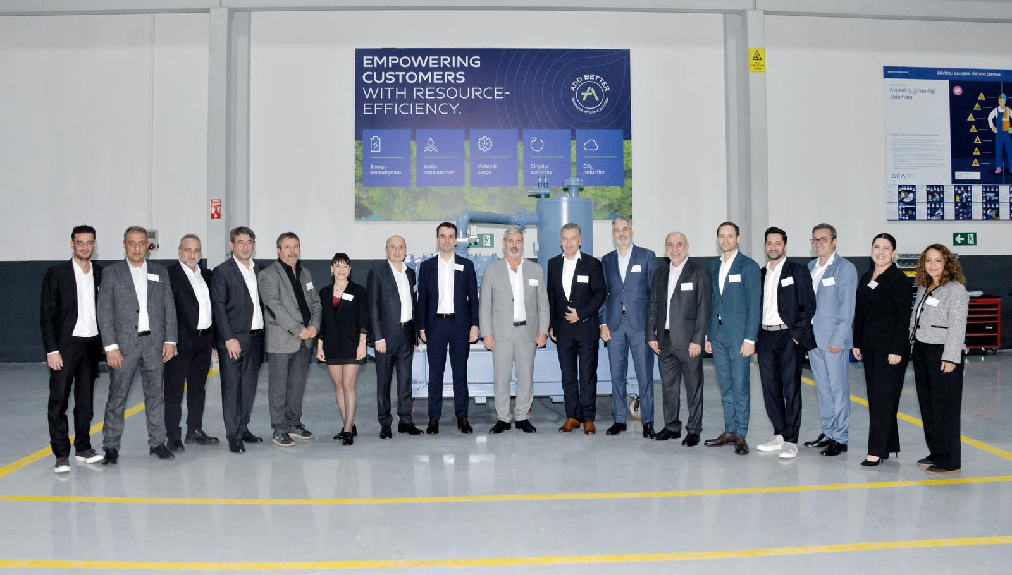

Photo 2, caption: The GEA team at the opening of the new assembly line of a reciprocating compressor packages in Izmir, Turkey. (Photo: GEA)

Photo 3:

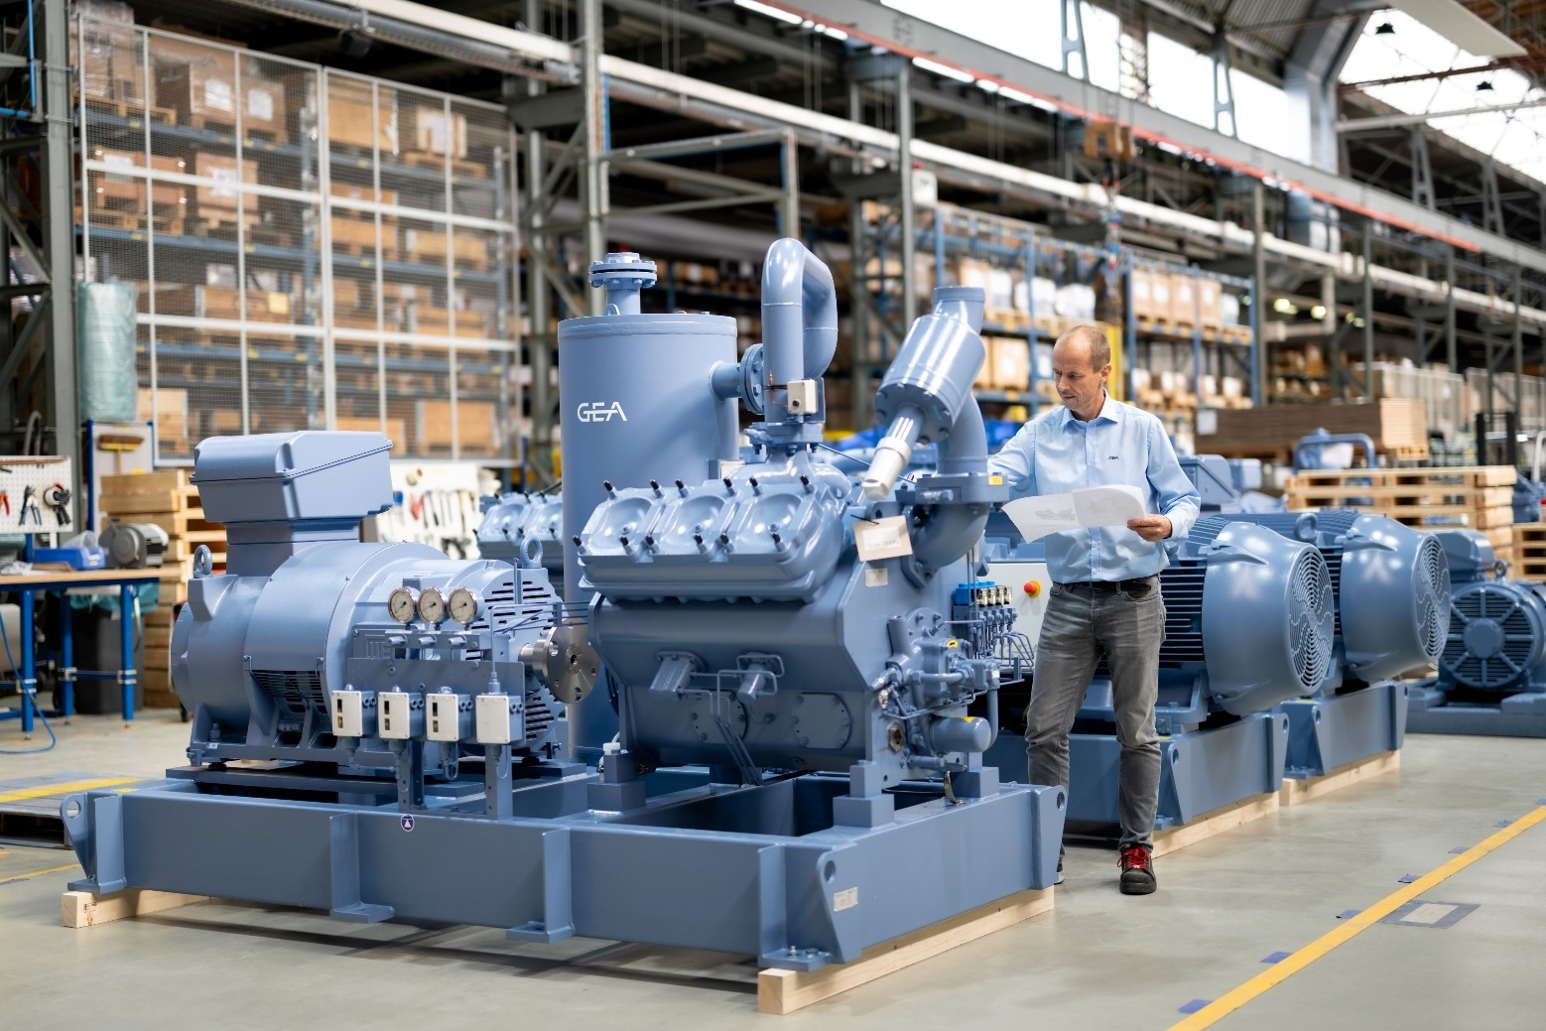

Photo 3, caption: The Izmir site complements GEA’s European operations by assembling packages to global standards while increasingly leveraging regional suppliers to reduce import dependency and strengthen supply resilience. (Photo: GEA)

About GEA
GEA is one of the world’s largest suppliers of systems and components to the food, beverage and pharmaceutical industries. The international technology group, founded in 1881, focuses on machinery and plants, as well as advanced process technology, components and comprehensive services. For instance, every second pharma separator for essential healthcare products such as vaccines or novel biopharmaceuticals is produced by GEA. In food, every fourth package of pasta or every third chicken nugget are processed with GEA technology. With more than 18,000 employees, the group generated revenues of about EUR 5.5 billion in more than 150 countries in the 2024 fiscal year. GEA plants, processes, components and services enhance the efficiency and sustainability of customers’ production. They contribute significantly to the reduction of CO2 emissions, plastic usage and food waste. In doing so, GEA makes a key contribution toward a sustainable future, in line with the company’s purpose: ”Engineering for a better world.”

GEA is listed on the DAX, the STOXX® Europe 600 Index and is also a constituent of the leading sustainability indices DAX 50 ESG, MSCI Global Sustainability and Dow Jones Best-in-Class World.

More information can be found online at gea.com.
If you do not want to receive any further information from GEA, please send an e-mail to pr@gea.com.

NOTE TO EDITORS

- Further information about GEA
- To the GEA Press page
- To the GEA Media Center
- Background information on current topics can be found at Features
- Follow GEA on  

GEA
Media Relations GEA
Dr. Michael Golek
Ulmenstraße 99, 40478 Düsseldorf
Phone +49 211 91361505
Tel. +491736205746
michael.golek@gea.com

