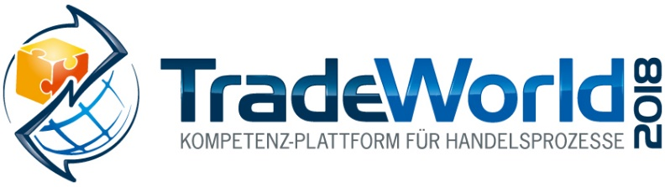
Messe- und Kongress-GmbH
Joseph-Dollinger-Bogen 7
D-80912 Munich, Germany
Phone: +49 (0)89 323 91-259
Fax: +49 (0)89 323 91-246
www.euroexpo.de/en
www.logimat-messe.de/en
www.tradeworld.de/en
March 13–15, 2018, Messe Stuttgart

Presented at:

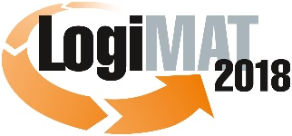

16th International Trade Show for Intralogistics Solutions and Process Management
March 13–15, 2018, Messe Stuttgart

Munich, January 09, 2018

Press Release

TradeWorld at LogiMAT 2018 in Stuttgart
Current practice, trends, and strategies for retail and logistics professionals

Distinguished speakers from the business and academic communities and professional associations come together March 13–15, 2018, at the TradeWorld expert forums in Hall 6 to present a top-notch continuing education program on the successful interaction of e-commerce and logistics – all communicated in the plain language of today’s business world.

The volume of goods ordered online continues to rise, and this business segment comes with its own unique set of logistical challenges. That’s why logistics has become the Achilles heel of e-commerce. “Almost no negative factor weighs so heavily as a late or faulty delivery or unsuccessful delivery attempt,” explains Dr. Petra Seebauer, Managing Director of EUROEXPO Messe- und Kongress-GmbH in Munich, which organizes LogiMAT. “What’s more, free shipping is the main reason that many consumers decide for or against a particular online shop. That’s why fulfillment, delivery services, and above all accurately picked package contents have become such big issues in e-commerce as well,” Seebauer adds.

The distinguished panel of speakers will focus on precisely this contentious issue at this year’s TradeWorld. In six presentations of 90 minutes each, industry insiders join experts in lively roundtable discussions to shed light on the challenges facing e-commerce. In addition, many TradeWorld exhibitors will take part in 30-minute “innovation forums” to present their products and solutions individually.

Forums at a glance:

B2B/e-commerce: Where is our journey taking us?
Dr. Georg Wittmann from the payment and logistics think tank ibi research at the University of Regensburg and Dr. Markus Preissner from the Institute for Trade Research (IFH) in Cologne, partners in the “Mittelstand 4.0-Agentur Handel” project, focus on the unique challenges of B2B e-commerce. Those who wish to succeed here and shift their business procurement processes online need to consider important issues that are largely unknown in the B2C world.

Clash of trends: What trends will affect the e-commerce sector of tomorrow?
Franziska Ulbricht, who in her role at Händlerbund is very well acquainted with the needs of retailers, talks with experts about such trends as same-day delivery, voice commerce or chatbots, cross-channel, platform services, and instant payment as a driving force for new business models.

The last mile: transport of the future
It’s one of the greatest challenges that parcel services and mail-order companies must face in their supply chains: transport to the customer’s door, the so-called “last mile,” where logistics costs tend to soar. Vera Günther, Editor-in-Chief of e-commerce Magazin, joins industry insiders for a discussion of current solutions for last-mile logistics and what the transport of the future might look like.

Omni-channel retailing: what not only the fashion sector should know
Dr. Franz Vallée, founder of the logistics and IT consulting firm Vallée und Partner (VuP), heads a panel discussion focusing on omnichannel – the process of transacting through more than one channel. Dr. Vallée will take listeners through the phases of pre-sales, goods availability, advice, selection, payment, delivery, after-sales, and returns. All these stages in the process must be designed so that the customer does not change merchants.

Retail logistics 4.0: taking stock!
Dr. Volker Lange, Head of Packaging and Retail Logistics at the Fraunhofer Institute for Material Flow and Logistics in Dortmund, joins his fellow panelists to take stock: How far have Industry 4.0 and digitization taken hold in commerce? Which technologies are currently being used? Which mobile apps are already playing a role in retail logistics? What changes are imminent, and what can we expect in the near future?

Platforms in the world of commerce: creating best practice in logistics processes
Matthias Pieringer, Deputy Editor-in-Chief of the trade journal LOGISTIK HEUTE, brings the TradeWorld expert forum to a close with a much-discussed issue about trade platforms today: “Are you just a trader or are you already a platform?” The question is crudely formulated perhaps, but it does describe a trend in the retail world that companies must face, whether they themselves operate a retail platform or their partners do.

For detailed information on the forums and speakers, visit us online at www.tradeworld.de/en/accompanying-program/expert-forums.

Event organizer:
EUROEXPO Messe-und Kongress-GmbH
Joseph-Dollinger-Bogen 7; 80807 Munich, Germany
Phone: +49 (0)89 32391-245
Fax: +49 (0)89 32391-246

About TradeWorld/LogiMAT

LogiMAT 2018, the 16th International Trade Show for Intralogistics Solutions and Process Management, will take place March 13 – 15 on the grounds of Messe Stuttgart, directly adjacent to Stuttgart International Airport. LogiMAT, now the world’s largest intralogistics trade show with over 1,500 exhibitors, offers a comprehensive overview of everything driving the intralogistics industry, from procurement to production to shipping. International exhibitors gather early in the year to showcase innovative technologies, products, systems, and solutions for streamlining operations, optimizing processes, and cutting costs in a company’s internal logistics.

LogiMAT includes the extra bonus of TradeWorld, a professional platform for trade processes, which showcases innovative e-commerce concepts for designing, managing, and integrating digitization in the areas of procurement, online shops and marketing, payment, software, fulfillment, parcel services, returns, and after-sales. Rounding off the package is the TradeWorld expert forum in Hall 6, featuring a new series of presentations each day covering such topics as “B2B/e-commerce: Where is our journey taking us?”; “What trends will affect the e-commerce sector of tomorrow?” “The last mile: transport of the future”; “Omnichannel retailing: what not only the fashion sector should know”; “Retail logistics 4.0: taking stock!”; and “Platforms in the world of commerce.”

TradeWorld’s exhibition area and expert forum are a special strategic component of LogiMAT.

For more information, please visit: www.tradeworld.de or www.logimat-messe.de

6,267 characters (with spaces)
Munich, January 09, 2018 – This text may be reprinted free of charge, but please send a copy to EUROEXPO Messe- und Kongress-GmbH, Press and Public Relations Department, 80912 Munich.

