Active commitment to sustainability and corporate environmental protection

LAMILUX Composites joins the Bavarian Environmental and Climate Pact

LAMILUX Composites, a leading manufacturer of composite materials, has joined the Bavarian Environmental and Climate Pact to reaffirm its commitment to climate protection and a sustainable future. On Monday 22 May, Dr Oliver Bär, District Administrator of the district of Hof, presented the certificate of the Bavarian Environmental and Climate Pact to Managing Directors Dr Heinrich and Dr Alexander Strunz on behalf of the Bavarian State Government.

The Bavarian Environmental and Climate Pact is an initiative of the Bavarian State Government that encourages companies, municipalities and organisations to take concrete measures to reduce greenhouse gas emissions and protect the climate. As a member of the Climate Pact, LAMILUX Composites is committed to playing an active role in promoting sustainability and environmental protection.

By participating in the Bavarian Environmental and Climate Pact, LAMILUX Composites is sending a strong signal about its corporate values and its commitment to sustainable production. The company will intensify its efforts to save energy and reduce CO₂ emissions and seek innovative solutions to increase resource efficiency and further minimise its environmental footprint.

LAMILUX Composites is proud to join the Bavarian Climate Pact and be part of a network of organisations working together for a sustainable future. "Joining the Bavarian Environmental and Climate Pact is an important step for us in making our contribution to climate protection and driving sustainable development," says Dr Alexander Strunz, LAMILUX Managing Director. Mr Strunz continues: "We are proud to be part of this important initiative and will continue our efforts to work with other stakeholders to bring about positive change." The company sees joining as an opportunity to strengthen its commitment to environmental protection and actively raise awareness of this essential issue - among customers, employees, the public and the region.

Being a member of the Bavarian Climate Pact reflects LAMILUX Composites' long-term commitment to sustainable development. This is also confirmed by the District Administrator of Hof, Dr Oliver Bär: "We are all aware that LAMILUX always has high quality standards and is at the forefront of topics relating to future technology and sustainability." The Rehau-based company LAMILUX Composites strives to make a positive contribution to the environment and the conservation of natural resources through continuous innovation and emission reduction measures.

…

www.lamilux.com

About LAMILUX Composites GmbH
LAMILUX Composites GmbH has been producing fibre-reinforced composites for around 70 years. The medium-sized company is a leading European producer thanks to its technologically advanced continuous production process, large manufacturing capacities and wide product range. LAMILUX supplies customers around the globe in a wide range of sectors, such as the building industry, the automotive and recreational vehicle sectors, refrigerated store room and cell construction, and many other industrial sectors. In 2022, LAMILUX and its some 1,300 employees generated a turnover of 392 million euros. The family-managed company is based in Rehau, Bavaria.

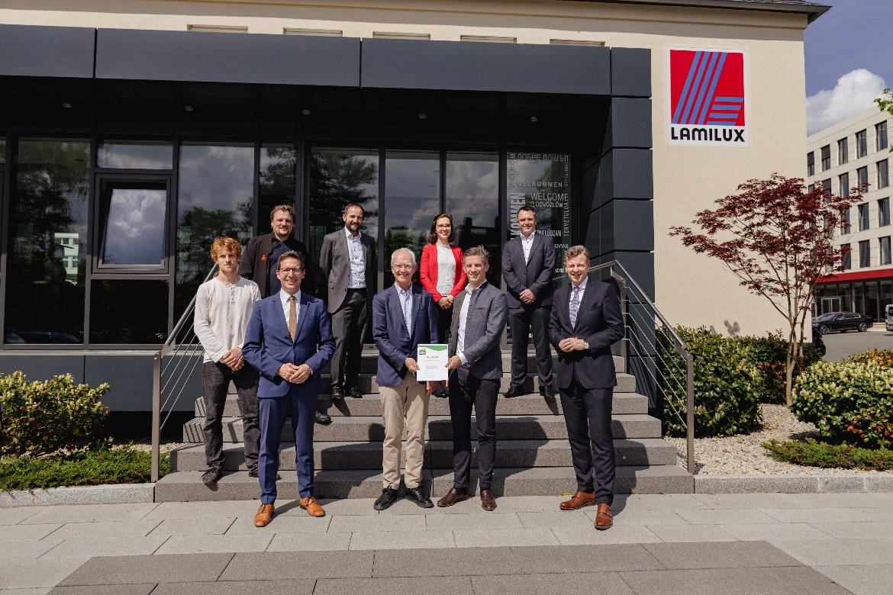
Left to right, rear row: Moritz Rödel and Dr Manuel Gaszner (LAMILUX Industrial Engineering), Dr Marcus Seitz, (Technical Manager of LAMILUX Composites), Dr Karolina Ewers (Management Assistant) and Markus Bächer (Marketing Officer LAMILUX Composites).
Left to right, front row: Michael Abraham (Mayor of Rehau), Dr Heinrich and Dr Alexander Strunz (LAMILUX Managing Director), as well as Dr Oliver Bär (District Administrator of Hof).

