Celle: The Sustainable German Travel Destination
See, taste and experience sustainability

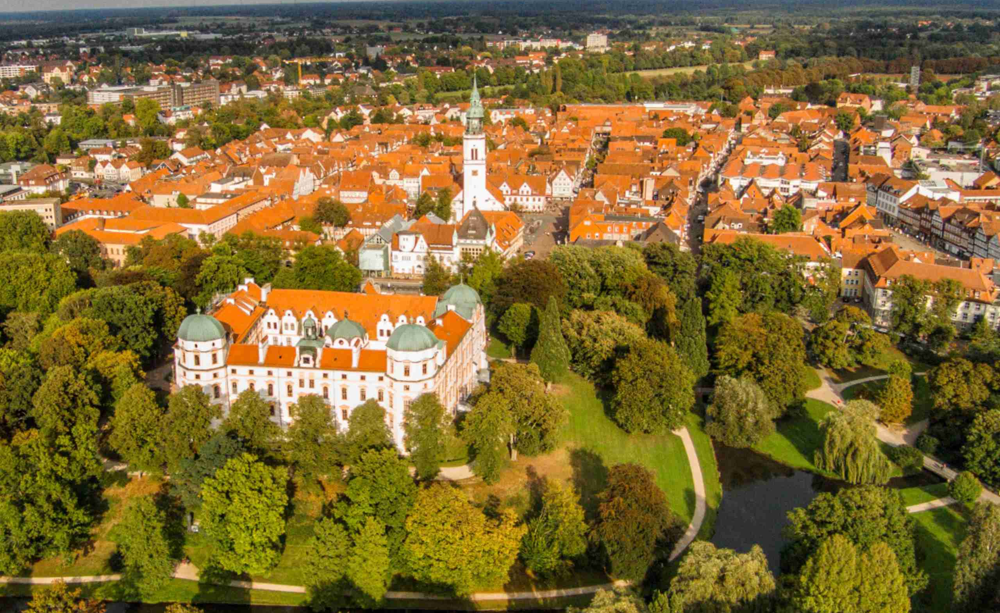

The north German town Celle, worldwide unique for its half-timbered old town, is certified as “sustainable travel destination”. (Copyright: Celle-von-oben.de)

CELLE - Germany | July 2021 – Celle, the first town in Northern Germany to be awarded sustainable travel destination certification (2017) has once more been re-certified by TourCert, the non-profit sustainable travel consultancy. Celle’s diverse and highly proactive ‘green’ policies ensured it met the strict criteria necessary for re-certification, which was also awarded for the input and support of the many local businesses: hoteliers who produce their own honey, restaurants using the freshest, regional products and the local farmer’s market reflecting the seasons, providing organic food and mouth-watering culinary delights. Professional event organisers in Celle were another factor - cutting down on waste and supporting local social projects, as were leisure facilities that generate their own electricity. These are just some of the facets that make Celle one of Germany’s top sustainable destinations.

"Celle was and is a pioneer in terms of sustainable tourism," says Klaus Lohmann, Managing Director of Celle Tourismus und Marketing GmbH (CTM), adding: "the re-certification from TourCert confirms that sustainability is a way of life in Celle. It encompasses all areas of the tourism infrastructure and this is something our visitors from all over the world can see, taste and experience".

Celle’s re-certification partner
Other examples highlighting Celle’s ‘green’ credentials include the ‘Congress Union Celle’, the town’s largest conference and event centre, which relies on seasonal and regional products for its restaurants, uses photovoltaic, supports social projects and a children’s daycare centre, the Celler Tafel (food bank), and the railway mission. The Ringhotel Celler Tor, a traditional family business with 600 years of history, creates flowering meadows - a habitat for insects - and produces its own honey.

At the Hotel Blumlage, inclusion is a priority which has been part of its daily life for years, providing an harmonious co-working environment for people with a diverse range of needs, skills and abilities. The local swimming pool ‘Celler Badeland’ covers its electricity needs with a combined heat and power plant and the public utility ‘Stadtwerke Celle’ exclusively supplies 100 per cent green electricity. Local entrepreneur Dörte Hirschfeld has opened a new venture based on an old tradition – ‘Alter Provisor’ - in the premises of the former pharmacy ‘Ratsapotheke’ in the heart of Celle’s historical town centre; Alter Provisor is a herbal liqueur known far beyond Celle, made to an original recipe more than 100 years old and which Dörte produces and sells in refillable bottles, from this restored and beautiful historical location.

Sustainability is becoming a competitive factor
Around 20 Celle companies, tourist businesses and institutions are currently involved in the town’s initiative ‘Celle - Excellently Sustainable’. They are all committed to continually expanding and evolving their services, in terms of environmental protection, working conditions, customer relationships and fair business practice, not forgetting Celle’s Christmas market (25. 11. – 26.12.2021), which was voted Germany’s Best Christmas Market in 2019 and also reflects its TourCert status. "This makes sustainability in Celle as diverse and varied as the town itself," says Lohmann, who is proud of the many ongoing initiatives, projects and campaigns, explaining: "many companies go far above and beyond what is legally required and
this makes Celle not only a sustainable and attractive place to visit, but also adds significantly to the day to day quality of life here”.

Last but not least, Celle is surrounded by nature and an ideal starting point for many inspiring, easy to follow hiking and cycling trails. It is also the southern gateway to the bio-diverse nature reserve of the Lüneburg Heath, an area which is a highly important historic heath landscape.

For more information on the "Celle - Excellently Sustainable" initiative, please go to:
www.celle-tourismus.de/nachhaltigkeit

Notes to Editors:

The sustainability process in Celle:
Under the leadership of Celle Tourismus und Marketing GmbH, sustainability factors for tourism in Celle were analysed and evaluated. In this context, improvement measures were identified, a sustainability report was created and sustainability was integrated into the tourism strategy. An essential part of the process is a partner system made up of tourism businesses. Independent experts regularly check compliance with the TourCert criteria.

About TourCert:
The non-profit and independent organisation TourCert has been promoting sustainable tourism for more than ten years and awards the internationally recognised seal to tour operators, travel agencies, accommodation providers and destinations. They in turn undertake to go beyond the legal provisions to meet social and ecological requirements in their core business and to continuously improve their sustainability performance. The criteria of the TourCert system have been recognised by the Global Sustainability Tourism Council and are based on international quality and environmental management standards according to ISO and EMAS as well as the ISO guidelines for corporate responsibility (ISO 26000).
Additional Information: www.tourcert.org

(5.293 signs)
# # #

CELLE. surprising. diverse.
About 40 kilometers north of Hannover, Celle, with around 70,000 inhabitants, is the picturesque southern gateway to the Lüneburg Heath. This 700-year-old Ducal Town is not only home to one of the most beautiful Guelph castles of northern Germany with its own baroque theatre, Celle also impresses with its historic old town which has the largest half-timbered ensembles in the world. There is also Bauhaus Architecture, classic and modern museums and a diverse mix of culture and gastronomy. Celle is a holiday destination for young and old and with its many owner-managed shops in the old town, also inspires as a shopping town with flair. www.celle-tourismus.de

More pictures of Celle can be found in the Image Database on the homepage of Celle Tourismus und Marketing GmbH. Please contact us for additional pictures.

