IPPE, 30 January - 1 February 2024
GEA presents new continuous process for bacon at IPPE 2024

Duesseldorf (Germany), January 22, 2024 – Exhibiting under the banner ‘Excellence in Protein Processing’, food system supplier GEA will once again be welcoming visitors to the International Production and Processing Expo (IPPE) in Atlanta (US) with its latest innovations. An impressive selection of GEA’s food processing and packaging machines will be showcased, including solutions for slicing, packaging, cooking, freezing and marination. One highlight will be the company’s new continuous line for bacon, details of which will be available at IPPE for the first time.

“Our participation in shows like IPPE give us the opportunity to connect directly with customers,” says Azam Owaisi, CEO GEA North America. “The new technologies we showcase provide a variety of innovative solutions based on their business needs in the food industry.”

Continuous bacon line

Visitors to IPPE will have the opportunity to learn about GEA’s new continuous bacon process, which significantly increases speed and capacity, taking the ‘batch’ out of bacon production and simplifying the creation of this ever-popular food. This all-in-one solution comes with the option of a fully incorporated smoking stage, offering much shorter process times than a conventional smokehouse. The system perfectly complements GEA’s signature injection machine, the MultiJector 2mm, which injects the brine into the bacon using a dense needle pattern for even distribution and retention. It will be displayed on the stand. After the smoking step, bacon hardening is handled by GEA’s A-Tec spiral freezer, providing the right product conditions for slicing.

Ham processing

Of particular note and appearing for the first time at IPPE, GEA will be showcasing the OptiSlicer 6000, a high-speed slicing machine designed for standard shaped products such as cooked ham, calibrated sausage, salami and cheese. Various portion arrangements including shingle, stack, zig zag, shaved, interleaved and folded are all possible with this versatile slicer, which slices with pinpoint accuracy, keeping wastage to a minimum.

Visitors will also be able to find out more about GEA’s market leading technology for defrosting, including the efficient ColdSteam T. This is a defrosting tumbler featuring significant reduction in defrosting times and increased yield, due to reduced weight loss from purge. Suitable for use with all types of meat and poultry, the ColdSteam T is ideal for processors looking to retain optimum moisture in their ham prior to marination and brining.

PowerPak thermoformer

At the packing end, GEA’s highly flexible PowerPak MidSize will also be making its first appearance at IPPE, offering a multitude of thermoformed packaging options for virtually any food item. All well-known package types such as MAP, skin and vacuum packs or sustainable solutions including the GEA FoodTray can be produced on this convenient and reliable machine and units are available for immediate delivery.

Cooking and freezing technology

GEA will also show the latest cooking and freezing technology. A model of the company’s CookStar will be on the stand alongside vital information on cooking technologies. Freezing solutions include GEA’s ever popular A-Tec Spiral Freezer, a mainstay for food manufacturers all over the world since its launch in 1999. The latest generation of A-Tecs boasts a convenient recirculating clean-in-place system and is capable of 14 days’ continuous operation at up to 7 tons capacity per hour. Visitors will also be able to learn about the IVRT Carton Freezer, which can simultaneously handle various product sizes and types in cartons, totes or crates with different chilling and freezing profiles.

GEA offers complete line solutions for protein products including defrosting, forming, cooking, smoking, brine preparation, injection, tenderizing, tumbling and freezing, right through to slicing and packaging. Customers can be assured of stringent process control, which results in consistent, repeatable and premium quality results.

GEA at IPPE, Booth C35125
30 January–1 February, 2024
Georgia World Congress Center, Atlanta, USA

Link landing page: GEA at IPPE 2024

gea.com

Download link for high-res images

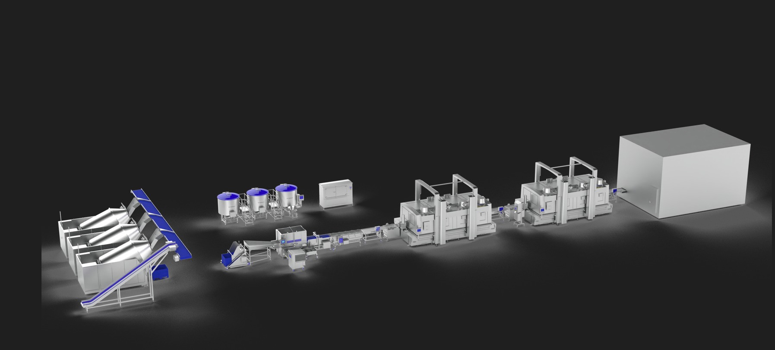
Pic. 1: The all-in-one bacon processing line from GEA comes with the option of a fully incorporated smoking stage, offering much shorter process times than a conventional smokehouse. (GEA)

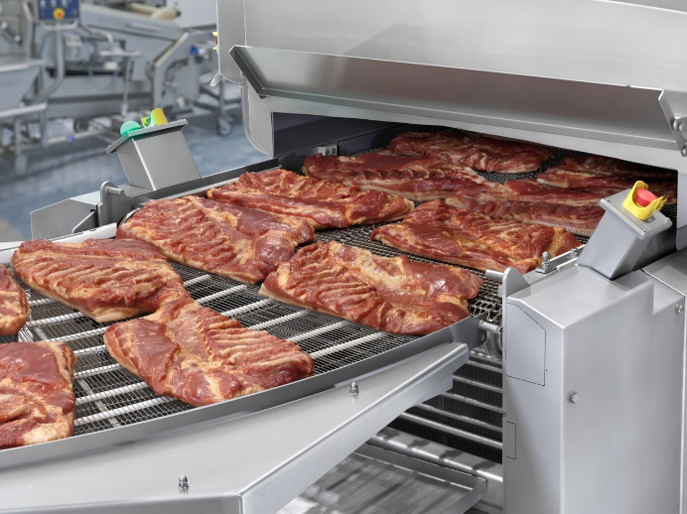
Pic. 2: GEA CookStar 1000 GEN 3 outfeed with smoked bacon bellies (GEA)

NOTE TO EDITORS
- Further information about GEA
- Please visit GEA’s press website
- GEA images
- Follow GEA on

About GEA
GEA is one of the world's largest suppliers of systems and components to the food, beverage, and pharmaceutical industries. The international technology group, founded in 1881, focuses on machinery and plants, as well as advanced process technology, components, and comprehensive services. With more than 18,000 employees working across five divisions and
62 countries, the group generated revenues of more than EUR 5.1 billion in fiscal year 2022. GEA plants, processes, components, and services enhance the efficiency and sustainability of production processes across the globe. They contribute significantly to the reduction of CO₂ emissions, plastic usage, and food waste. In doing so, GEA makes a key contribution toward a sustainable future, in line with the company’s purpose: "Engineering for a better world".

GEA is listed in the German MDAX and the STOXX® Europe 600 Index and is also among the companies comprising the
DAX 50 ESG and MSCI Global Sustainability and the Dow Jones Sustainability World Indices.

More information can be found online at gea.com.
If you do not want to receive any further information from GEA, please send an e-mail to pr@gea.com.

Media Relations GEA HQ Media Relations GEA North America
Nicole Meierotto Joel Palaschak
Peter-Müller-Str. 12 9165 Rumsey Road,
40468 Düsseldorf, Germany Columbia MD 21045, USA
Phone +49 211 9136-1503 Phone +1 667 327 9185
nicole.meierotto@gea.com joel.palaschak@gea.com

For sales enquiries please contact:
Mira Arts
Marketing Director
GEA Food Solutions
Email: mira.arts@gea.com
Website: www.gea.com

