LAMILUX: New rooflight with wave shape offers greater stability

New standard for the industrial flat roof

Gale-force winds, hail, heavy rain or snowstorms: For a number of years now, there has been an increase in extreme weather events, which mainly affect roofs and the skylights integrated into them. To ensure greater safety in such weather extremes and greater stability under heavy loads, skylight manufacturer LAMILUX has developed a new rooflight dome with a hitherto unique wave shape. Thanks to the wave shape of the dome shell, the new LAMILUX Rooflight F100 W ensures better load transfer and greater stiffness without using more material – an absolute revolution in the field of skylights.

The clever geometry of the brand new LAMILUX Rooflight F100 W is unique on the market and sets new standards for the industrial flat roof. Does the application demand more than expected? LAMILUX offers more than expected! For over 70 years, LAMILUX has been thinking and testing beyond standardised minimum requirements to deliver more than expected for customers and their projects with the most modern and technically advanced skylights.

Greater stability under heavy loads

Thanks to the wave-like structure of the Rooflight F100 W, the glazing absorbs loads better and distributes them evenly. This leads to better load transfer and greater stiffness. As a result, the new LAMILUX rooflight dome remains watertight at higher wind speeds and can withstand more wind and snow. Not only that: The load-bearing capacity for snow is also increased, depending on the size and rooflight variant, by up to four times compared to domed rooflights available on the market to date. Additional stability advantages: The new rooflight dome has been tested for resistance to heavy rainfall of 8 litres per square metre per minute and simultaneous hurricanes of up to 115 km/h and the highest hail resistance class HW5. This means: The wave-shaped rooflight can even withstand 50 mm hailstones hitting it from the sky with a final speed of 111 km/h.

Greater safety during weather extremes

Precisely because weather extremes occur irregularly and suddenly, it is particularly important to protect roofs from the dangers of environmental influences. “As a manufacturer of skylights, we consider it our duty to adapt our skylights to the constantly changing influences in order to protect buildings preventively against extreme weather events. Therefore, it was our goal to once again optimise the functionality and stability of our well-known classic skylight. This is how the LAMILUX Rooflight F100 W came into being – with an innovative wave shape,” explains Niklas Braun, technical manager for the daylight systems division of the LAMILUX Heinrich Strunz Group.

Greater comfort during installation

The new product from LAMILUX is impressive not only due to its technical advantages but also due to it being even easier to install on the roof. This is because the constructive improvement of the geometry without additional material does not generate any additional weight. Following the tradition of other LAMILUX skylights, the new Rooflight F100 W is also delivered to the construction site completely pre-assembled. There is thus nothing standing in the way of uncomplicated installation for fabricators. Those who want to configure their own individual version of the new rooflight dome can now also find the F100 W rooflight dome in the award-winning LAMILUX [product configurator](https://www.lamilux.com/skylights/products/rooflight-dome/rooflight-f100-w.html).

…

[www.lamilux.com](http://www.lamilux.com)

**LAMILUX Heinrich Strunz Group, Rehau, Germany**

Continuous rooflights, glass roofs, flat roof windows or rooflight domes: The LAMILUX Heinrich Strunz Group is one of the leading manufacturers of skylights in Europe. The visually appealing products ensure efficient use of natural daylight in a wide variety of buildings. In addition, special smoke and heat exhaust ventilation systems provide safety in case of fire and are thus essential components of fire protection concepts. Furthermore, the medium-sized family business founded in 1909 is one of the world's largest producers of carbon and glass fibre reinforced plastics. These special composite materials are used in commercial vehicles and are impressive thanks primarily to their stability, lightweight construction and impact resistance in roof, wall and floor cladding and their lightness. The internationally active family-run company based in Rehau currently employs a workforce of more than 1250 people and achieved a turnover of roughly 335 million euros in 2021. The LAMILUX Group also includes the steel-glass specialist MIROTEC, which produces constructions that span wide roof surfaces or large façades, as well as the lighting and ventilation experts roda/E.M.B.

**Captions**

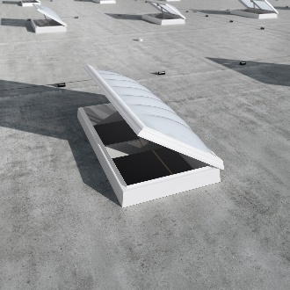**LAMILUX Rooflight F100 W_01**  
*The wave shape of the dome shell creates better load transfer and more rigidity without using more material - an absolute revolution in the field of skylights.*

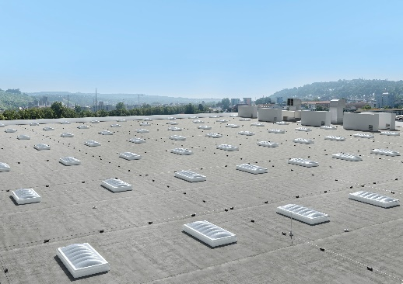**LAMILUX Rooflight F100 W_02**

*The geometrically optimised design of the rooflight dome shell creates architectural highlights on the flat roof that are so far unique on the market.*

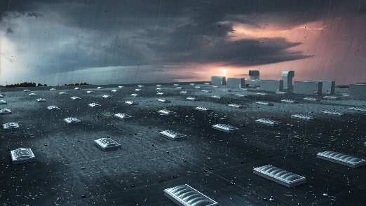**LAMILUX Rooflight F100 W_03**

*The new LAMILUX Rooflight F100 W provides more stability under heavy loads, more safety in extreme weather conditions and more convenience during installation.*

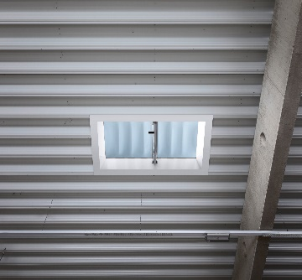**LAMILUX Rooflight F100 W_04**

*The new LAMILUX Rooflight F100 W dome enables safe daylight penetration even under extreme loads.*