PRESS RELEASE
Schwäbisch Hall, 12/20/2019

Modular assembly machines for medical products
OPTIMA automation at Arab Health 2020

OPTIMA automation, as the leading provider of modular assembly machines for medical products like blood collection tubes as well as auto and pen injectors, will present its range of products at Arab Health 2020. These machines can be used in a variety of ways, from semiautomatic to fully automatic.
The versatile, proven technologies and processes from OPTIMA automation create high-quality medical products. Machines to manufacture blood collection tubes like the OPTIMA BCT-200 are one of the company’s main focuses in presenting at Arab Health. As complete solutions, these can include component feeding, tube cleaning, germ reduction, additive dosage, drying, and vacuum processes. Various packaging solutions as well as control and monitoring features are also provided as part of these systems as needed.
OPTIMA automation will also provide information about its flexible machine platforms used for the final assembly of auto and pen injectors. These machines can be set up for semiautomatic, lower performance machines from the beginning, as is typically required during the qualification phase, in order to then scale up to full automation for production. Machines like the OPTIMA AIM for auto injectors and the OPTIMA PIM for pen injectors can be adapted for use with injection systems from various manufacturers.
Depending on the required capacity and application, OPTIMA automation machines, as rotary transfer machines, can be set up in modular or linear configurations.
From the beginning of the project, OPTIMA automation follows a cooperative advisory approach. Transparency over the entire course of the project is key here. Qualification and validation processes are carried out in accordance with regulatory provisions. OPTIMA automation is headquartered in Germany and undertakes projects and provides services around the world. The company is part of the Optima Packaging Group, which employs more than 2,400 people at 19 locations in Germany and abroad.
OPTIMA automation at Arab Health (Dubai), January 27 - 30, 2020: Booth no. Z4.E19
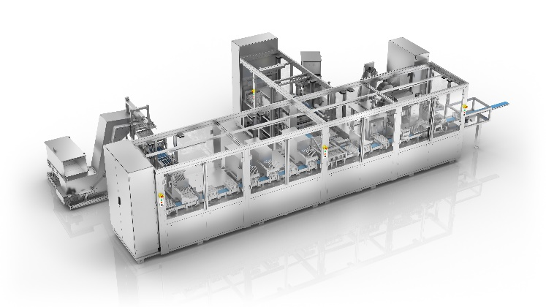
At Arab Health, OPTIMA automation will present its extensive range of machines used to assemble medical products. Machines like the OPTIMA BCT-200 for blood collection tubes are designed to be modular and scalable.

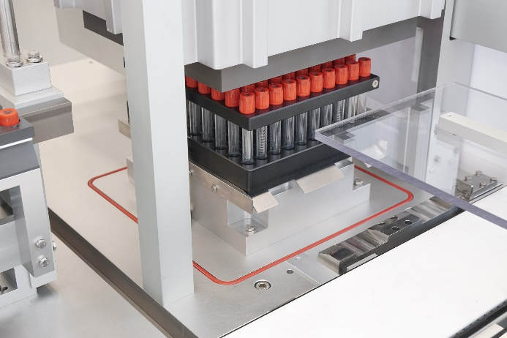
Oxygen is removed from the blood collection tubes at a vacuum station. Before this, they are filled with additives and dried out as necessary.

Characters (including spaces): 2,143

Press contact:
OPTIMA packaging group GmbH
Jan Deininger
Editor
+49 (0)791 / 506-1472
jan.deininger@optima-packaging.com
www.optima-packaging.com
Thank you for publishing this information. We would be pleased to receive a file copy.

