International, culturally diverse:
new English Website reflects the unique treasures of Celle

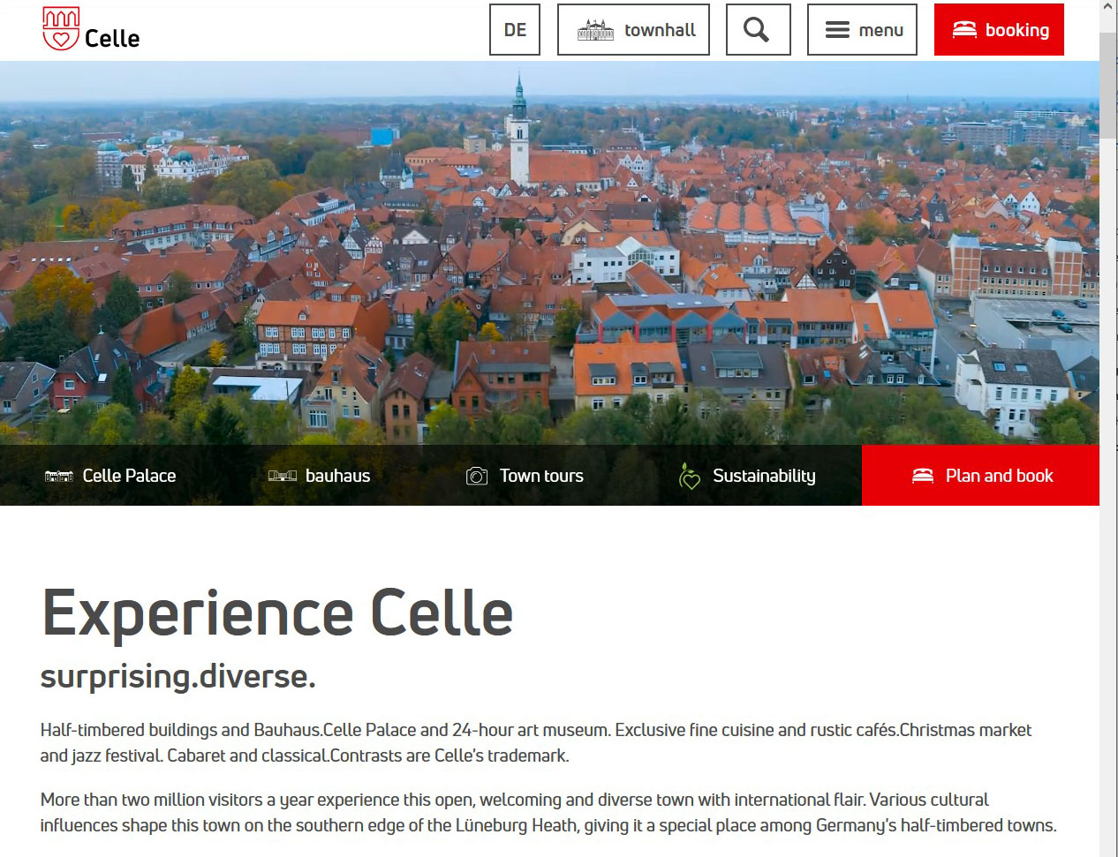
Celle’s new English-language website will offer international guests an even richer resource for information and holiday planning in future. (Copyright: Celle Tourismus)

CELLE - Germany | February 2022 – More than two million visitors a year visit Celle - the town of original, 725-year-old half-timbered buildings and contrasting Bauhaus settlements, in the heart of northern Germany. Many visitors are from neighbouring European countries, but with the launch of its new English-language website www.celle.travel, Celle has firmly set its sights on attracting an even bigger and wider international market.

As one of Northern Germany’s main tourist attractions, Celle’s historical old town has proved to be a magnet, especially for international visitors. With more than 500 half-timbered buildings extensively and carefully restored, plus memorable gastronomy and shopping experiences, Celle is unique – no other city in the world offers visitors the opportunity to experience such a densely packed, preserved ensemble of half-timbered architecture dating back five centuries with modern comforts. How fitting then that Celle has recently been voted one of the ‘Top 100’ sights in Germany by online visitors to the German National Tourist Board website (DZT).*

Through Celle’s new English language website visitors can now discover that there is even more to explore, in addition to the town’s remarkable history and architecture. “With the new website, we want to arouse visitors’ curiosity, to inspire people, to challenge their expectations” says Klaus Lohmann, Managing Director of Celle Tourismus und Marketing GmbH (CTM), adding: “Celle is very international and sustainable and often referred to as a 'hidden gem' but in the old town especially, with its eclectic variety of shops and mix of regional and international restaurants, you can feel cultural diversity at every corner. Celle offers a very special combination of architecture, culture, gastronomy and activities, plus glorious natural landscapes right on its doorstep. It’s a place to stop, to linger and to explore”.

In addition to its unique half-timbered architecture, Celle is home to the extensive Bauhaus legacy left by architect Otto Haesler, as well as the gleaming, Royal fairytale Guelph Palace and Renaissance chapel - three UNESCO-rich themes. With this new English website, the visitor has a window to the sheer diversity of attractions that Celle has to offer – where tradition meets modernity, art and culture, in the heart of an historical, yet vibrant old town – presenting Celle as the don’t-miss destination, in a very appealing way.

*Source: online survey conducted by The German National Tourist Board (GNTB); this question was put to international visitors and more than 14,000 people from around the world chose their personal favourites for 2020/2021.

(2.680 signs)
# # #

CELLE. surprising. diverse.
About 40 kilometers north of Hannover, Celle, with around 70,000 inhabitants, is the picturesque southern gateway to the Lüneburg Heath. This 725-year-old Ducal Town is not only home to one of the most beautiful Guelph castles of northern Germany with its own baroque theatre, Celle’s historic old town is highly impressive, with the largest ensemble of half-timbered buildings in the world. There is also Bauhaus Architecture, classic and modern museums and a diverse mix of culture and gastronomy. Celle is a holiday destination for young and old and with its many independent, owner-managed shops in the old town, also inspires as a shopping town with style and flair. www.celle.travel

More pictures of Celle can be found in the Image Database on the homepage of Celle Tourismus und Marketing GmbH. Please contact us for additional pictures.

