PRESS RELEASE
Schwaebisch Hall, April 12, 2022

Even closer to its customers, expanding space for growing demand
OPTIMA pharma is expanding its service presence in the USA by opening a service hub in North Carolina

The Optima Group's Pharma business unit is massively expanding its service presence in the USA. The number of service personnel in the U.S. will triple between 2019 and the end of 2022. Mid-2022, Optima will be opening a new service hub in Knightdale near Raleigh, North Carolina. The service hub will be offering comprehensive services, systems' sales and spare parts, along with training. Optima’s goal is to expand capacity to meet the needs of pharma customers.
For Optima Group, the Pharma business unit serves as an important and growing market in North America. The pharmaceutical sector yields high demand for Optima machinery and systems, as well as its services, generating expansion opportunity for Optima. The service hub will be located in Knightdale, a suburb near Raleigh, North Carolina. Knightdale is located in what is known as the Research Triangle, where many of Optima Pharma customers are located. Restrictions on travel has made direct customer contact more difficult for every company. "The COVID-19 pandemic has once again demonstrated how important local support is", says Gerhard Breu, Chairman of the Optima Pharma Division.
Rapid availability of services and components
"The new service hub will bring us even closer to our customers and allows us to provide faster service along with enhanced spare parts availability", adds Ulrich Unterriker, Managing Director of the Optima Machinery Corporation in Green Bay, Wisconsin. Experienced engineer, Doug Nash will be overseeing operations within the new service hub. Nash studied electrical engineering and has 20 years of experience as a maintenance engineer in filling and packaging companies within a variety of industries, including pharmaceuticals.
Optimal pharma system availability
"By expanding our service presence in the U.S., we are continuing to optimize the availability of our customers' machines and systems," says Holger Burgermeister, Director Service at Optima Pharma. Optima Pharma, working in cooperation with Optima’s Green Bay office will provide both remote and on-site customer support from the new service hub. Optima Pharma sales experts will also be available to provide advice on new and existing machine projects. Comprehensive services offered will include maintenance, modifications, qualification of pharmaceutical systems, and the training of operating personnel. Spare parts will be stored at the site to ensure system availability at all times.
Service personnel numbers to triple between 2019 and 2022
Optima Pharma's presence in the American market has been consistently expanding in recent years. Service personnel is expected to increase by threefold near the end of 2022. Optima has had a subsidiary in Green Bay, Wisconsin for almost 40 years. In 2017, the site expanded by 1,200 square meters. In total, over 50 sales and service staff provide on-site support to Optima's American customers in the pharmaceutical sector.

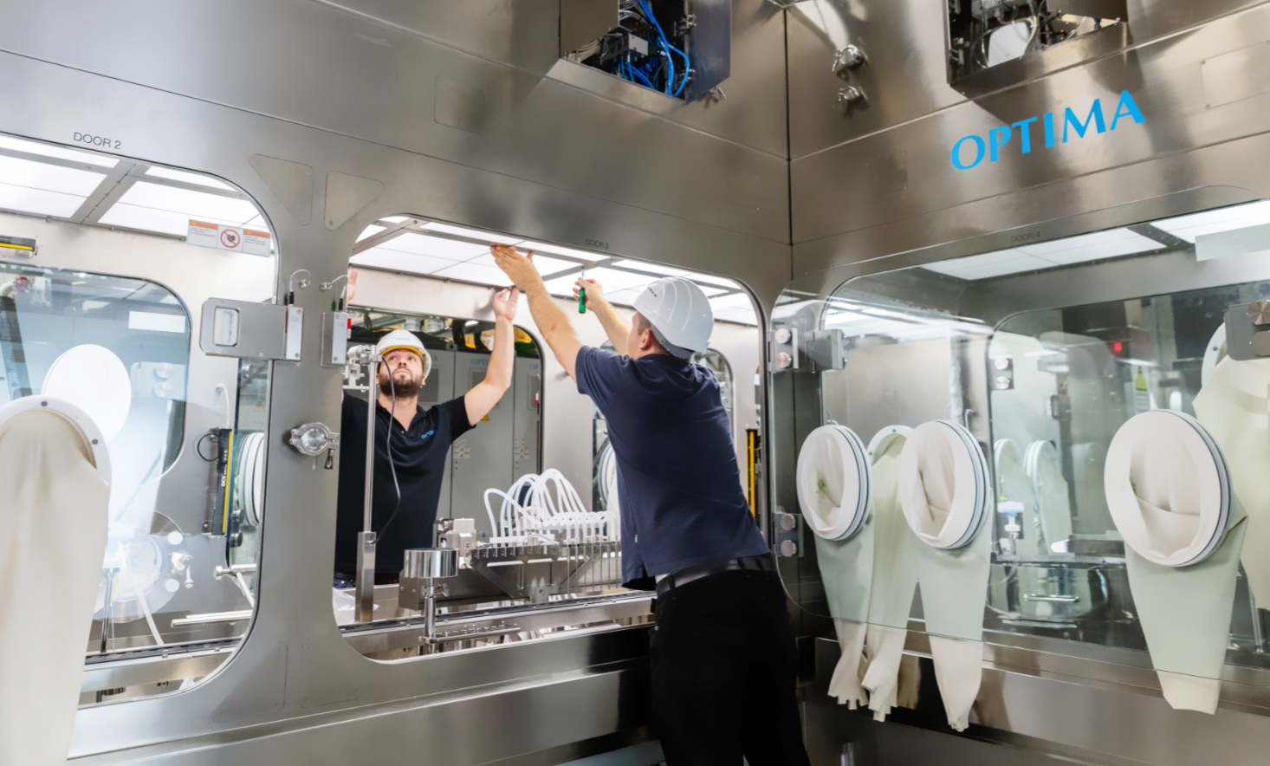
Proximity to customers, faster support, more personal – Optima Pharma is expanding its service presence in the USA. (Source: Optima)

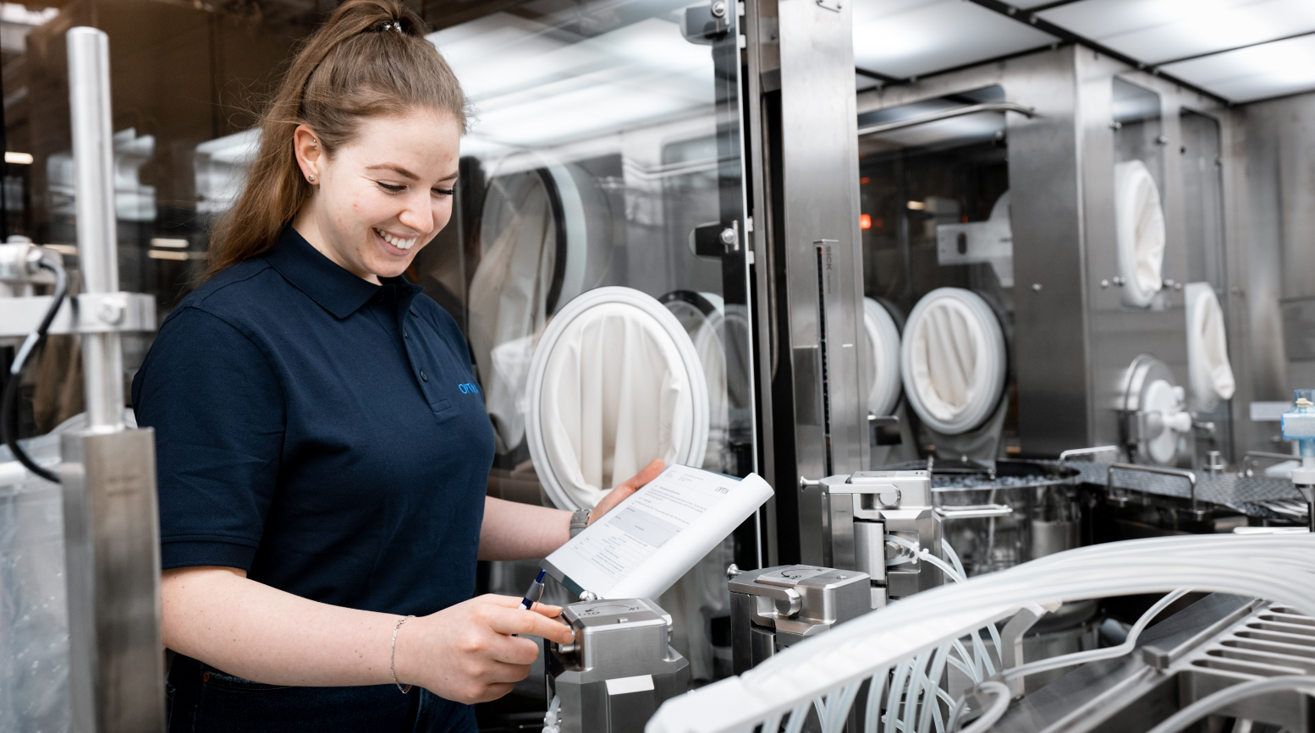
The new service location in Knightdale, North Carolina aims to ensure optimum availability of machinery and systems. (Source: Optima)

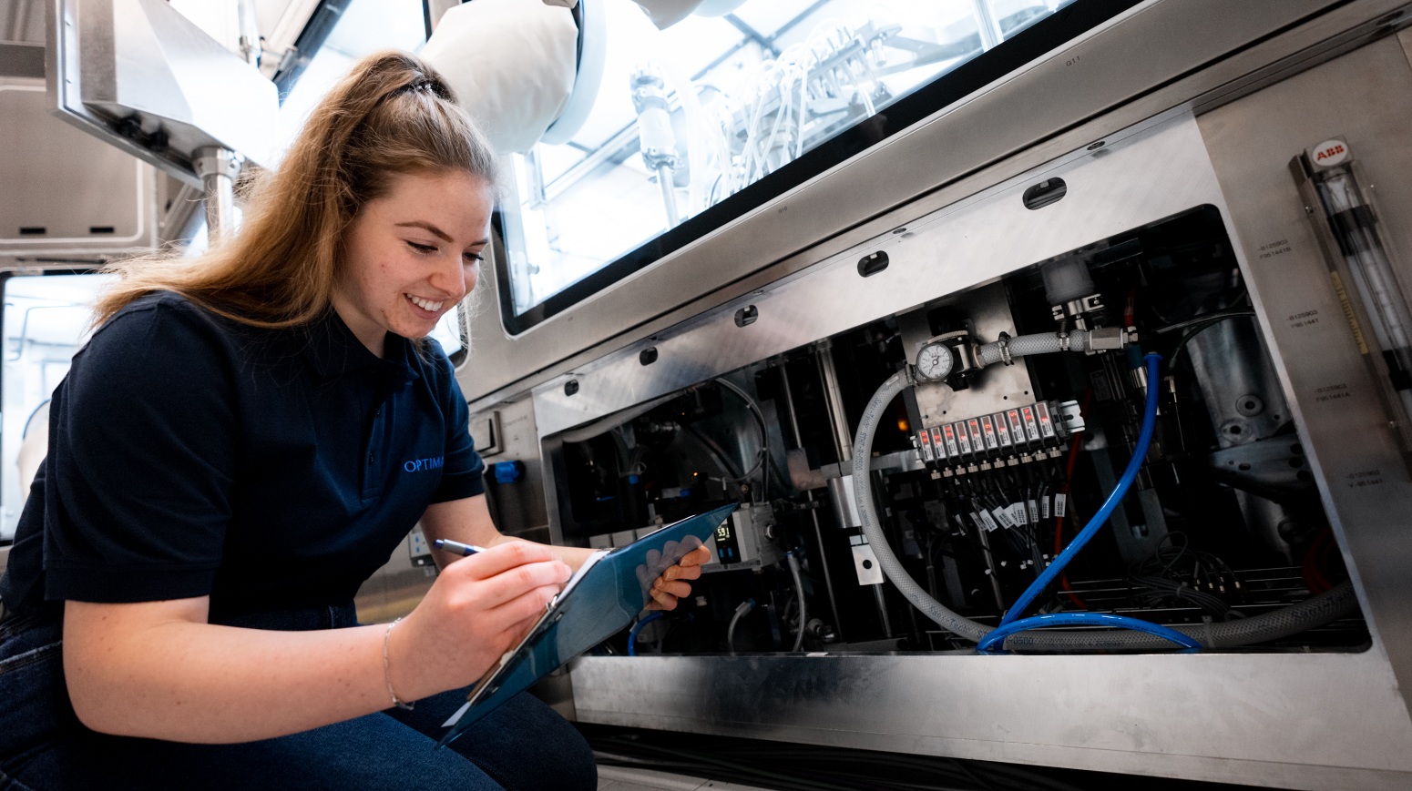
The aim of the new service location in Knightdale, North Carolina, is to ensure optimum availability of machinery and systems. (Source: Optima)

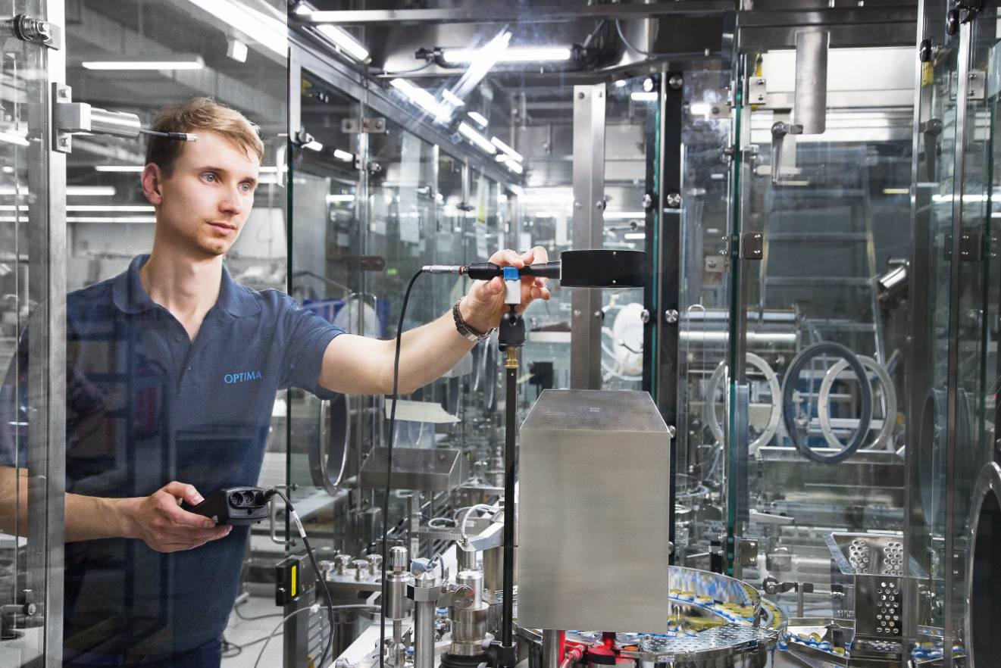
Calibration of pharmaceutical systems is just one of the many services offered at the new site. (Source: Optima)

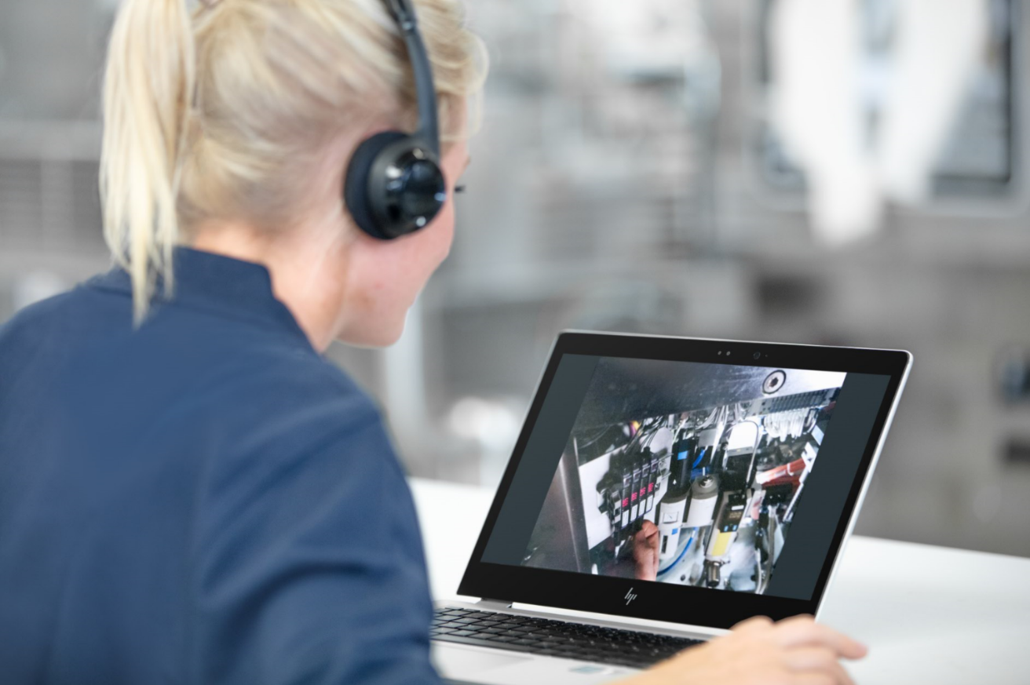
Be it remotely or on-site, Optima's service experts will find solutions to customers' challenges around the clock. (Source: Optima)

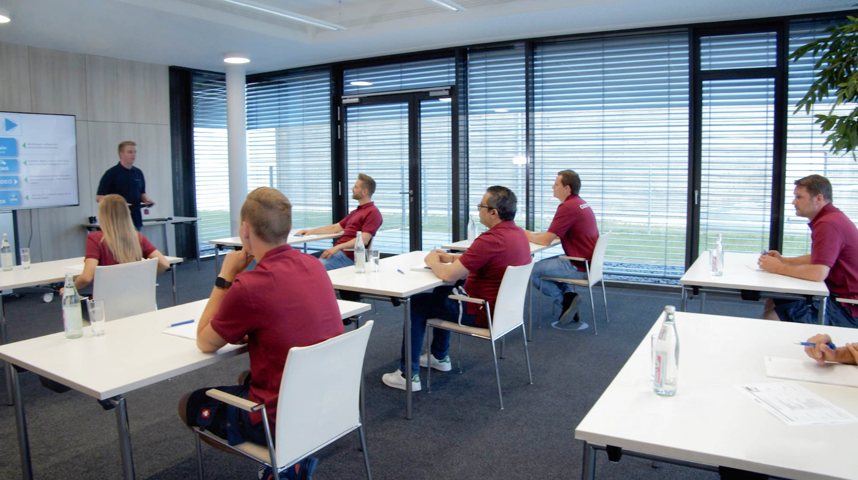
Transfer of knowledge occurs through training and formal courses, allowing customers’ personnel to become system experts. (Source: Optima)

Characters (incl. spaces): 3,103

Press contact:
OPTIMA packaging group GmbH
Jan Deininger
Group Communications Manager
+49 (0)791 / 506-1472
jan.deininger@optima-packaging.com
www.optima-packaging.com

OPTIMA Machinery Corporation:

Jennifer Yang
Marketing Project Coordinator
+1-920-983-3132
jennifer.yang@optima-packaging.com
www.optima-packaging.com

About OPTIMA
Optima supports companies worldwide with flexible and customer-specific filling and packaging machines for pharmaceuticals, consumer goods, paper hygiene and medical devices markets. As a provider of solutions and systems, Optima accompanies these companies from the product idea through to successful production and throughout the entire machine life cycle. Over 2,800 experts around the globe contribute to Optima's success. 20 locations in Germany and abroad ensure the worldwide availability of services. In 2022, Optima celebrates the company's 100th anniversary.
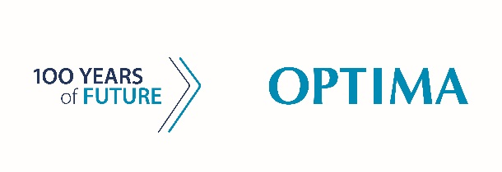
Exciting stories from 100 years of Optima: www.100-years-of-future.com

Thank you very much for your publication. We look forward to receiving a digital specimen copy.

